**Patient-Medicine-And-Appointment-System**

**1. Introduction**

**DoctorsCare is an innovative application designed to provide healthcare services online, allowing patients to access medical aid from the comfort of their homes. This platform caters to the growing need for digital healthcare solutions, offering convenience and efficiency to both patients and doctors. As technology evolves rapidly, DoctorsCare aims to bridge the gap between healthcare services and technology, creating a seamless user experience.**

**Purpose**

**DoctorsCare aims to eliminate traditional healthcare systems' challenges, such as long waiting lines, misplaced medical records, and time-consuming processes. By digitizing healthcare, DoctorsCare not only saves time and cost for patients but also empowers doctors with comprehensive access to patient records for improved treatment.**

**Scope**

**DoctorsCare is a future-oriented platform designed for individuals who seek:**

* **Online medical consultations.**
* **Access to previous medical records.**
* **The convenience of scheduling appointments and accessing prescriptions digitally.**
* **Reduced costs and time spent on healthcare services.**

**2. Features of DoctorsCare**

**2.1 Patient-Centric Features**

1. **Online Appointments:**
   * **Patients can book appointments with doctors at their convenience.**
   * **Avoids long queues in hospitals.**
2. **E-Prescriptions:**
   * **Doctors can provide digital prescriptions, reducing the risk of losing them.**
   * **Patients can easily access and share prescriptions with pharmacies or other doctors.**
3. **Access to Medical History:**
   * **Patients’ previous medical records, reports, and prescriptions are securely stored in the database.**
   * **Enables easy retrieval and sharing.**
4. **Cost-Effective Consultations:**
   * **Reduced travel and waiting time.**
   * **Saves on transportation and other expenses.**
5. **Home-Based Healthcare:**
   * **Patients can consult doctors from their homes, ensuring convenience and comfort.**

**2.2 Doctor-Centric Features**

1. **Comprehensive Medical Records:**
   * **Doctors have access to patients' complete medical histories, aiding in accurate diagnosis and better treatment.**
2. **Time Management:**
   * **Doctors can manage appointments and consultations more effectively.**
3. **Digital Prescriptions:**
   * **Reduced paperwork and faster prescription delivery to patients.**
4. **Enhanced Communication:**
   * **Direct communication with patients through the platform for follow-ups and clarifications.**

**Screenshots:  
  
Home Page:**



**You can sign up as doctor or patient by clicking signup button  
  
**

**Sign-up as patient  
  
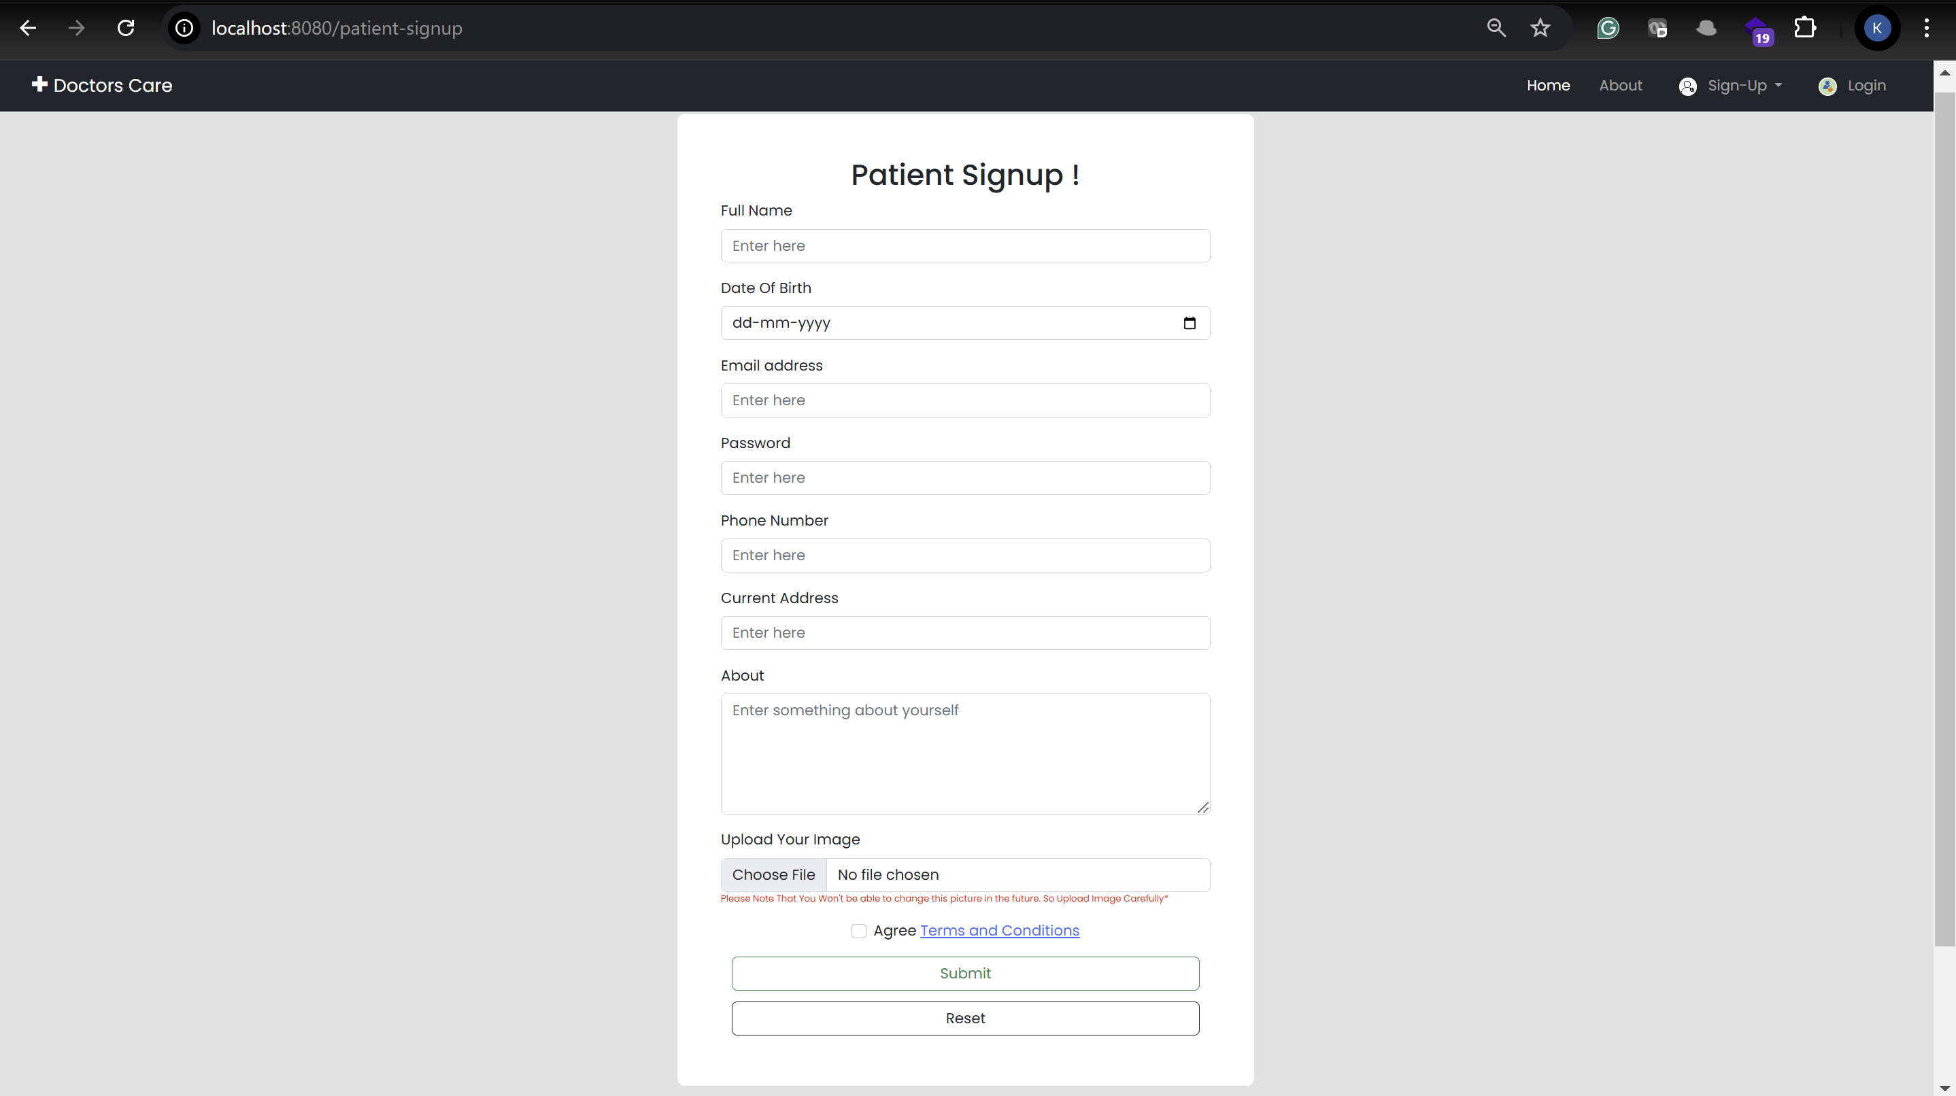**

**As a doctor**

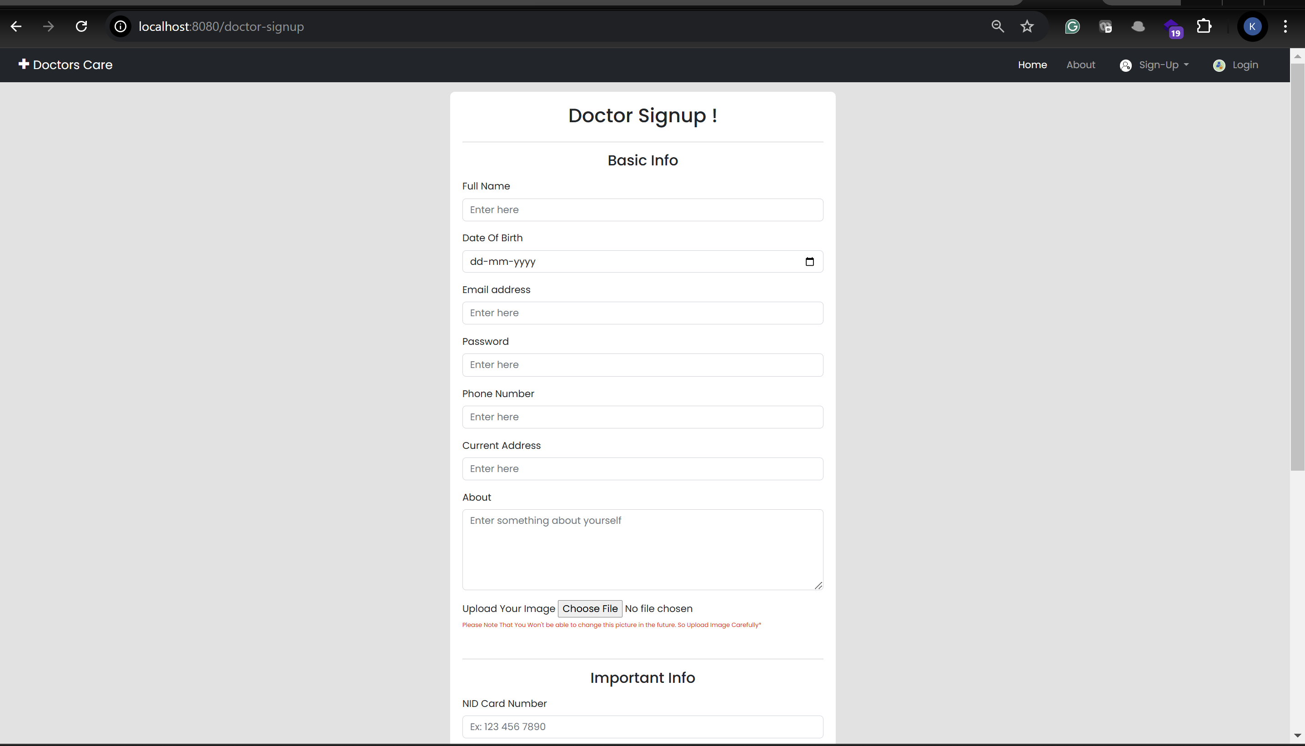

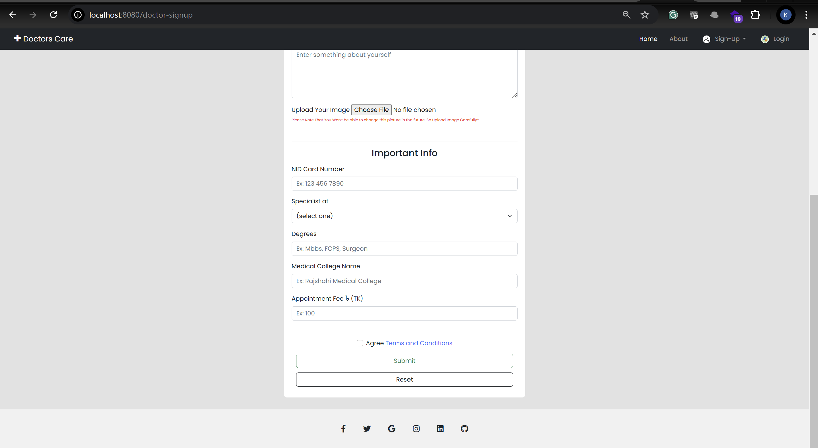

**Sign-in/ Log-in**

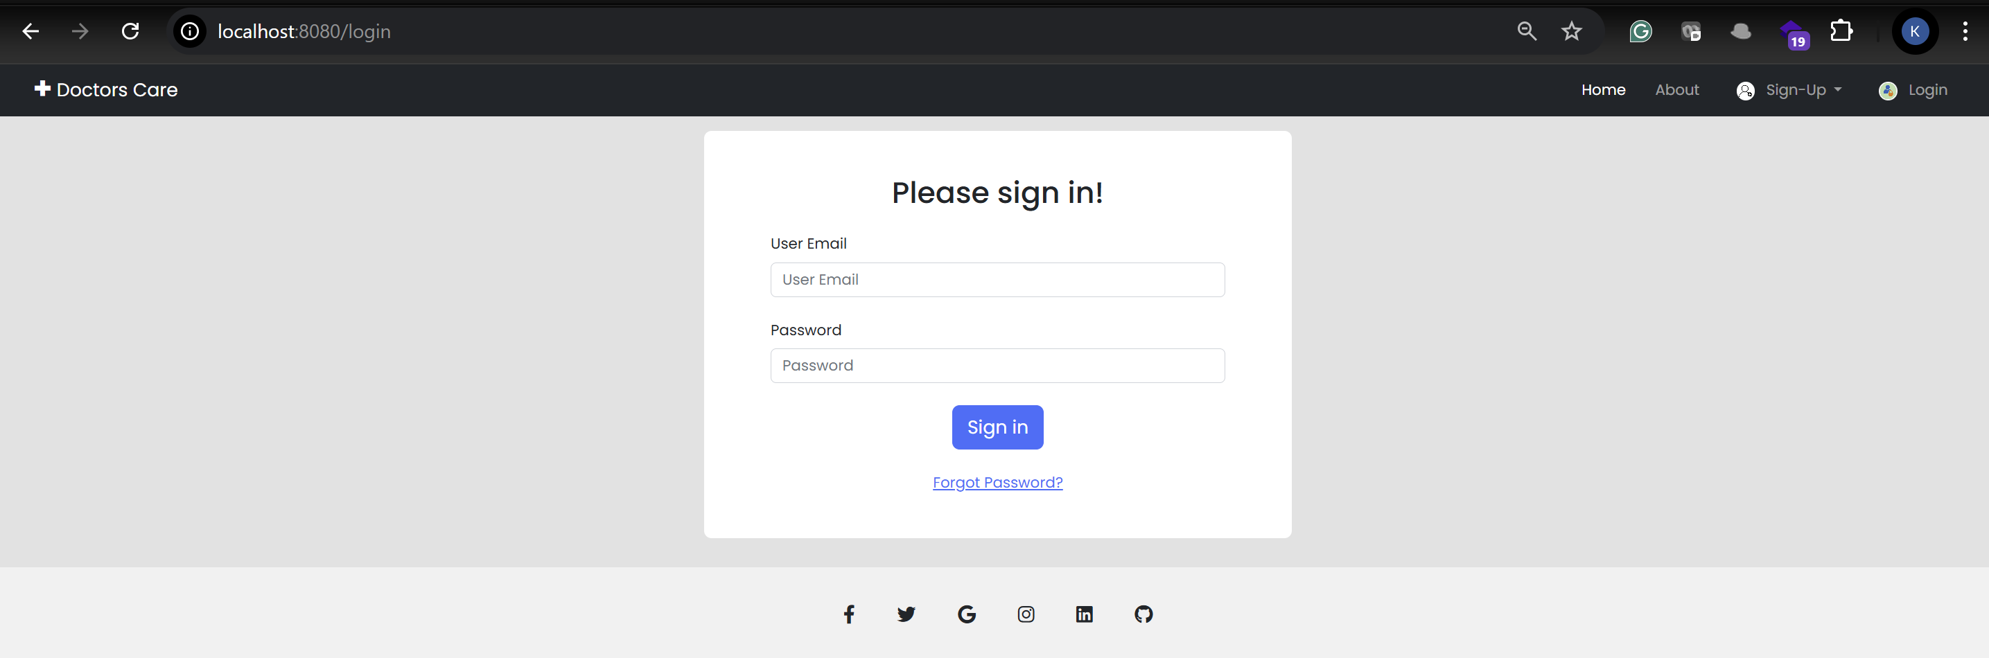

**Patient Dashboard  
  
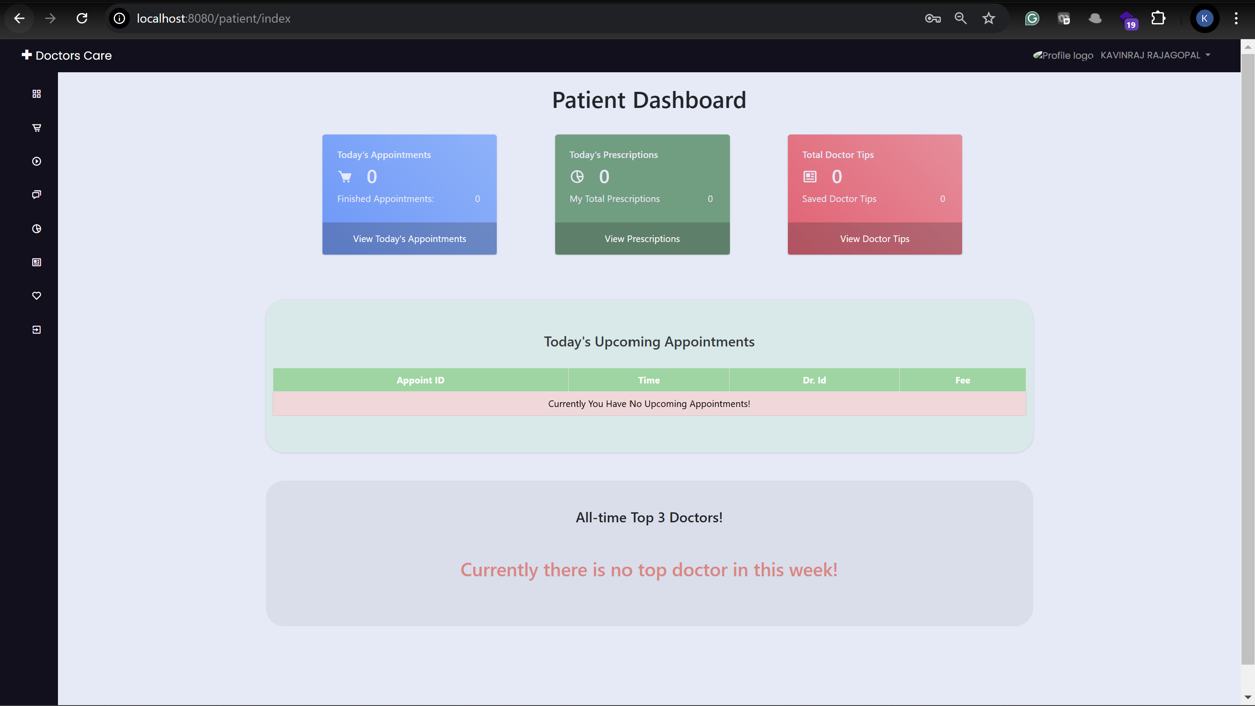**

**To book an appointment click the appoint doctor button from left side pannel  
  
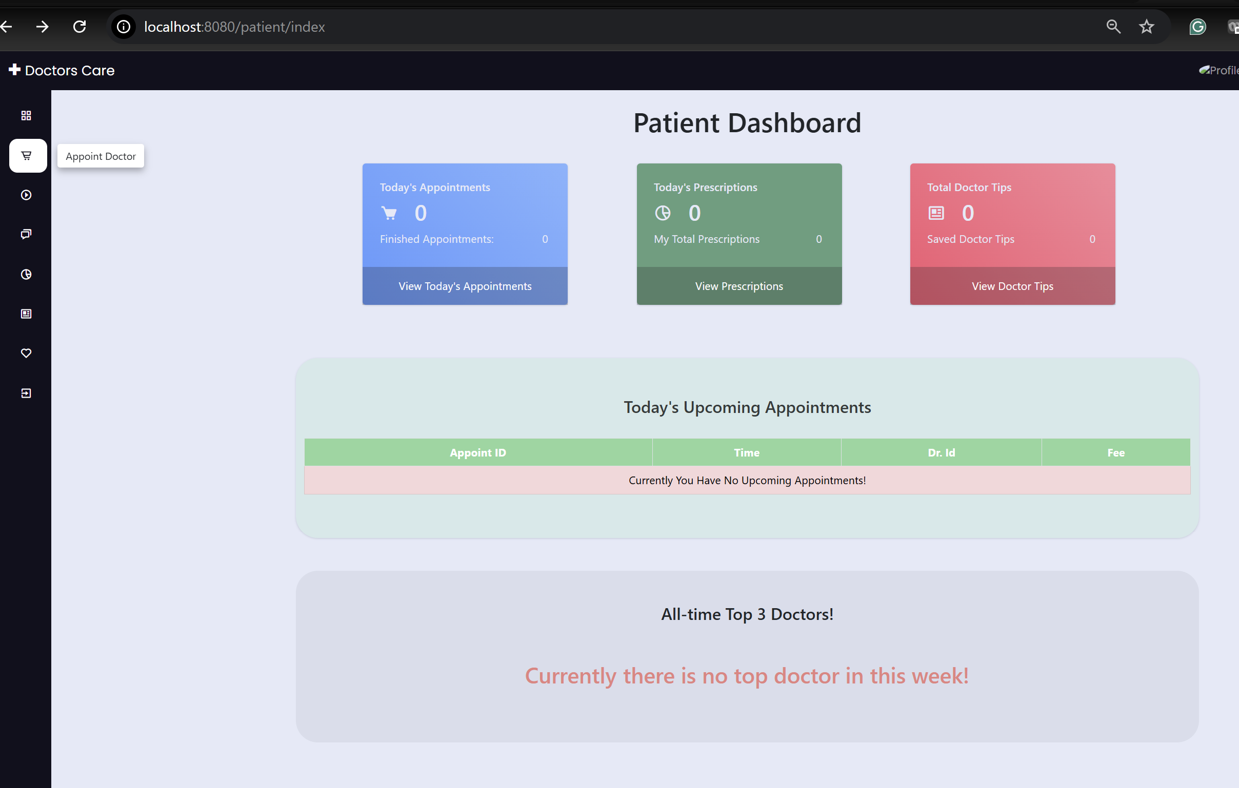**

**You will be land on the below page  
  
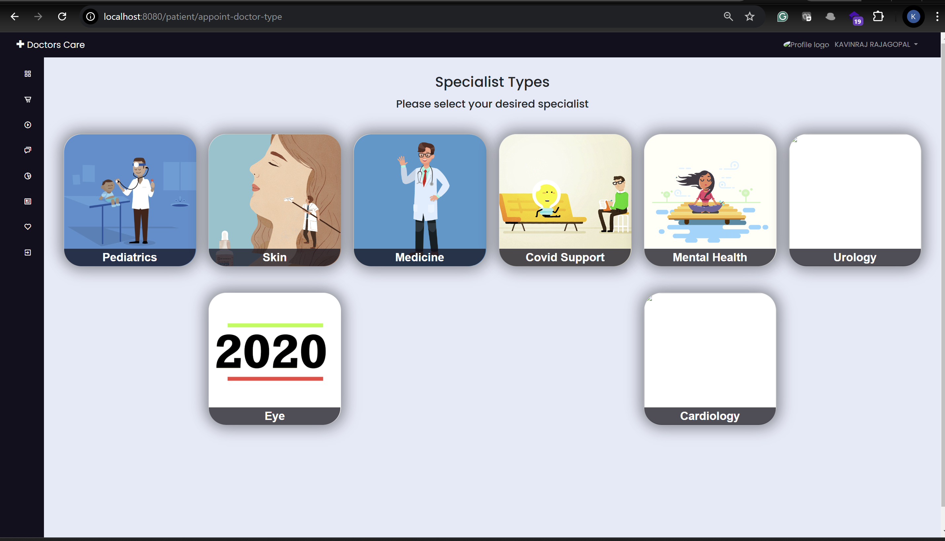**

**Now it’s patients can choose the specialist**

**Currently, I have registered 3 skin specialist  
  
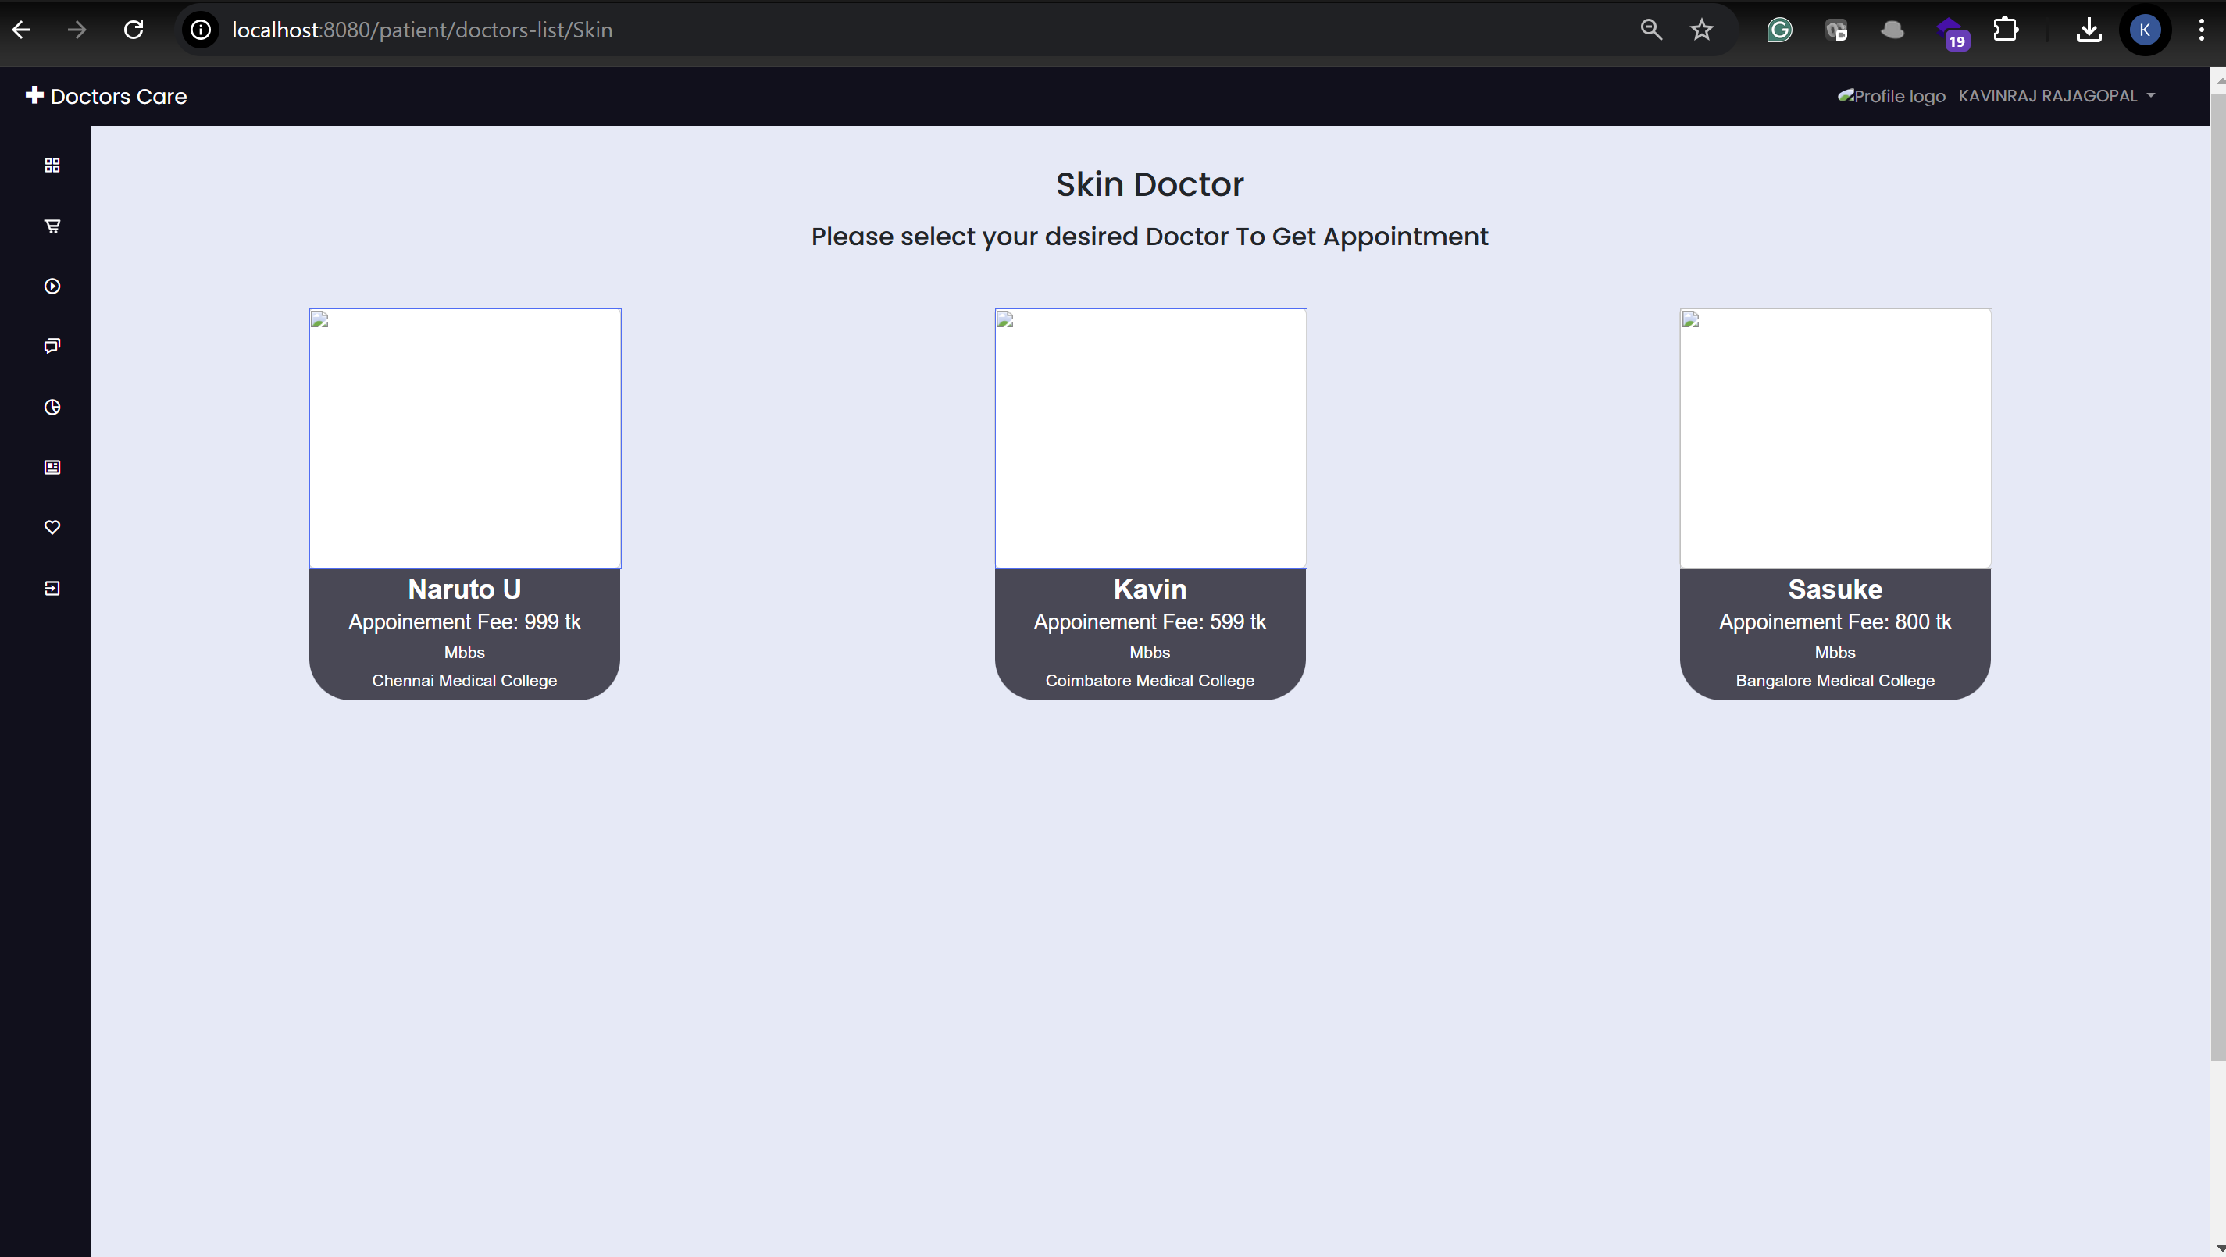**

**I choose Doctor Kavin and booked and appointment for 2 pm  
  
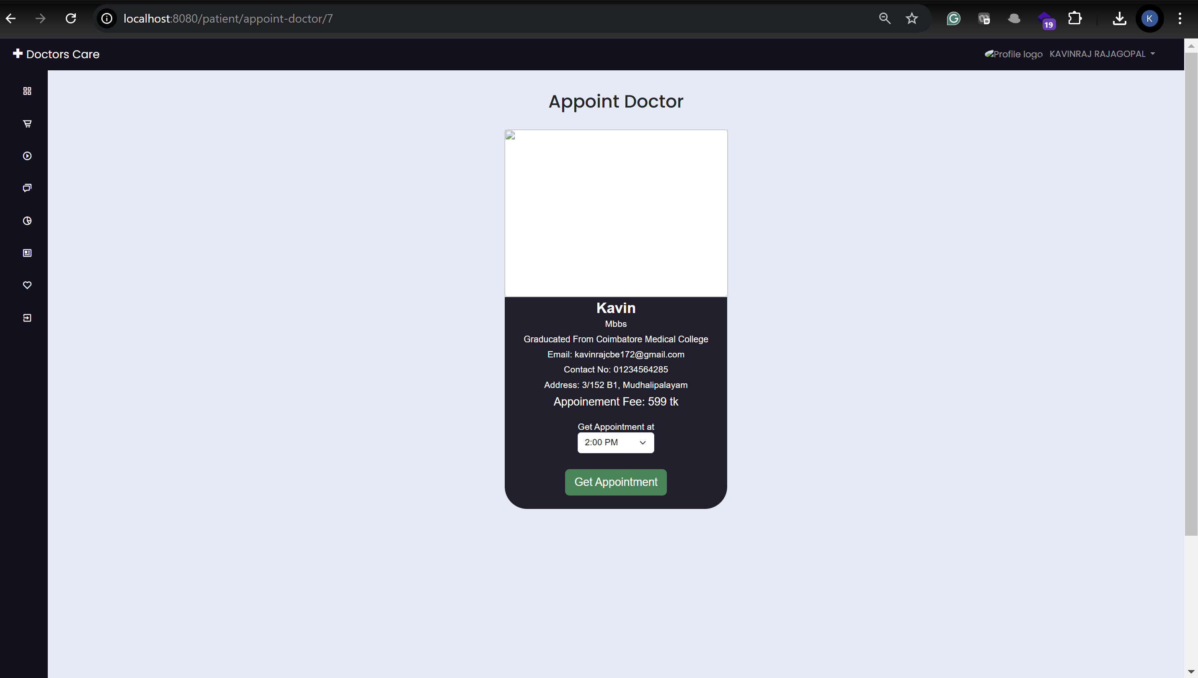**

**Next step is payment Process  
  
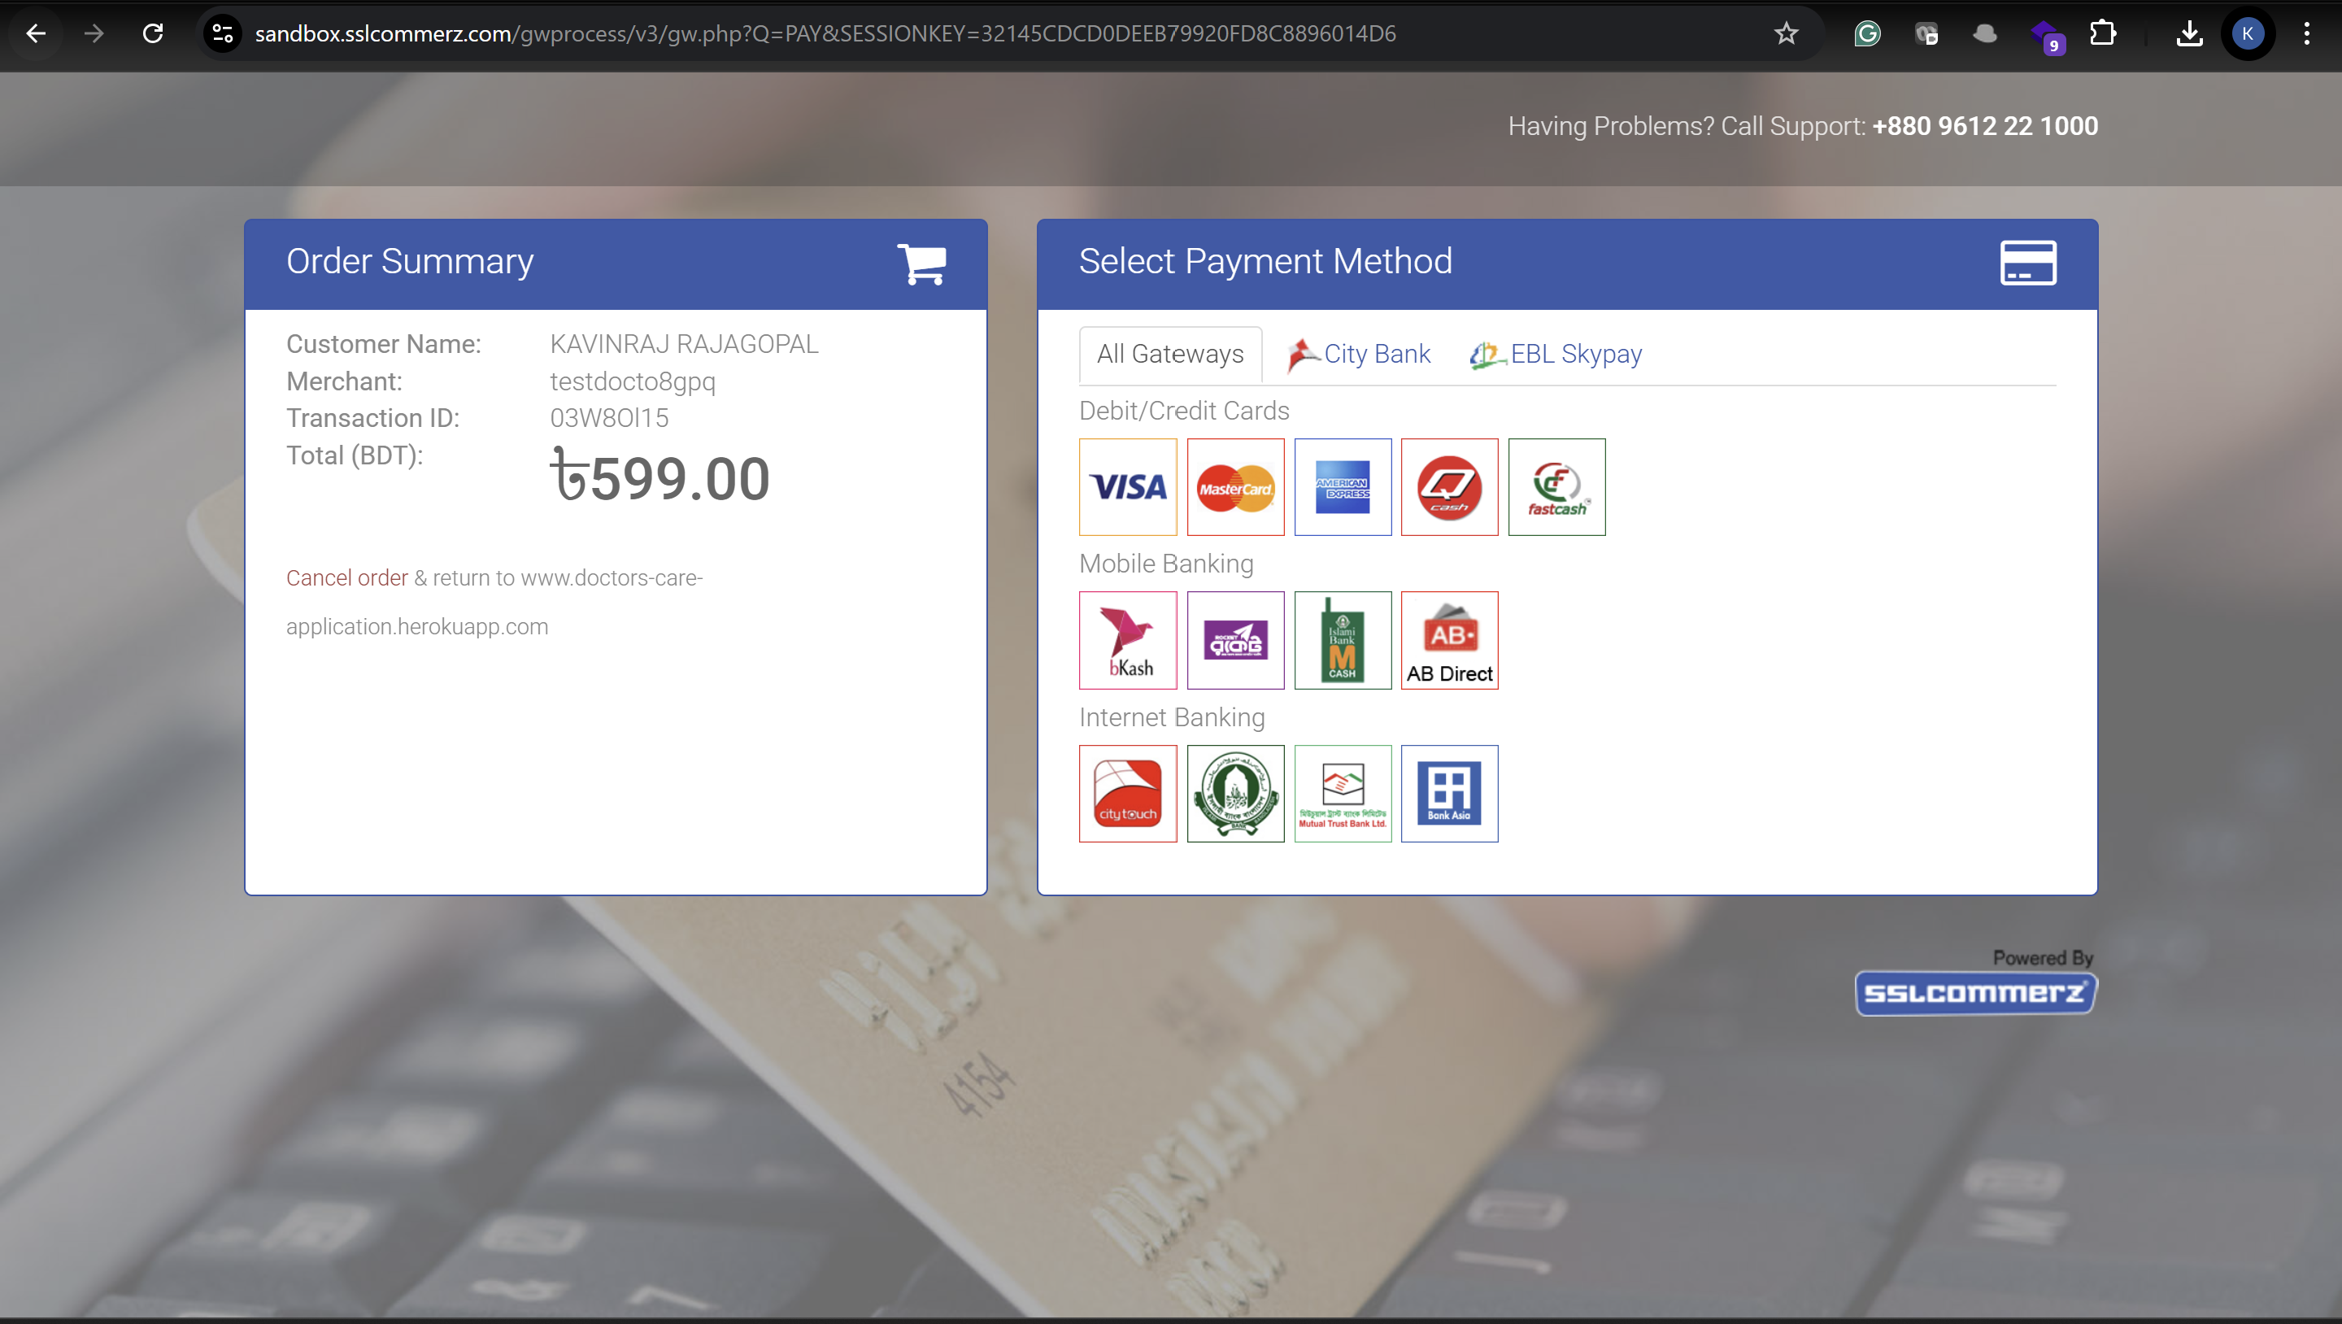**

**Once the payment is made patient will see below image**

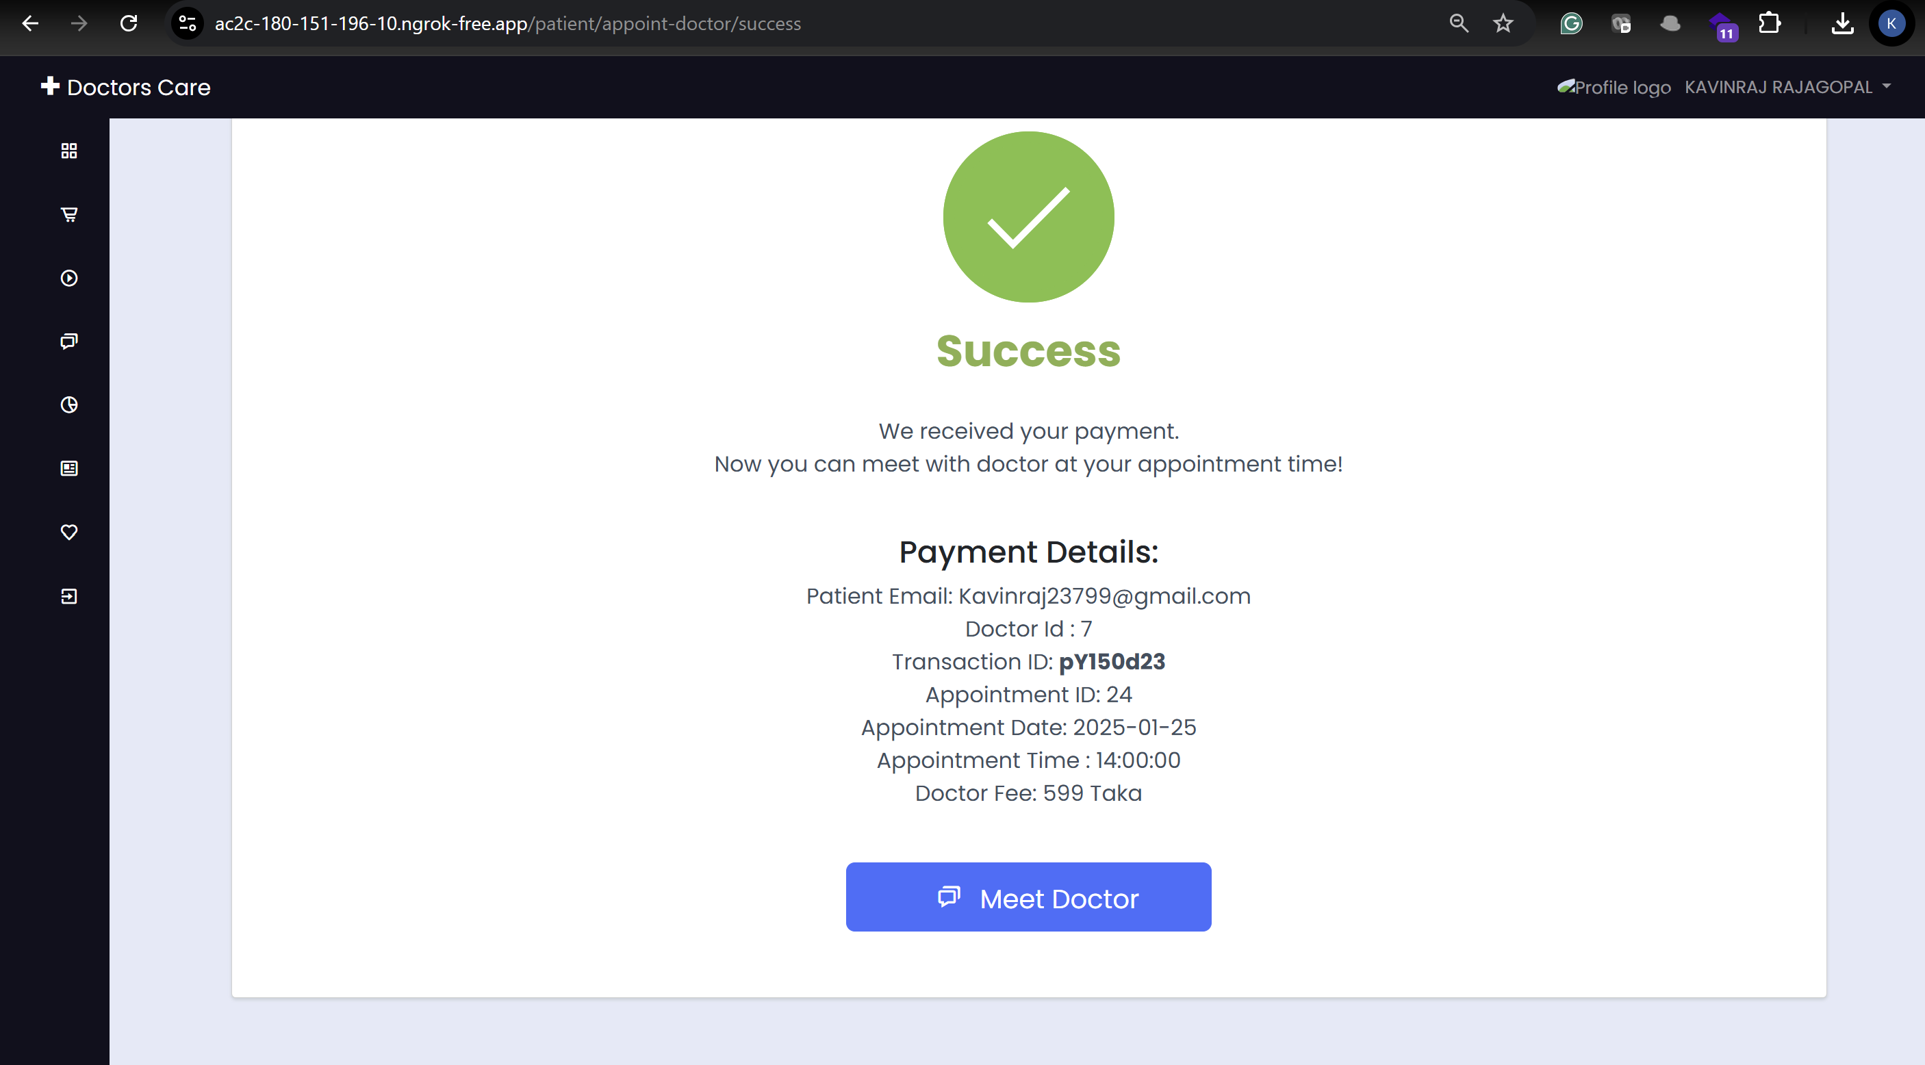

**The patient can see their appointment by clicking today’s appointment button**

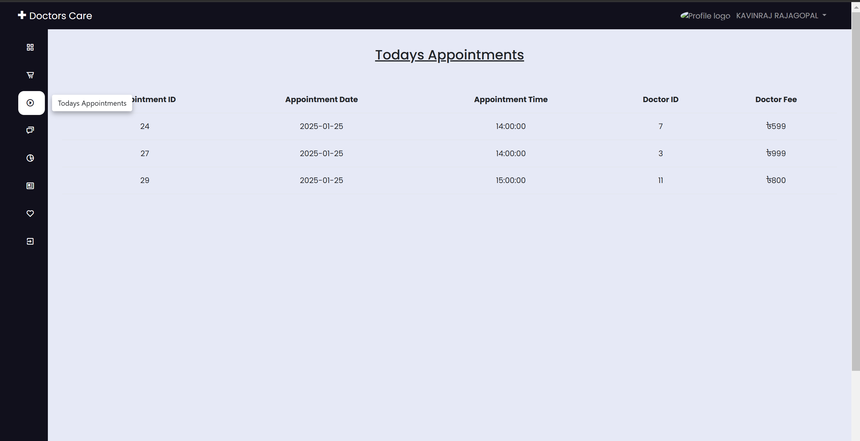

**By clicking Prescription they can see their Prescription**

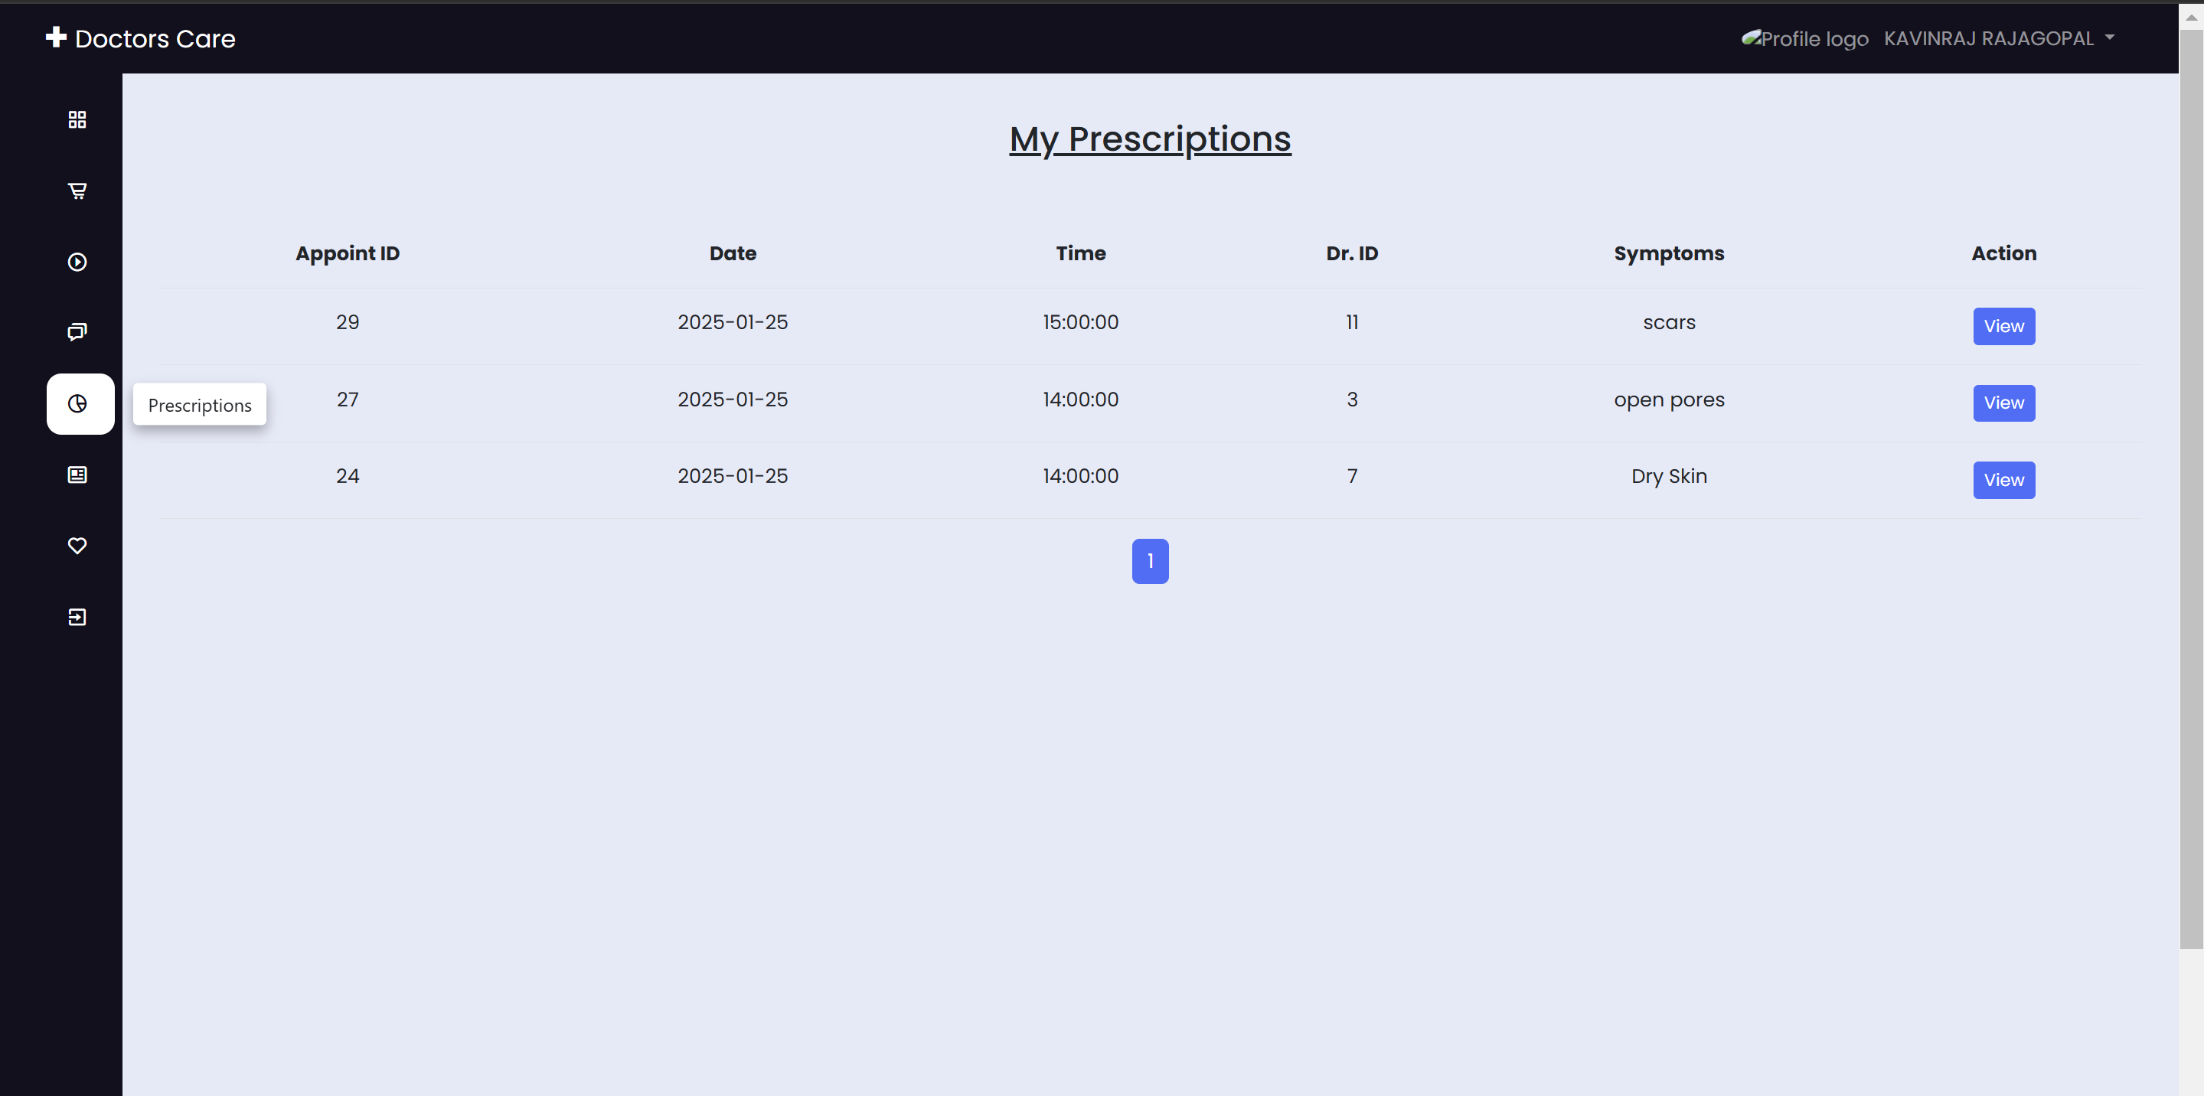

**The patient can view their detailed prescription as below, they can download and print the document**

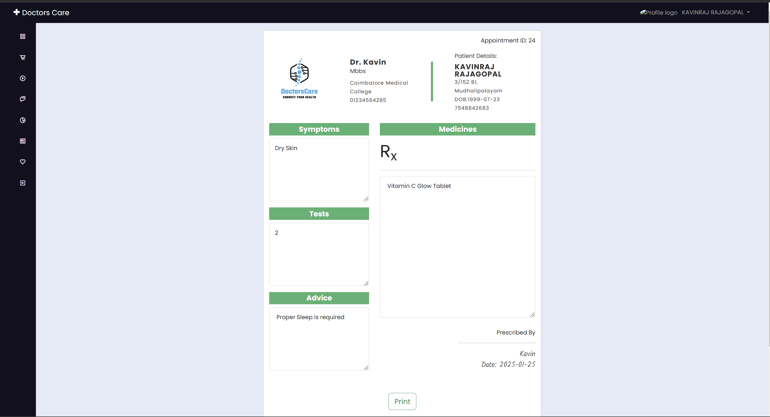

**Patients can see the top three doctors in the hospital  
  
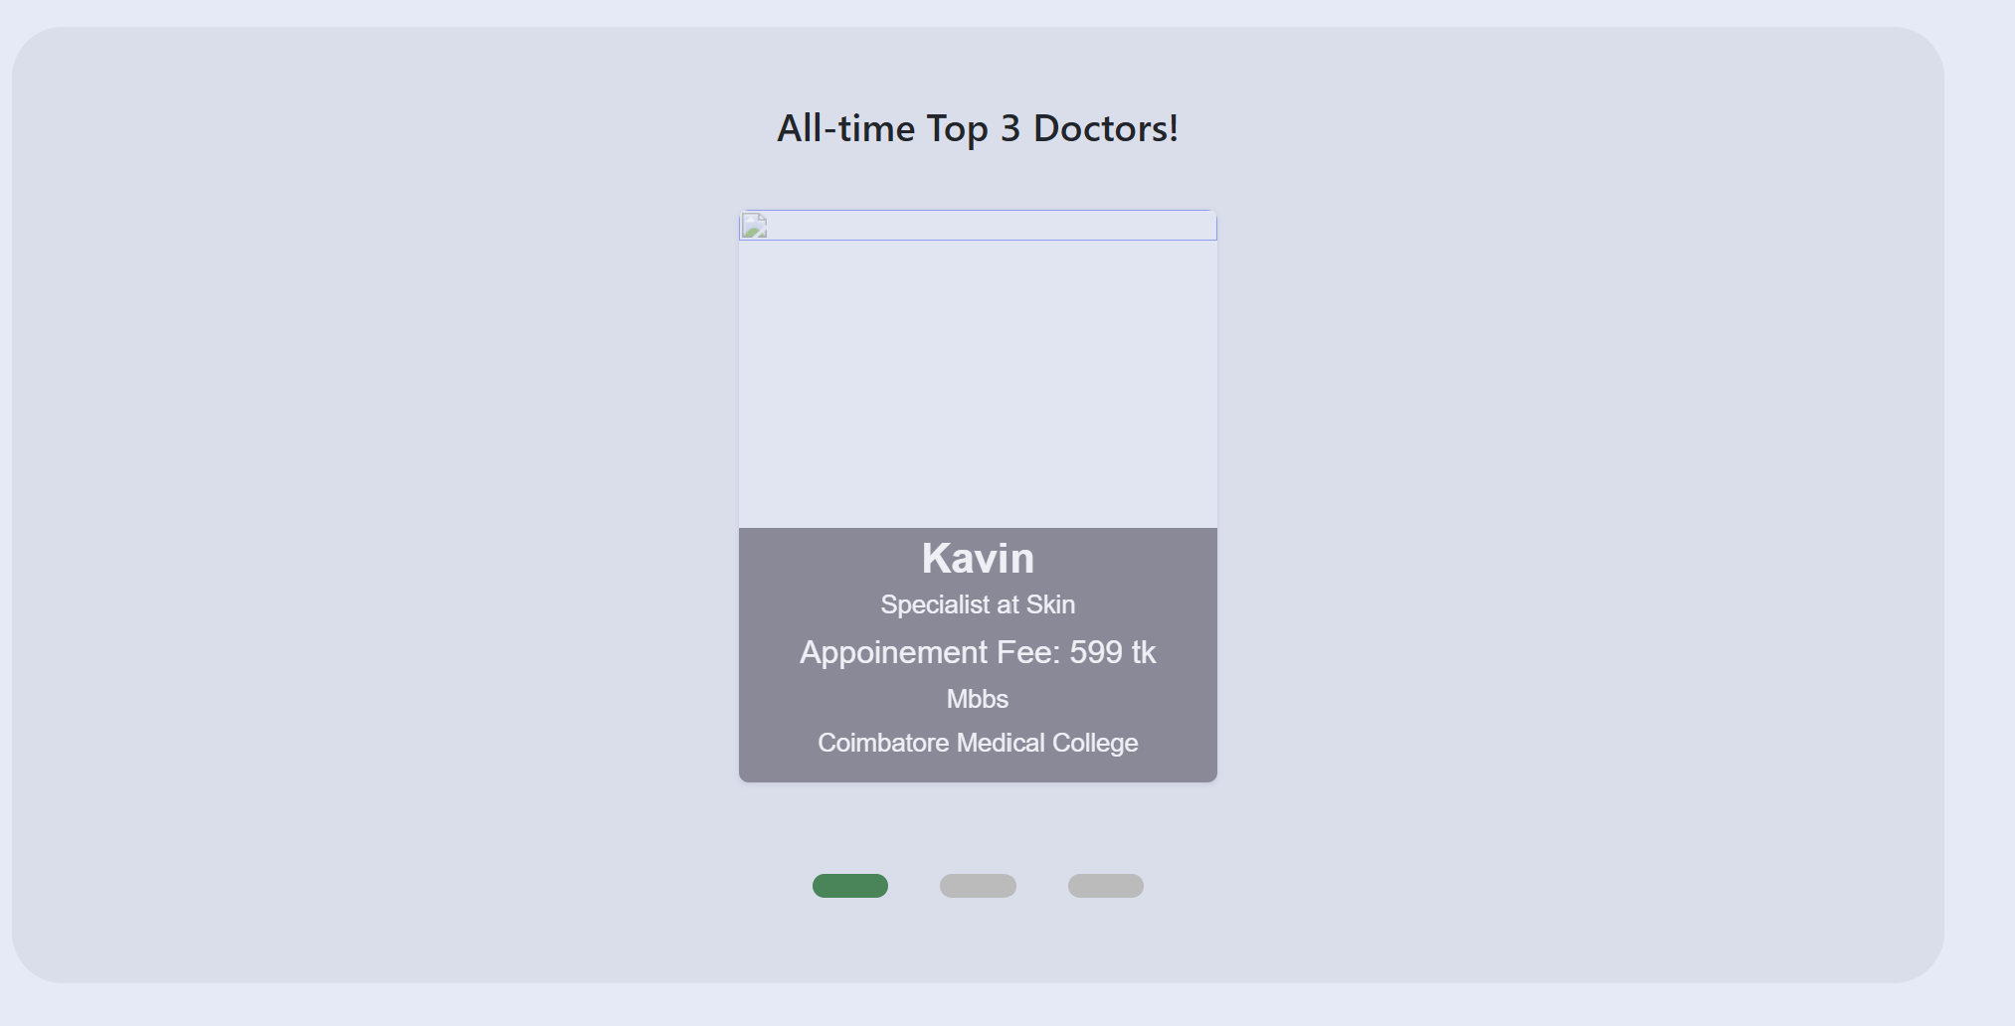**

**3. Benefits of DoctorsCare**

**3.1 For Patients**

* **Convenience: No need to physically visit the hospital for minor issues or routine follow-ups.**
* **Data Security: All medical records are securely stored in the cloud, reducing the risk of loss or damage.**
* **Accessibility: 24/7 access to medical records and prescriptions.**
* **Time-Saving: Avoid long waiting periods at hospitals or clinics.**
* **Affordable Healthcare: Saves on travel and other incidental expenses.**

**3.2 For Doctors**

* **Efficient Workflow: Streamlines patient management with access to their medical history in one place.**
* **Better Treatment Decisions: Comprehensive medical records ensure informed decisions.**
* **Paperless Workflow: Reduces administrative burden by digitizing prescriptions and reports.**

**4. Challenges Addressed by DoctorsCare**

**4.1 Traditional Healthcare Issues**

1. **Long Waiting Times:**
   * **Patients often wait in long lines for consultations. DoctorsCare eliminates this by enabling online appointments.**
2. **Misplaced Medical Records:**
   * **In the traditional system, losing prescriptions or reports was common. DoctorsCare ensures all records are securely stored and easily accessible.**
3. **Inconvenience for Patients:**
   * **Patients, especially those with mobility challenges, often face difficulties visiting hospitals. DoctorsCare provides healthcare from the comfort of their homes.**

**4.2 Modern-Day Expectations**

1. **Time Efficiency:**
   * **People value their time more than ever. DoctorsCare respects this by minimizing unnecessary delays.**
2. **Cost Reduction:**
   * **Digital consultations are cost-effective, saving on transportation and related expenses.**

**5. System Design and Architecture**

**5.1 High-Level Architecture**

**DoctorsCare consists of three primary modules:**

1. **User Module:**
   * **Handles patient and doctor registration, login, and profile management.**
2. **Appointment Module:**
   * **Manages online appointment scheduling, cancellation, and reminders.**
3. **Medical Records Module:**
   * **Stores and retrieves medical reports, prescriptions, and consultation notes.**

**5.2 Database Design**

* **Patient Table:**
  + **Stores patient details such as name, contact info, and medical history.**
* **Doctor Table:**
  + **Stores doctor details including specialization, experience, and availability.**
* **Appointment Table:**
  + **Tracks appointment details such as date, time, and status.**
* **Medical Records Table:**
  + **Securely stores prescriptions and test reports.**

**5.3 Security**

**DoctorsCare ensures data privacy and security through:**

* **Role-based access control (RBAC) for patients and doctors.**
* **Encryption of sensitive data.**
* **Compliance with healthcare data regulations like HIPAA (if applicable).**

**6. Technologies Used**

**6.1 Frontend**

* **HTML5, CSS3, JavaScript: For user interface design.**
* **ReactJS/AngularJS: For building dynamic and interactive web pages.**

**6.2 Backend**

* **Spring Boot: For handling business logic and API development.**
* **Java: Primary programming language for backend development.**

**6.3 Database**

* **MySQL/PostgreSQL: For secure and efficient data storage.**

**6.4 Deployment**

* **Cloud Platform: AWS, Azure, or Google Cloud for hosting the application.**
* **Docker: For containerization and seamless deployment.**

**7. Implementation Plan**

**7.1 Milestones**

1. **Phase 1: Requirement Analysis and Design**
   * **Identify core features and finalize system architecture.**
2. **Phase 2: Development**
   * **Develop frontend, backend, and integrate the database.**
3. **Phase 3: Testing**
   * **Perform unit, integration, and user acceptance testing (UAT).**
4. **Phase 4: Deployment**
   * **Deploy the application to a cloud platform for public use.**
5. **Phase 5: Maintenance**
   * **Regular updates and bug fixes.**

**7.2 Timeline**

* **Phase 1: 2 weeks**
* **Phase 2: 6 weeks**
* **Phase 3: 2 weeks**
* **Phase 4: 1 week**
* **Phase 5: Ongoing**

**SWAGGER API DETAILS**

**1 HOME CONTROLLER**

**PATIENT SIGNUP:**  
  
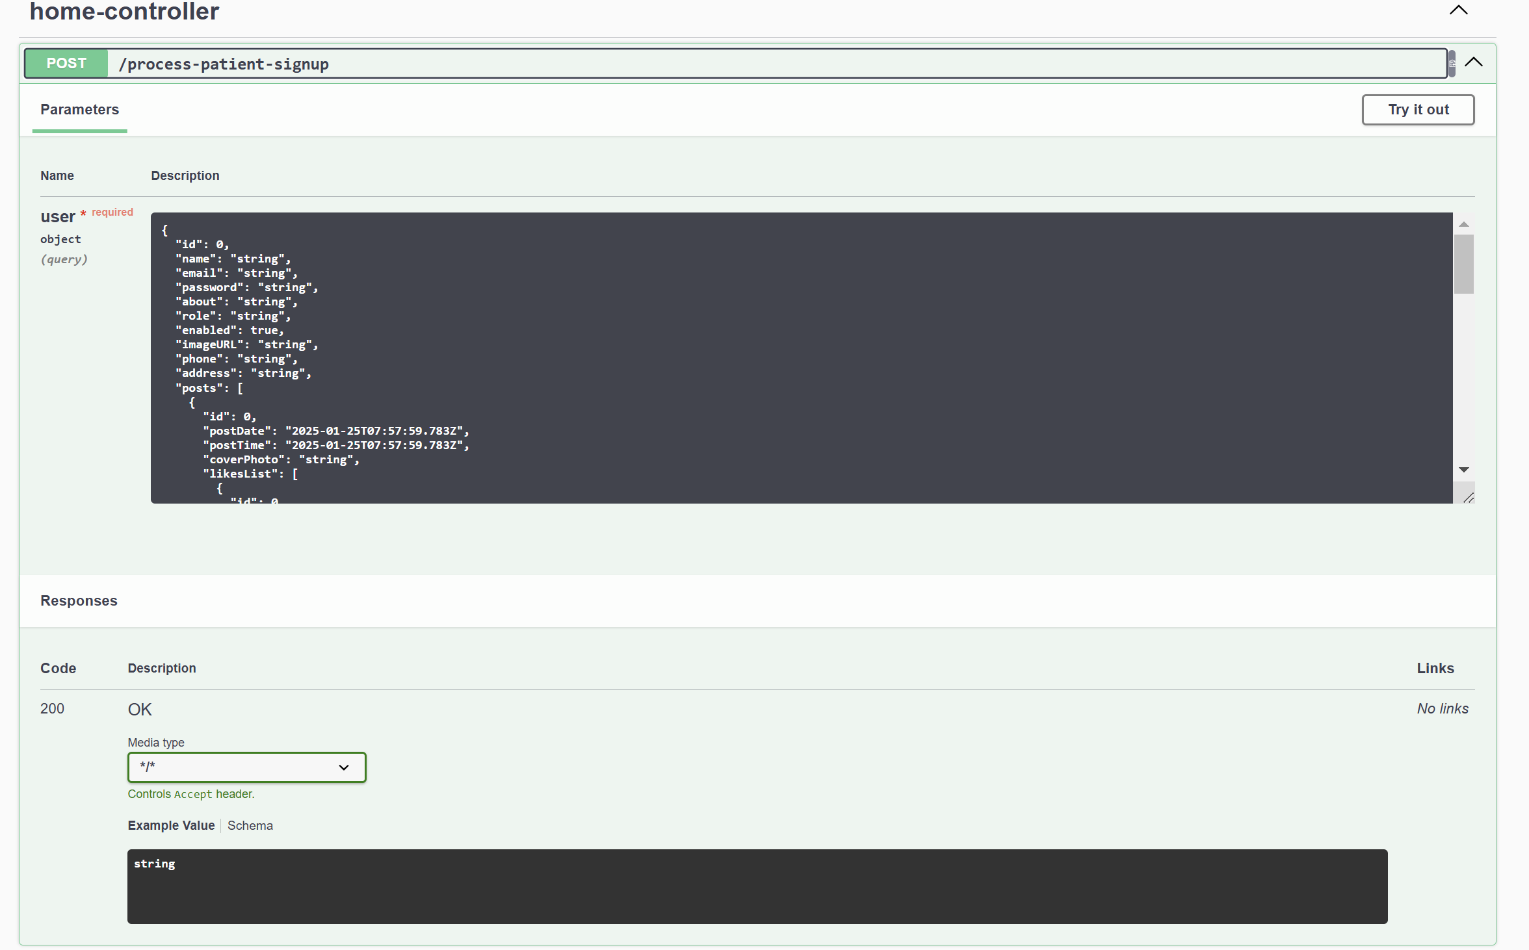

Payload:  
{

"id": 0,

"name": "string",

"email": "string",

"password": "string",

"about": "string",

"role": "string",

"enabled": true,

"imageURL": "string",

"phone": "string",

"address": "string",

"posts": [

{

"id": 0,

"postDate": "2025-01-25T07:57:59.783Z",

"postTime": "2025-01-25T07:57:59.783Z",

"coverPhoto": "string",

"likesList": [

{

"id": 0,

"likerId": "string",

"post": "string"

}

],

"commentsList": [

{

"id": 0,

"commenterId": "string",

"commenterName": "string",

"commenterImage": "string",

"comment": "string",

"posts": "string"

}

],

"savedPostsList": [

{

"id": 0,

"saverId": "string",

"posts": "string"

}

],

"user": "string",

"postContent": "string"

}

],

"doctorsAdditionalInfo": {

"id": 0,

"nid": "string",

"doctortype": "string",

"degrees": "string",

"medicalcollege": "string",

"appointmentfee": "string",

"user": "string"

},

"doctorsSchedule": {

"id": 0,

"is_10_00": true,

"is_10_30": true,

"is_11_00": true,

"is_11_30": true,

"is_12_00": true,

"is_2_00": true,

"is_2_30": true,

"is_3_00": true,

"is_3_30": true,

"user": "string"

},

"accountActiveToken": {

"id": 0,

"token": "string",

"tokenGenerationDate": "2025-01-25T07:57:59.783Z",

"user": "string",

"emailIsVerified": true

},

"dob": "string"

}

**DOCTOR SIGNUP**

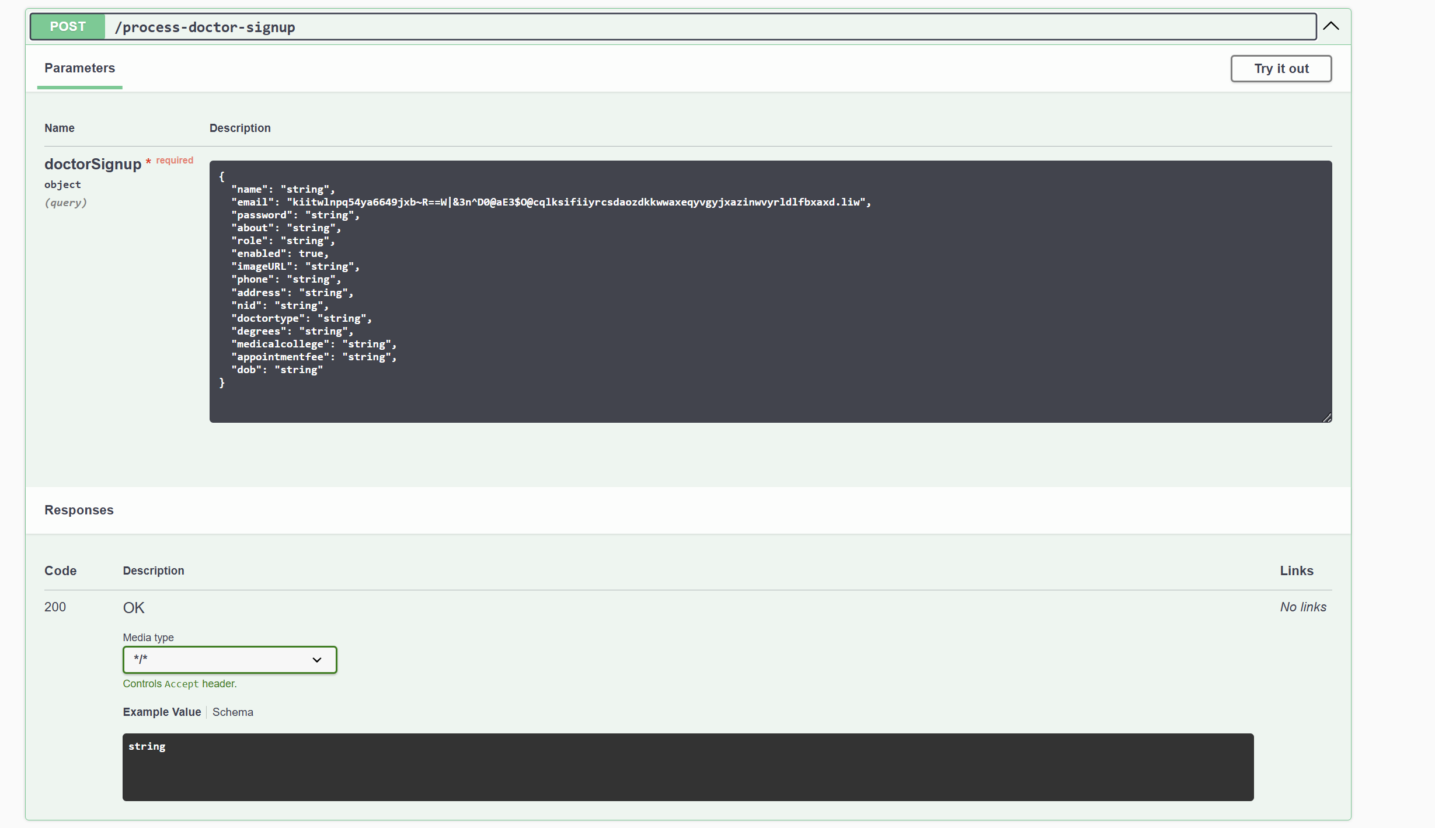

Payload:

{

"name": "string",

"email": "kiitwlnpq54ya6649jxb~R==W|&3n^D0@aE3$O@cqlksifiiyrcsdaozdkkwwaxeqyvgyjxazinwvyrldlfbxaxd.liw",

"password": "string",

"about": "string",

"role": "string",

"enabled": true,

"imageURL": "string",

"phone": "string",

"address": "string",

"nid": "string",

"doctortype": "string",

"degrees": "string",

"medicalcollege": "string",

"appointmentfee": "string",

"dob": "string"

}

**CHANGE PASSWORD**

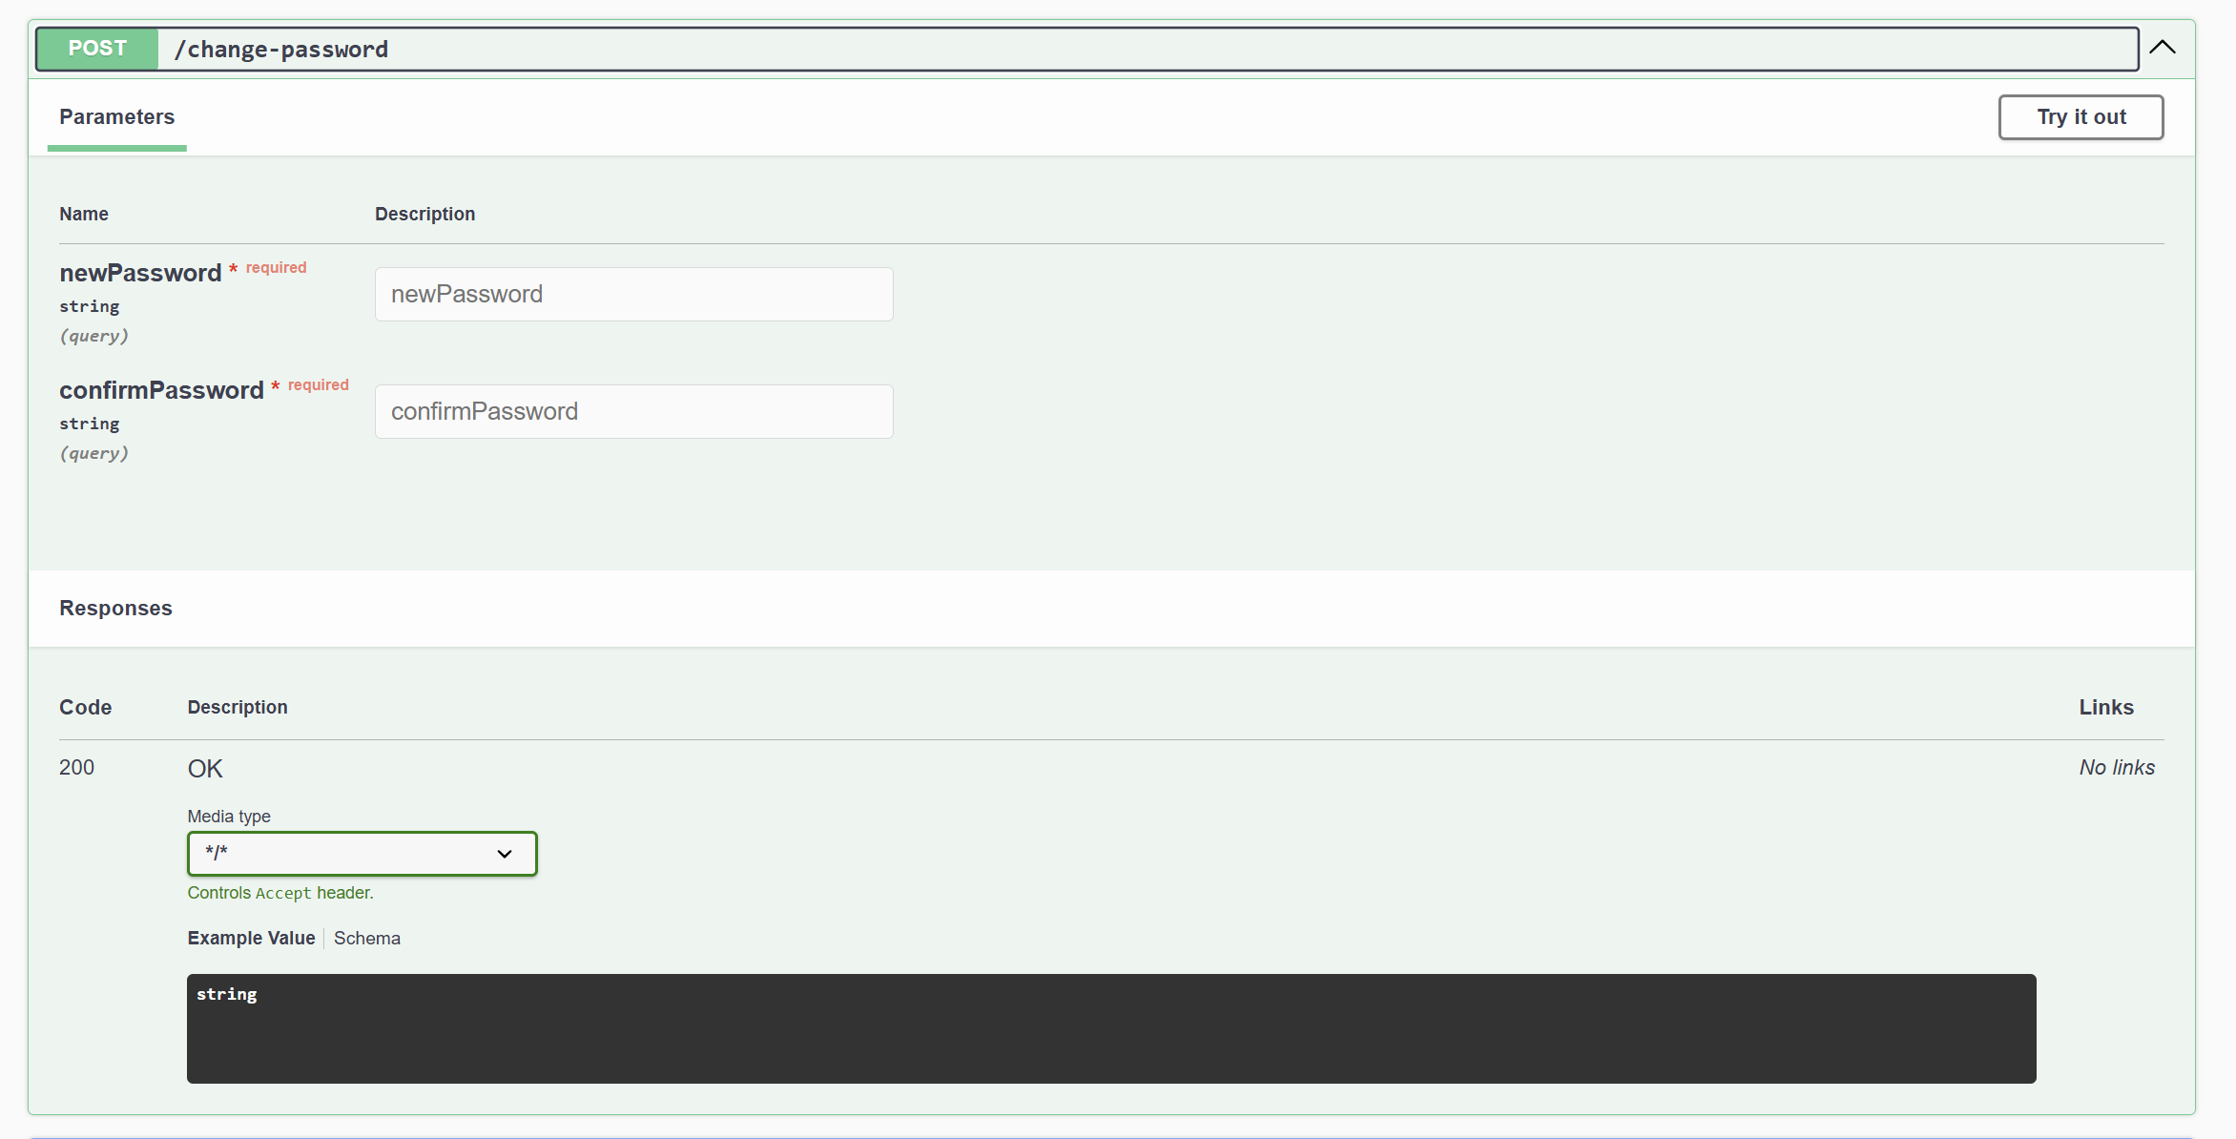

**GET OTP**

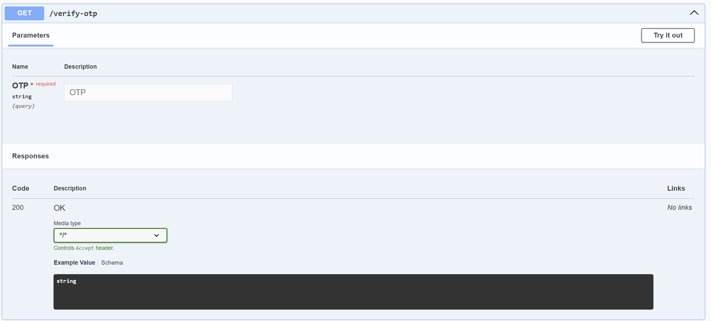

**VERIFY OTP**

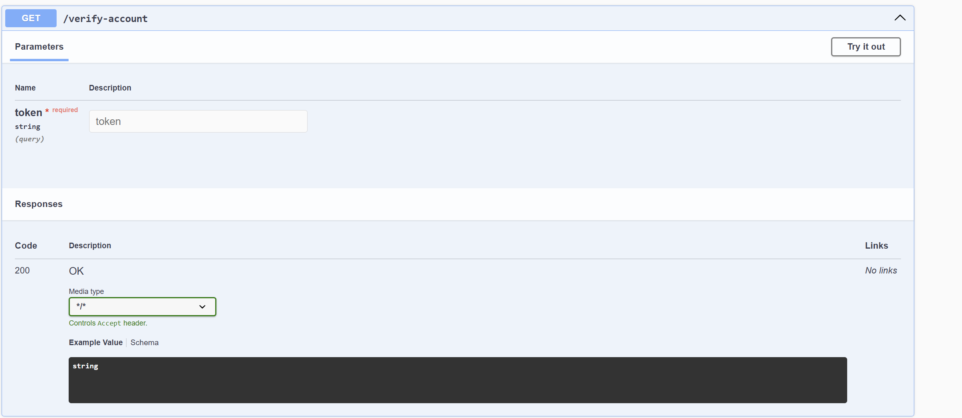

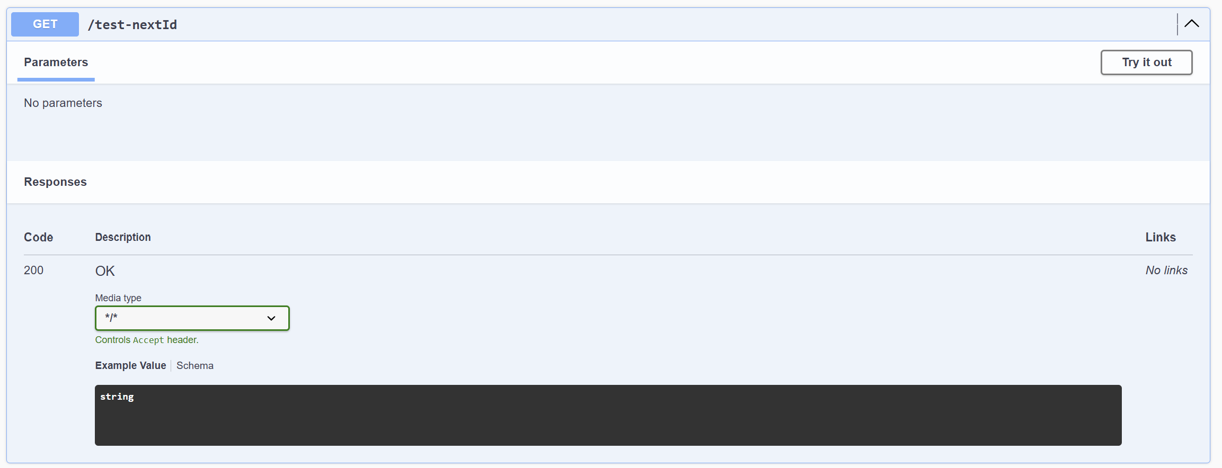

**TERMS AND CONDITION**

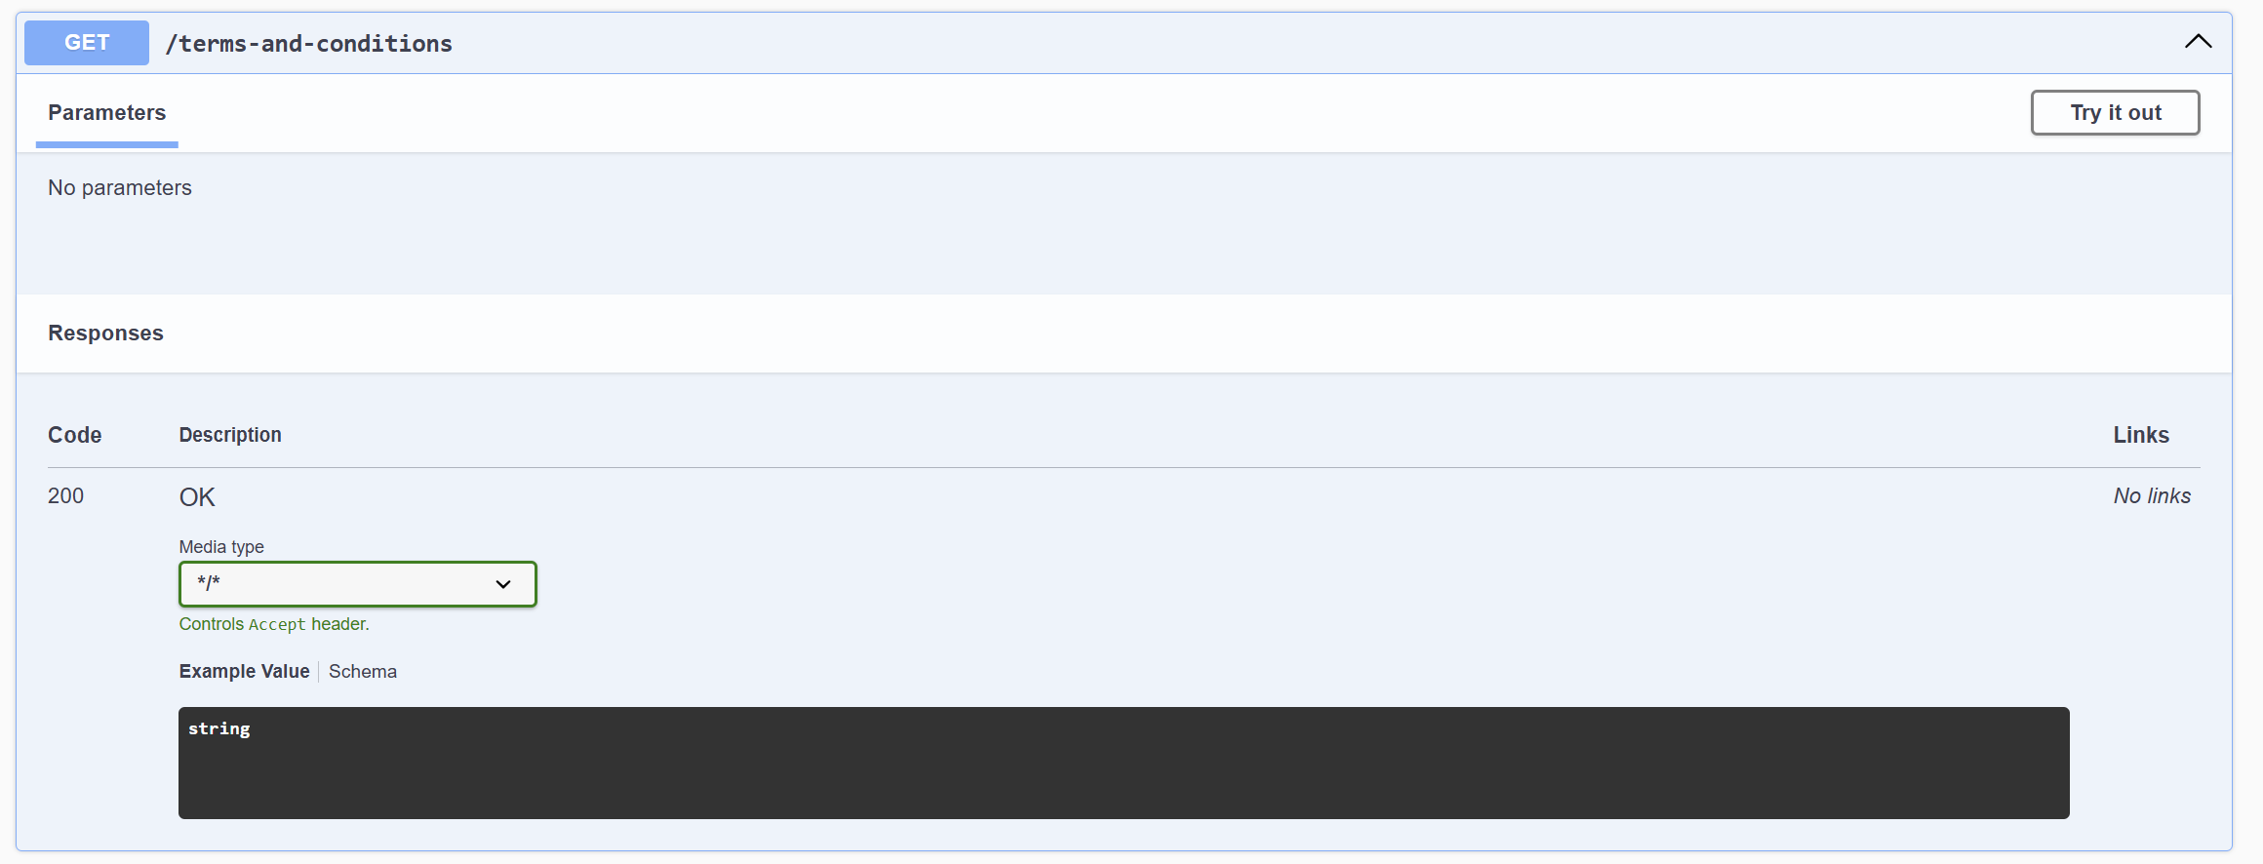

**SEND OTP**

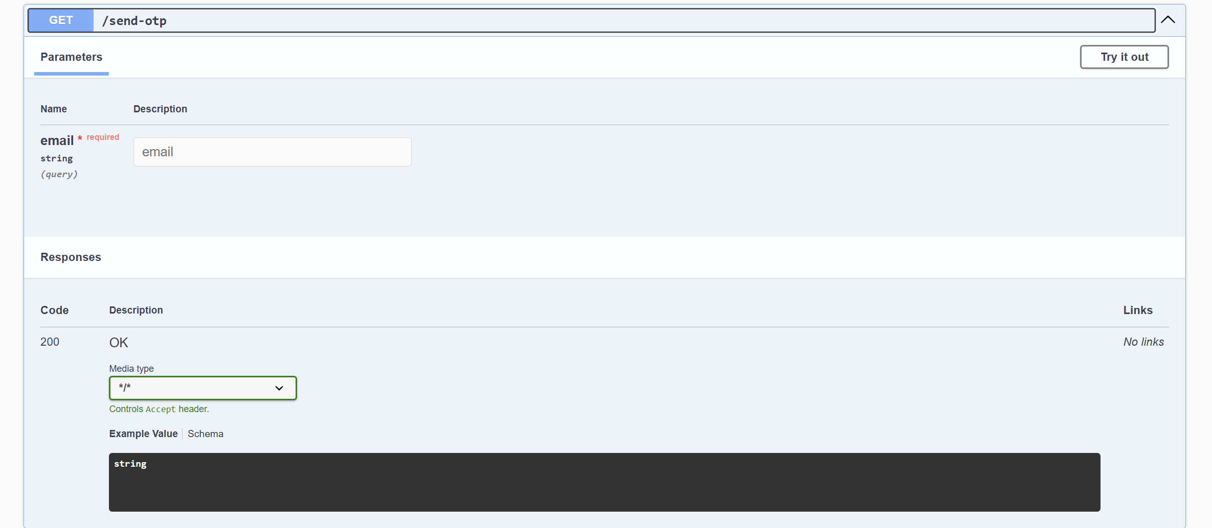

**PATIENT SIGNUP**

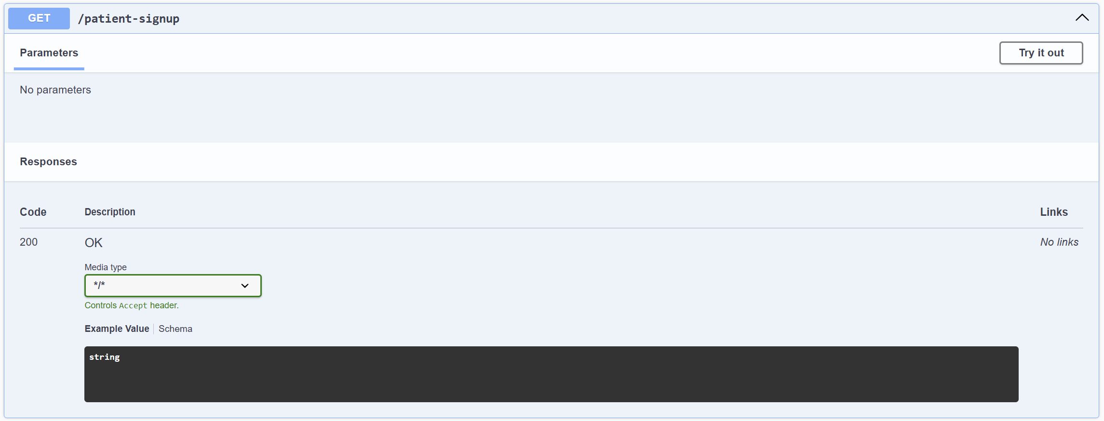

**LOGIN**

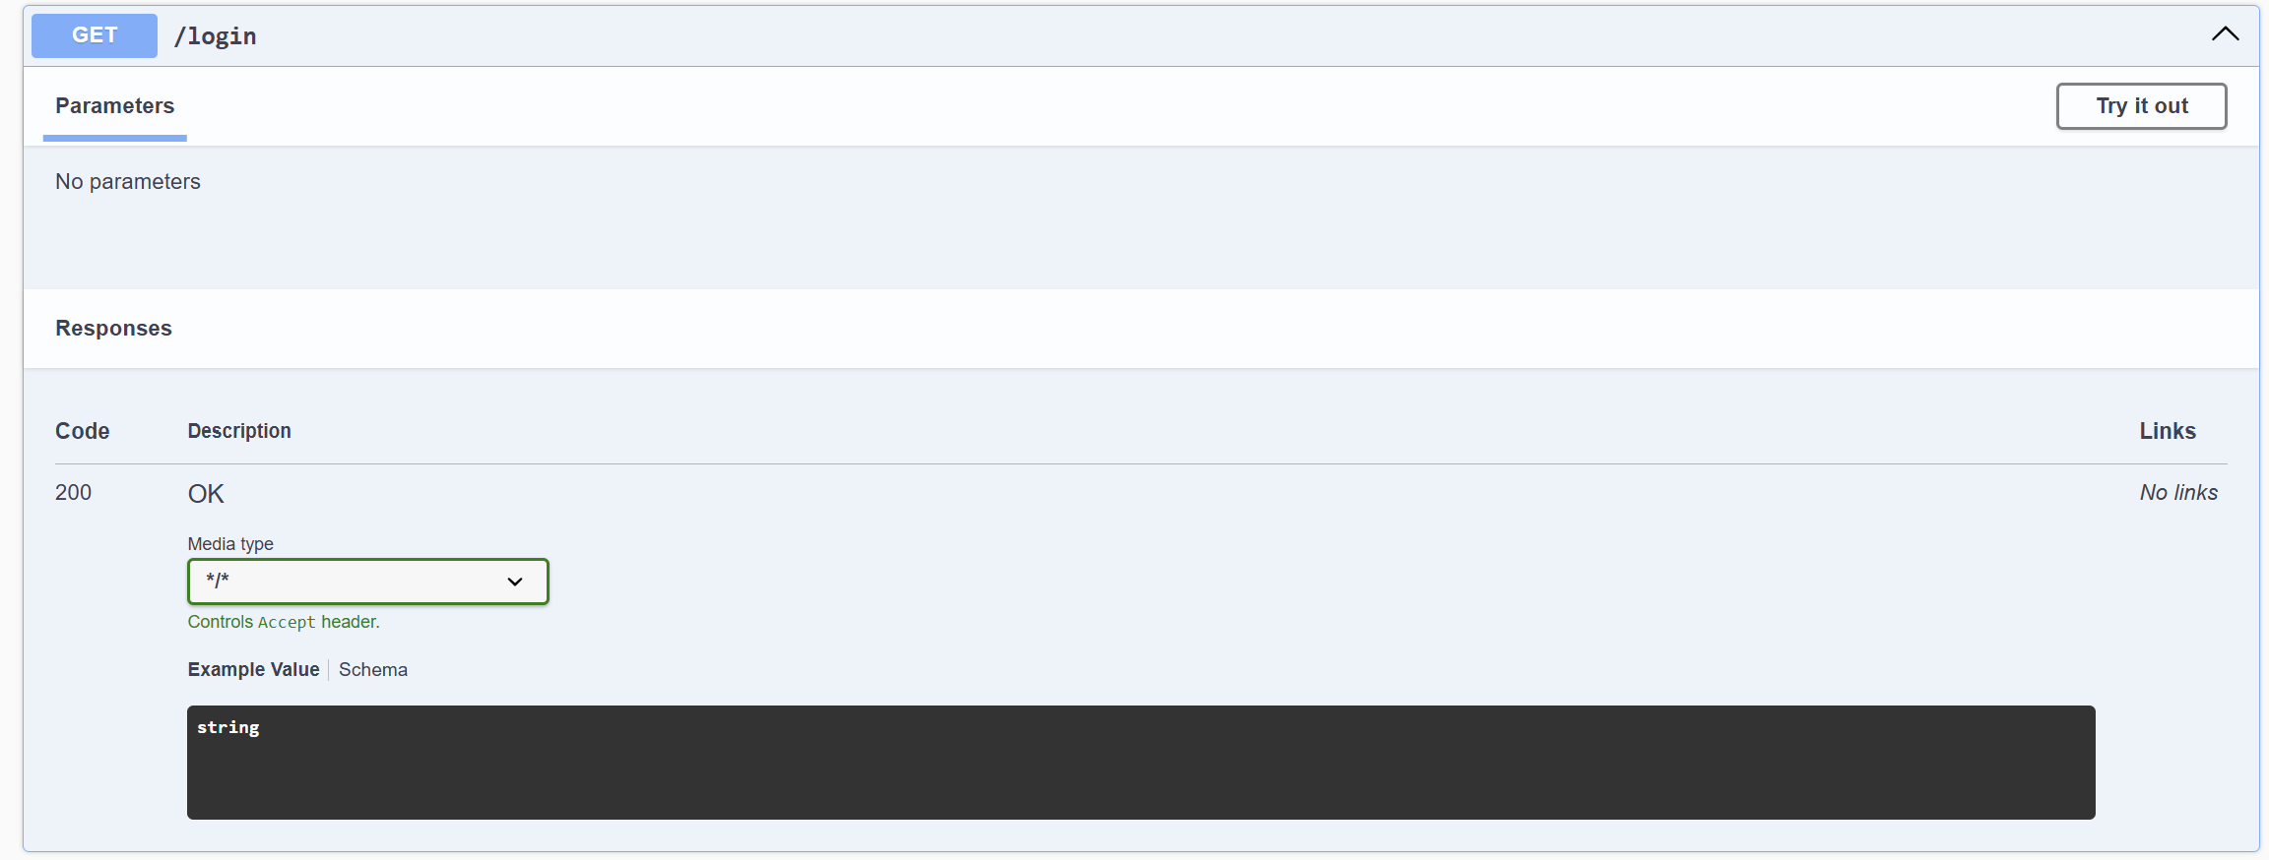

**HANDLE PAYMENT**

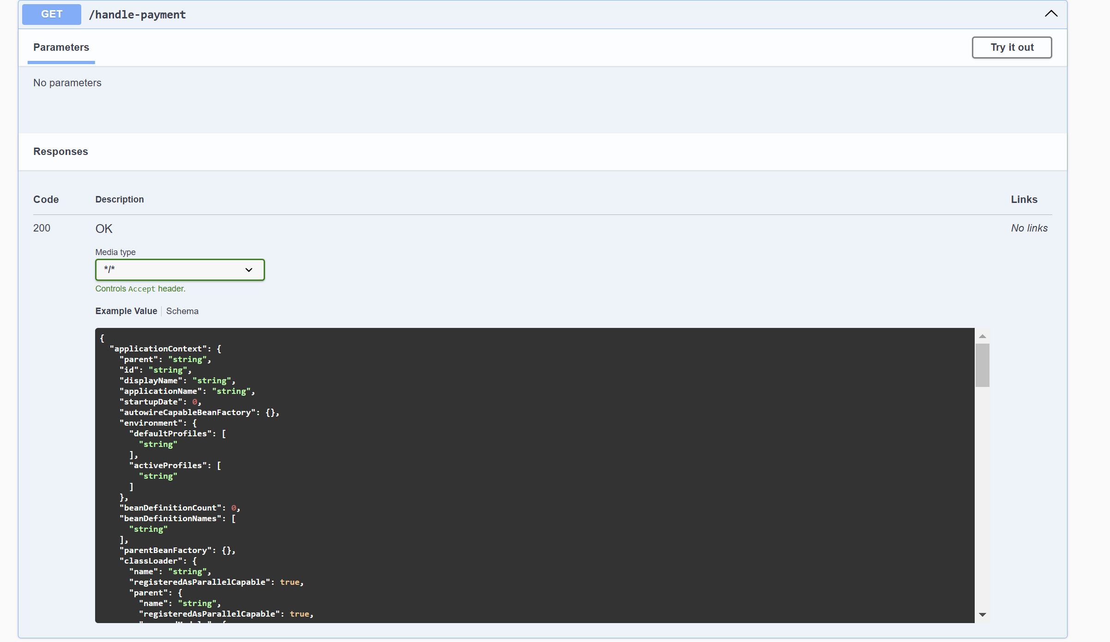

**EG:  
{**

**"applicationContext": {**

**"parent": "string",**

**"id": "string",**

**"displayName": "string",**

**"applicationName": "string",**

**"startupDate": 0,**

**"autowireCapableBeanFactory": {},**

**"environment": {**

**"defaultProfiles": [**

**"string"**

**],**

**"activeProfiles": [**

**"string"**

**]**

**},**

**"beanDefinitionCount": 0,**

**"beanDefinitionNames": [**

**"string"**

**],**

**"parentBeanFactory": {},**

**"classLoader": {**

**"name": "string",**

**"registeredAsParallelCapable": true,**

**"parent": {**

**"name": "string",**

**"registeredAsParallelCapable": true,**

**"unnamedModule": {**

**"name": "string",**

**"classLoader": {**

**"name": "string",**

**"registeredAsParallelCapable": true,**

**"definedPackages": [**

**{**

**"name": "string",**

**"annotations": [**

**{}**

**],**

**"declaredAnnotations": [**

**{}**

**],**

**"sealed": true,**

**"specificationTitle": "string",**

**"specificationVersion": "string",**

**"specificationVendor": "string",**

**"implementationTitle": "string",**

**"implementationVersion": "string",**

**"implementationVendor": "string"**

**}**

**]**

**},**

**"descriptor": {**

**"open": true,**

**"automatic": true**

**},**

**"named": true,**

**"annotations": [**

**{}**

**],**

**"declaredAnnotations": [**

**{}**

**],**

**"packages": [**

**"string"**

**],**

**"nativeAccessEnabled": true,**

**"layer": {}**

**},**

**"definedPackages": [**

**{**

**"name": "string",**

**"annotations": [**

**{}**

**],**

**"declaredAnnotations": [**

**{}**

**],**

**"sealed": true,**

**"specificationTitle": "string",**

**"specificationVersion": "string",**

**"specificationVendor": "string",**

**"implementationTitle": "string",**

**"implementationVersion": "string",**

**"implementationVendor": "string"**

**}**

**]**

**},**

**"unnamedModule": {**

**"name": "string",**

**"classLoader": {**

**"name": "string",**

**"registeredAsParallelCapable": true,**

**"definedPackages": [**

**{**

**"name": "string",**

**"annotations": [**

**{}**

**],**

**"declaredAnnotations": [**

**{}**

**],**

**"sealed": true,**

**"specificationTitle": "string",**

**"specificationVersion": "string",**

**"specificationVendor": "string",**

**"implementationTitle": "string",**

**"implementationVersion": "string",**

**"implementationVendor": "string"**

**}**

**]**

**},**

**"descriptor": {**

**"open": true,**

**"automatic": true**

**},**

**"named": true,**

**"annotations": [**

**{}**

**],**

**"declaredAnnotations": [**

**{}**

**],**

**"packages": [**

**"string"**

**],**

**"nativeAccessEnabled": true,**

**"layer": {}**

**},**

**"definedPackages": [**

**{**

**"name": "string",**

**"annotations": [**

**{}**

**],**

**"declaredAnnotations": [**

**{}**

**],**

**"sealed": true,**

**"specificationTitle": "string",**

**"specificationVersion": "string",**

**"specificationVendor": "string",**

**"implementationTitle": "string",**

**"implementationVersion": "string",**

**"implementationVendor": "string"**

**}**

**]**

**}**

**},**

**"contentType": "string",**

**"requestContextAttribute": "string",**

**"staticAttributes": {**

**"additionalProp1": {},**

**"additionalProp2": {},**

**"additionalProp3": {}**

**},**

**"exposePathVariables": true,**

**"beanName": "string",**

**"url": "string",**

**"hosts": [**

**"string"**

**],**

**"redirectView": true,**

**"propagateQueryProperties": true,**

**"attributesMap": {**

**"additionalProp1": {},**

**"additionalProp2": {},**

**"additionalProp3": {}**

**}**

**}**

**FORGOR PASSWORD**

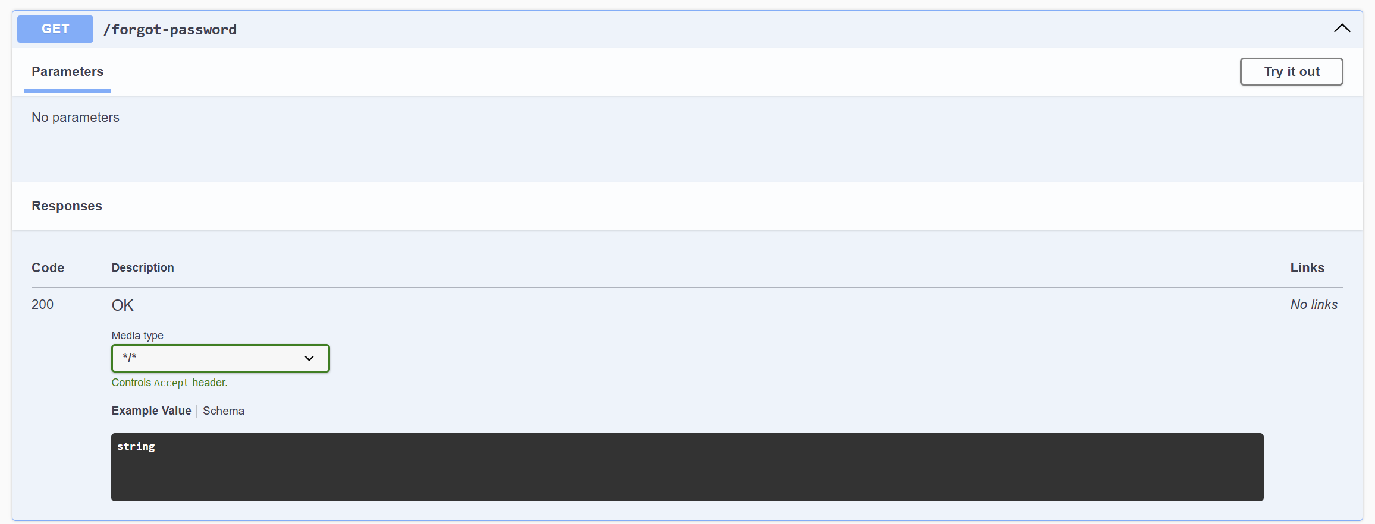

**DOCTOR SIGNUP**

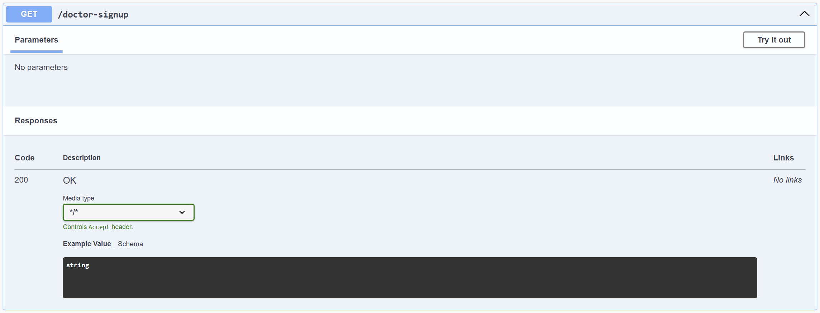

**2. APPOINT DOCTOR VALIDATOR**

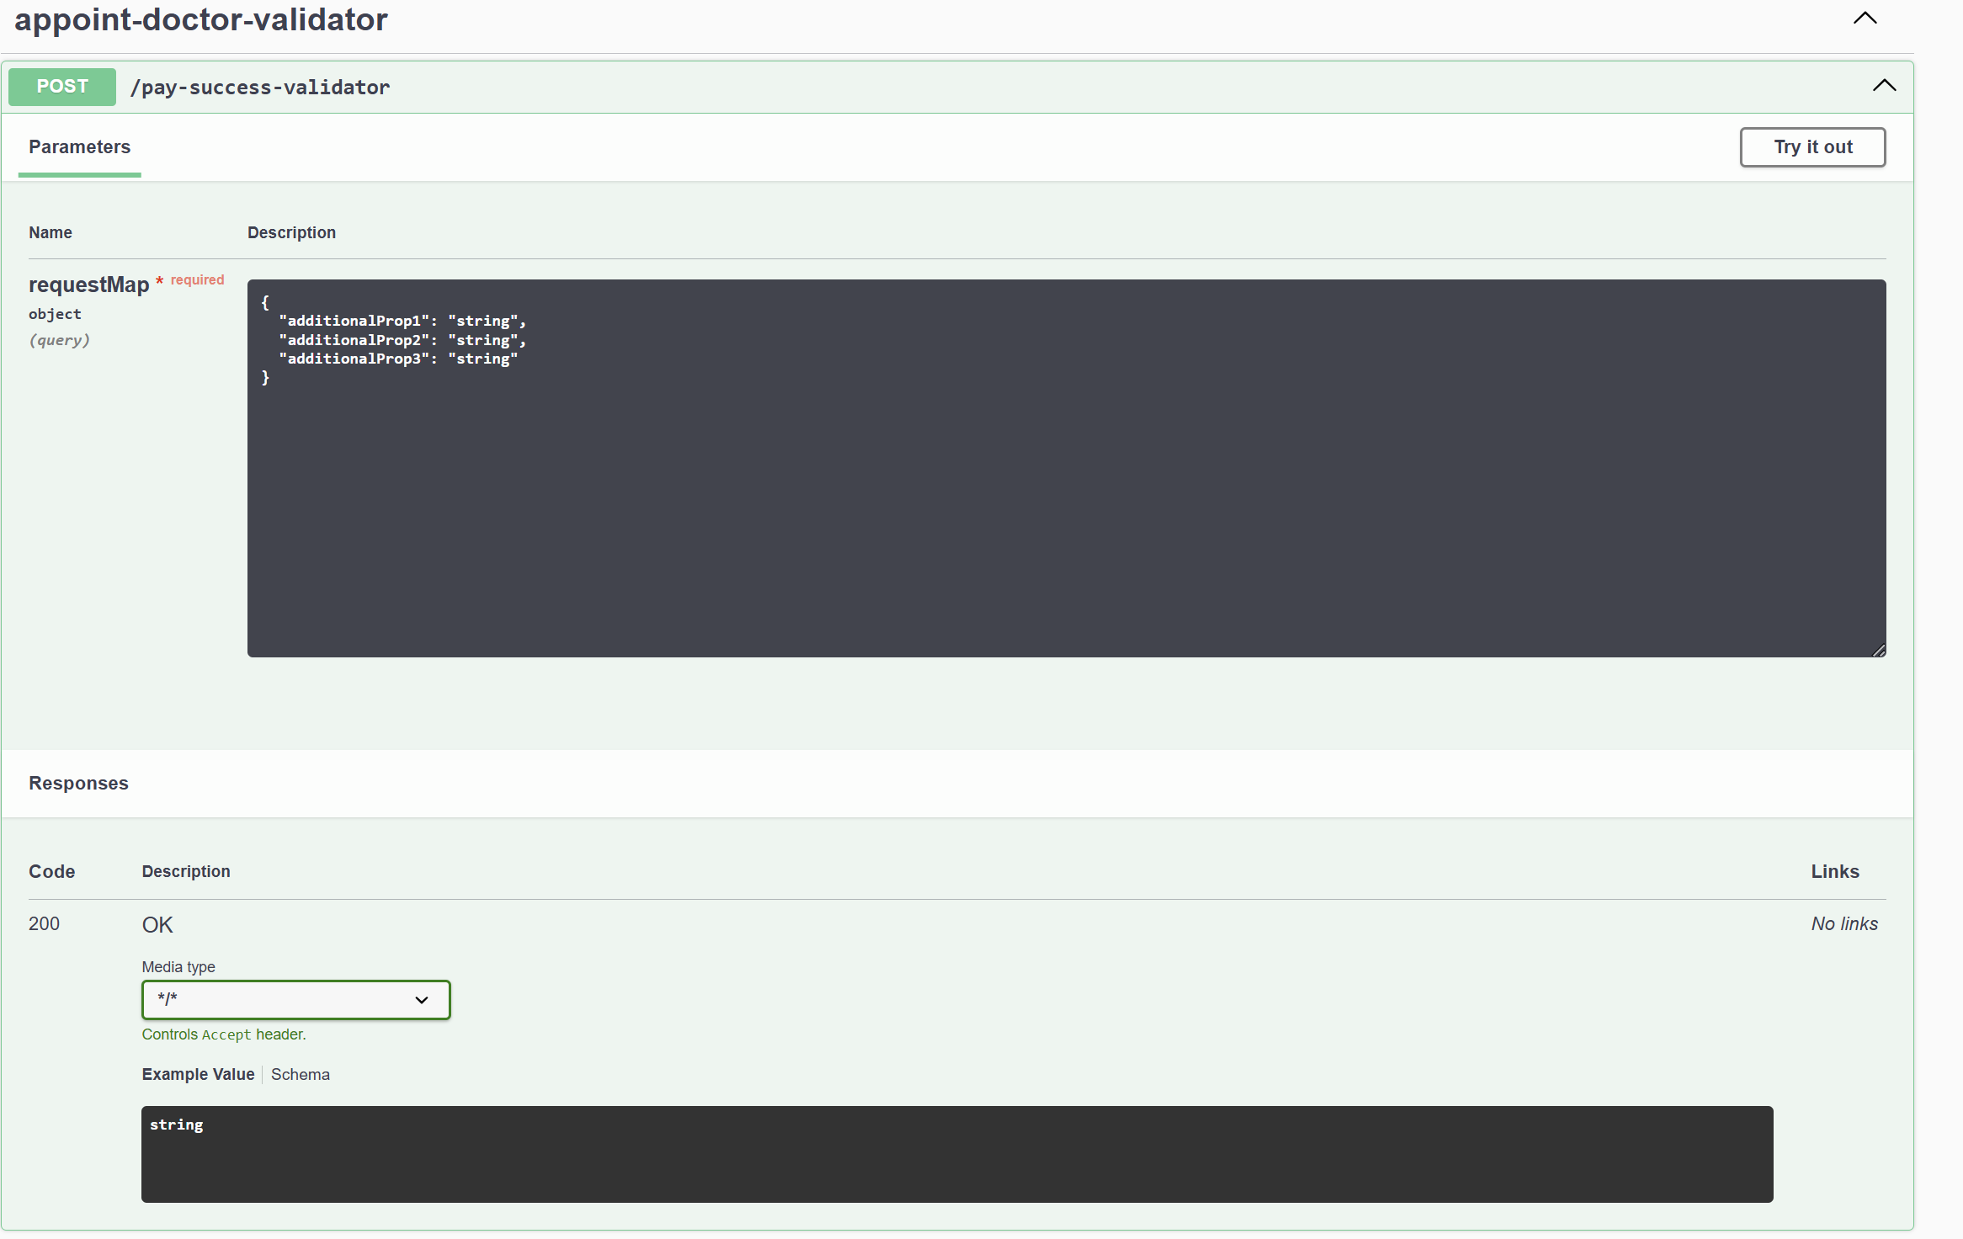

**3. PATIENT MAIN CONTROLLER**

**VIEW SINGLE PRESCRIPTION**

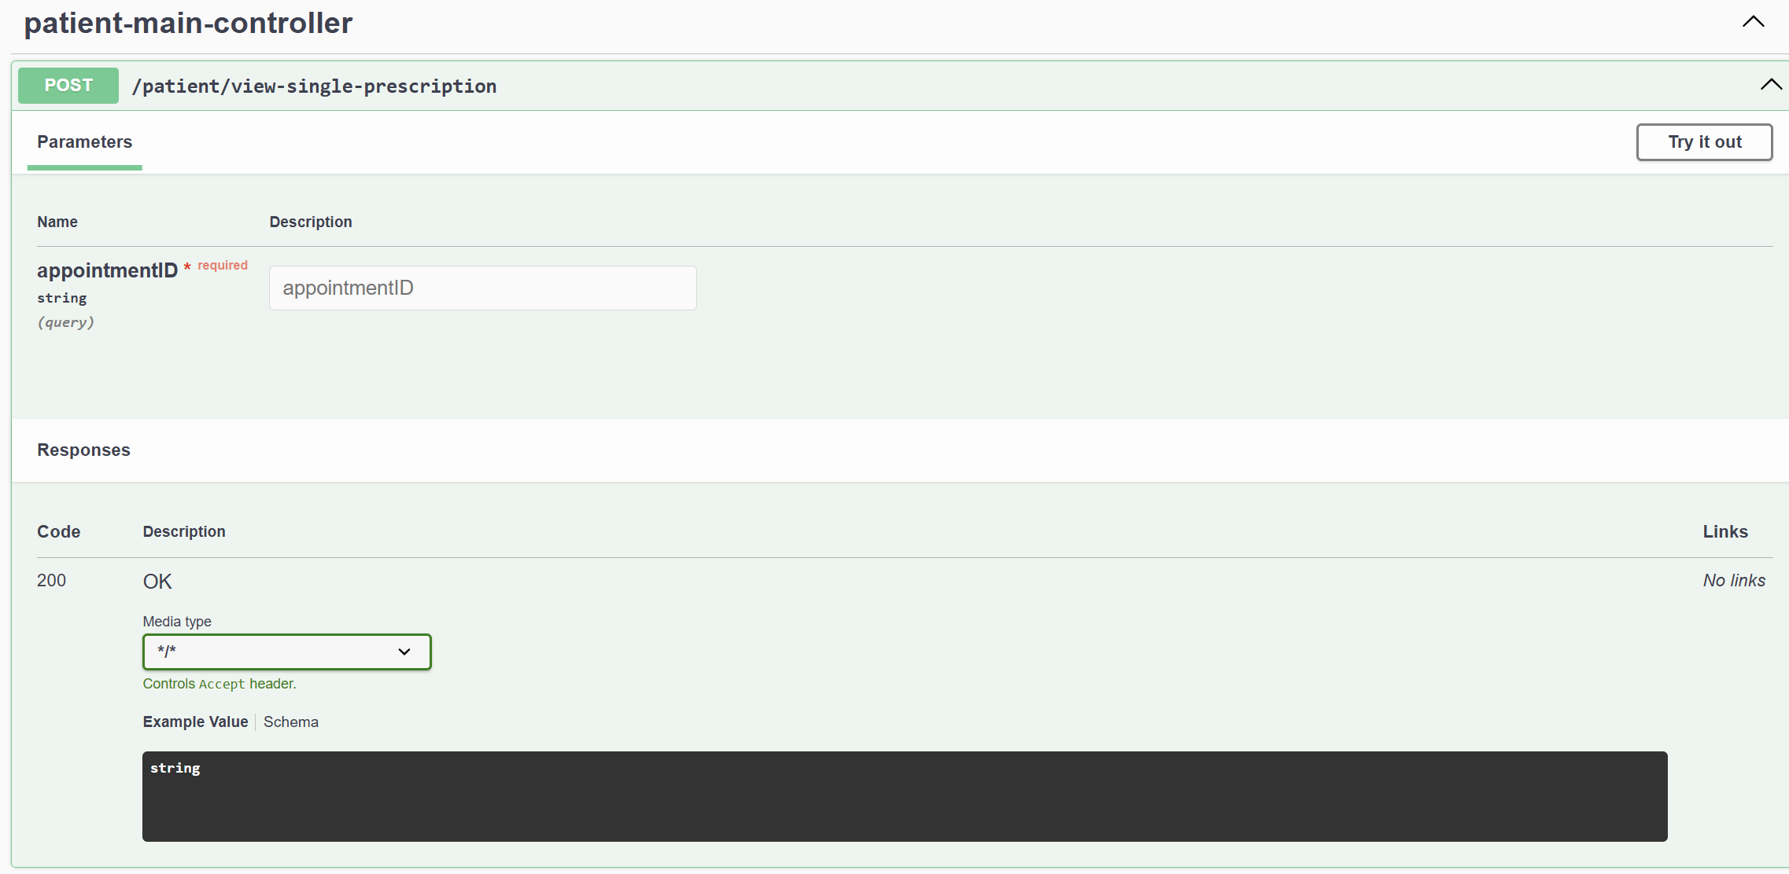

**VIEW PRESCRIPTION BASED ON PAGE NUMBER**

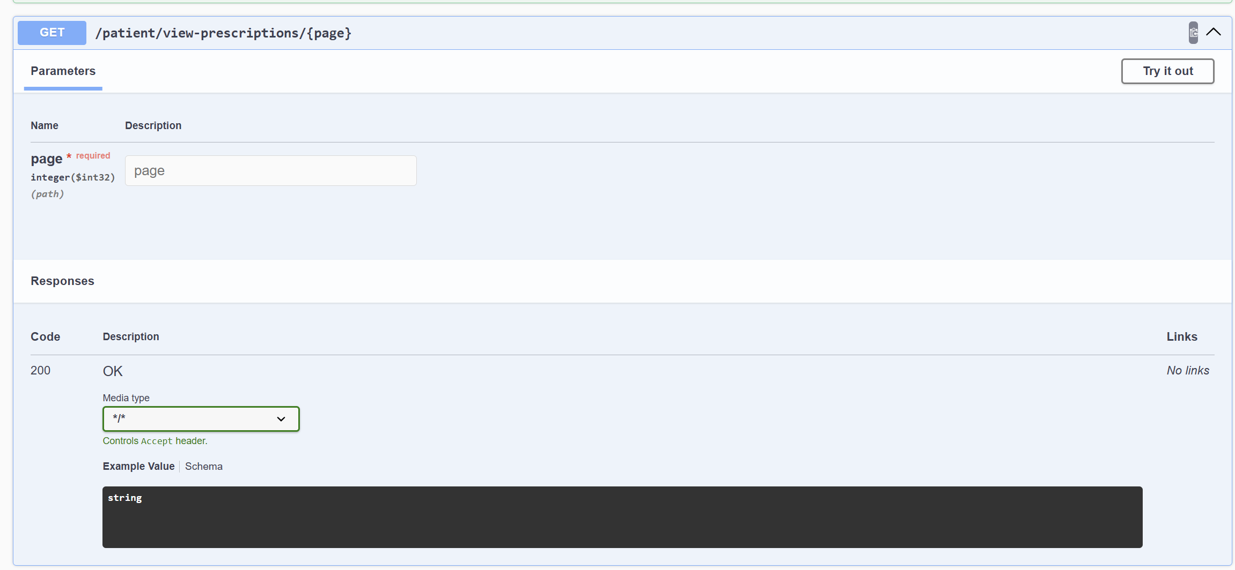

**UPLOAD IMAGE**

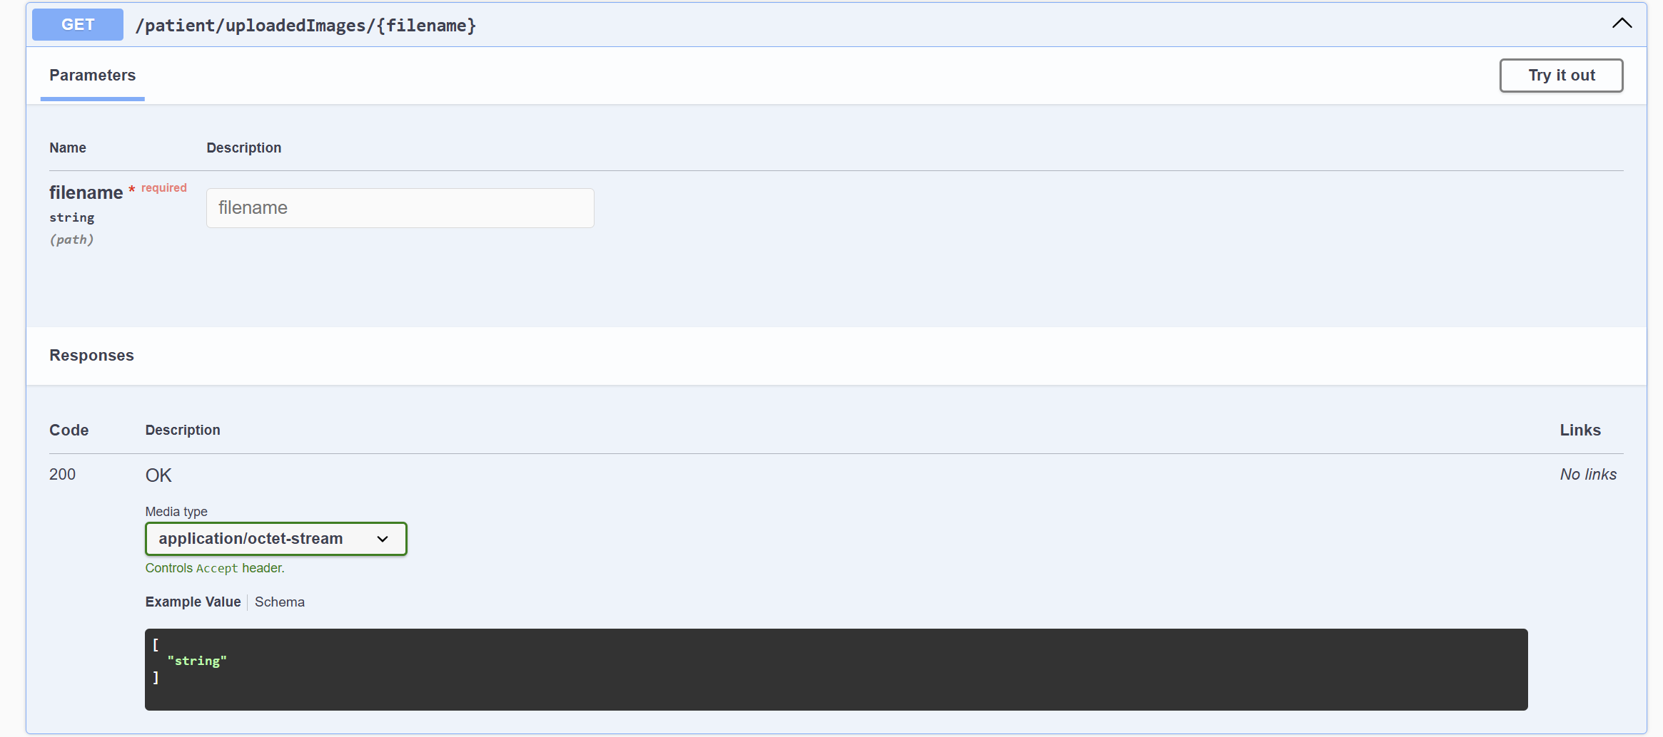

**TODAY’S APPOINTMENT**

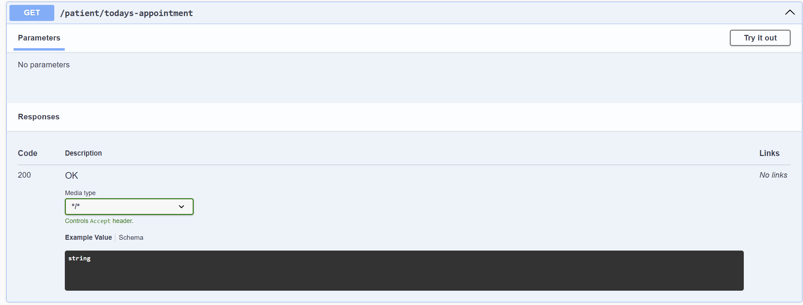

**PATIENT PROFILE**

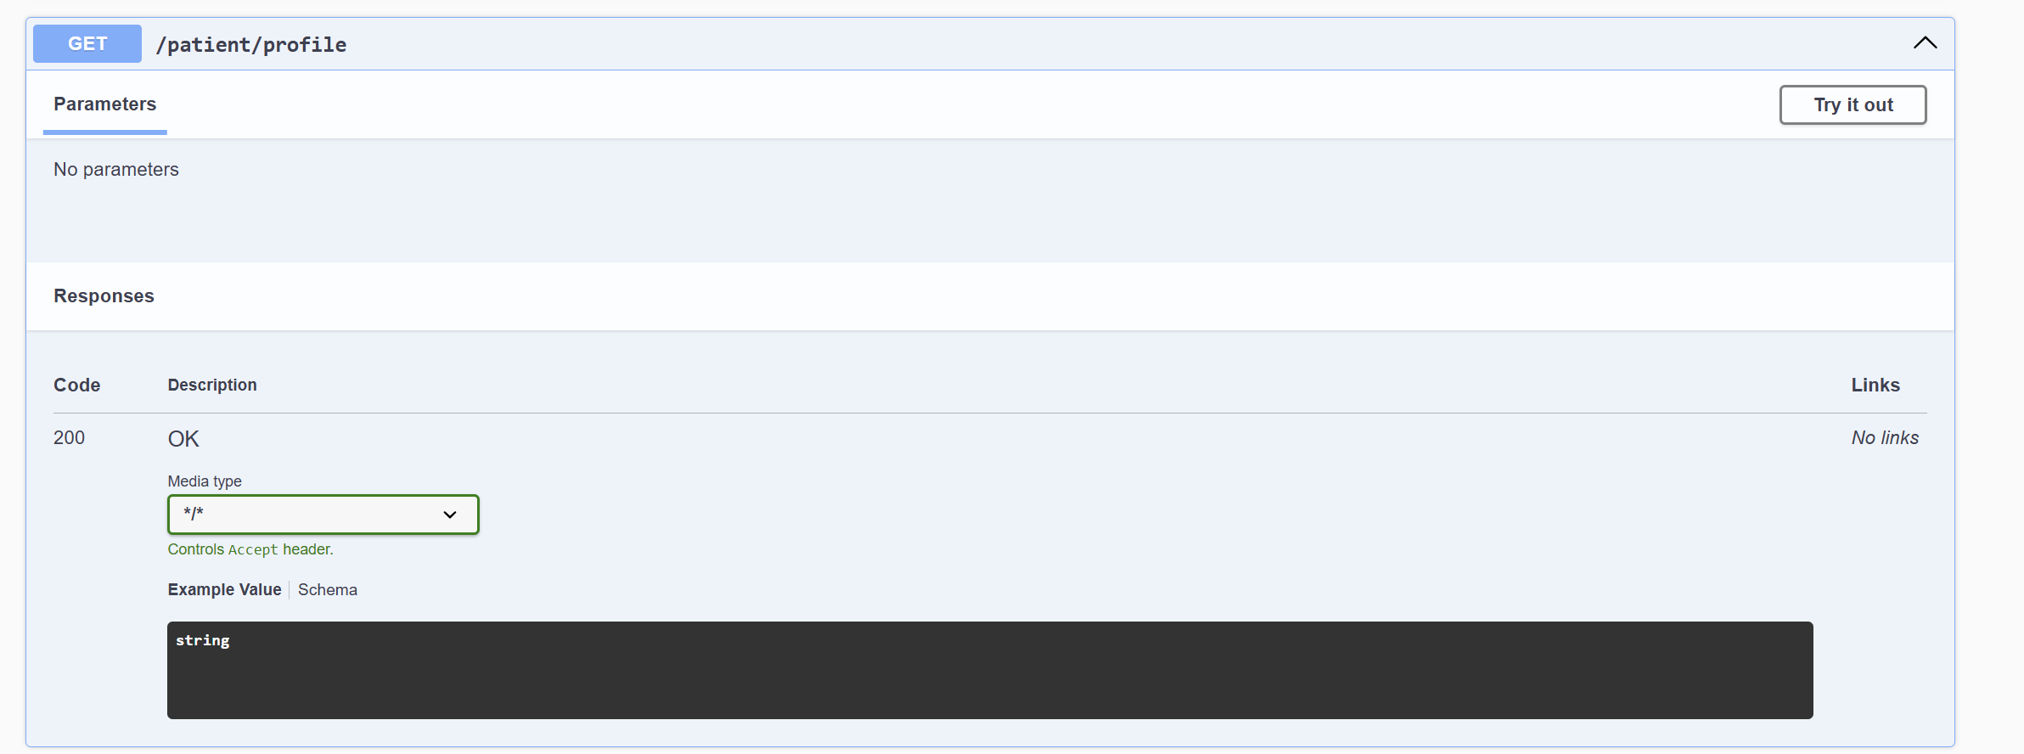

**MEET DOCTOR**

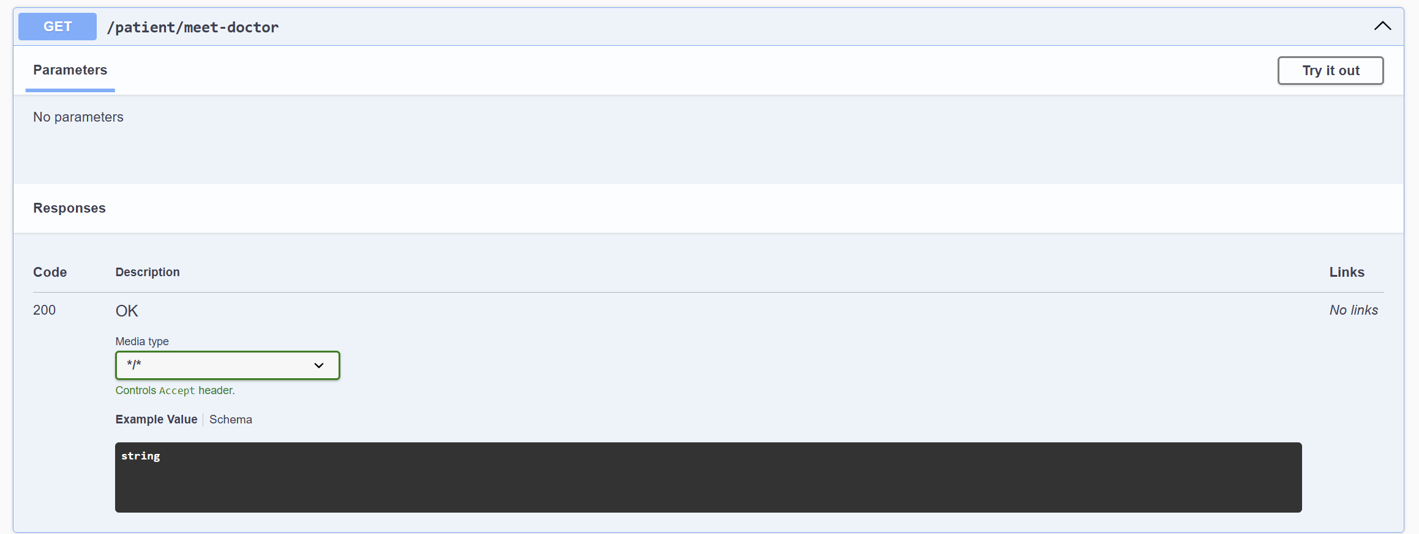

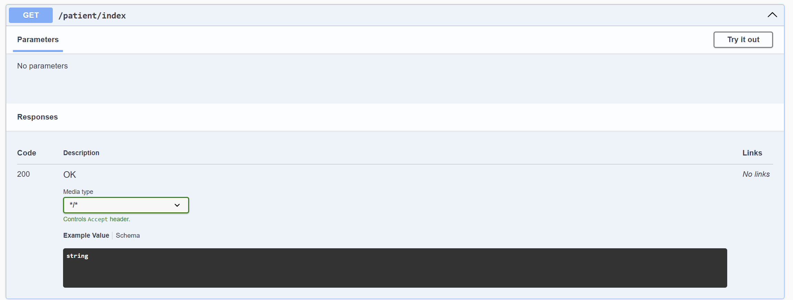

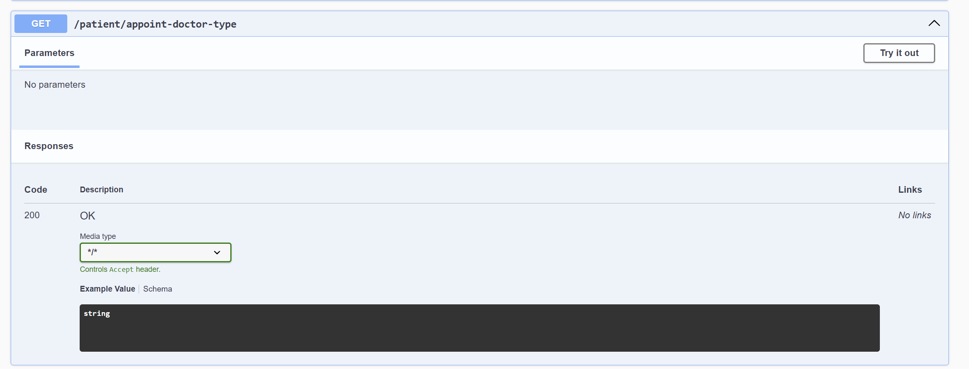

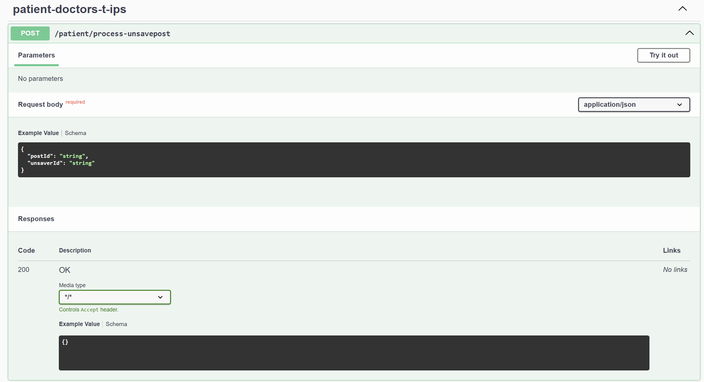

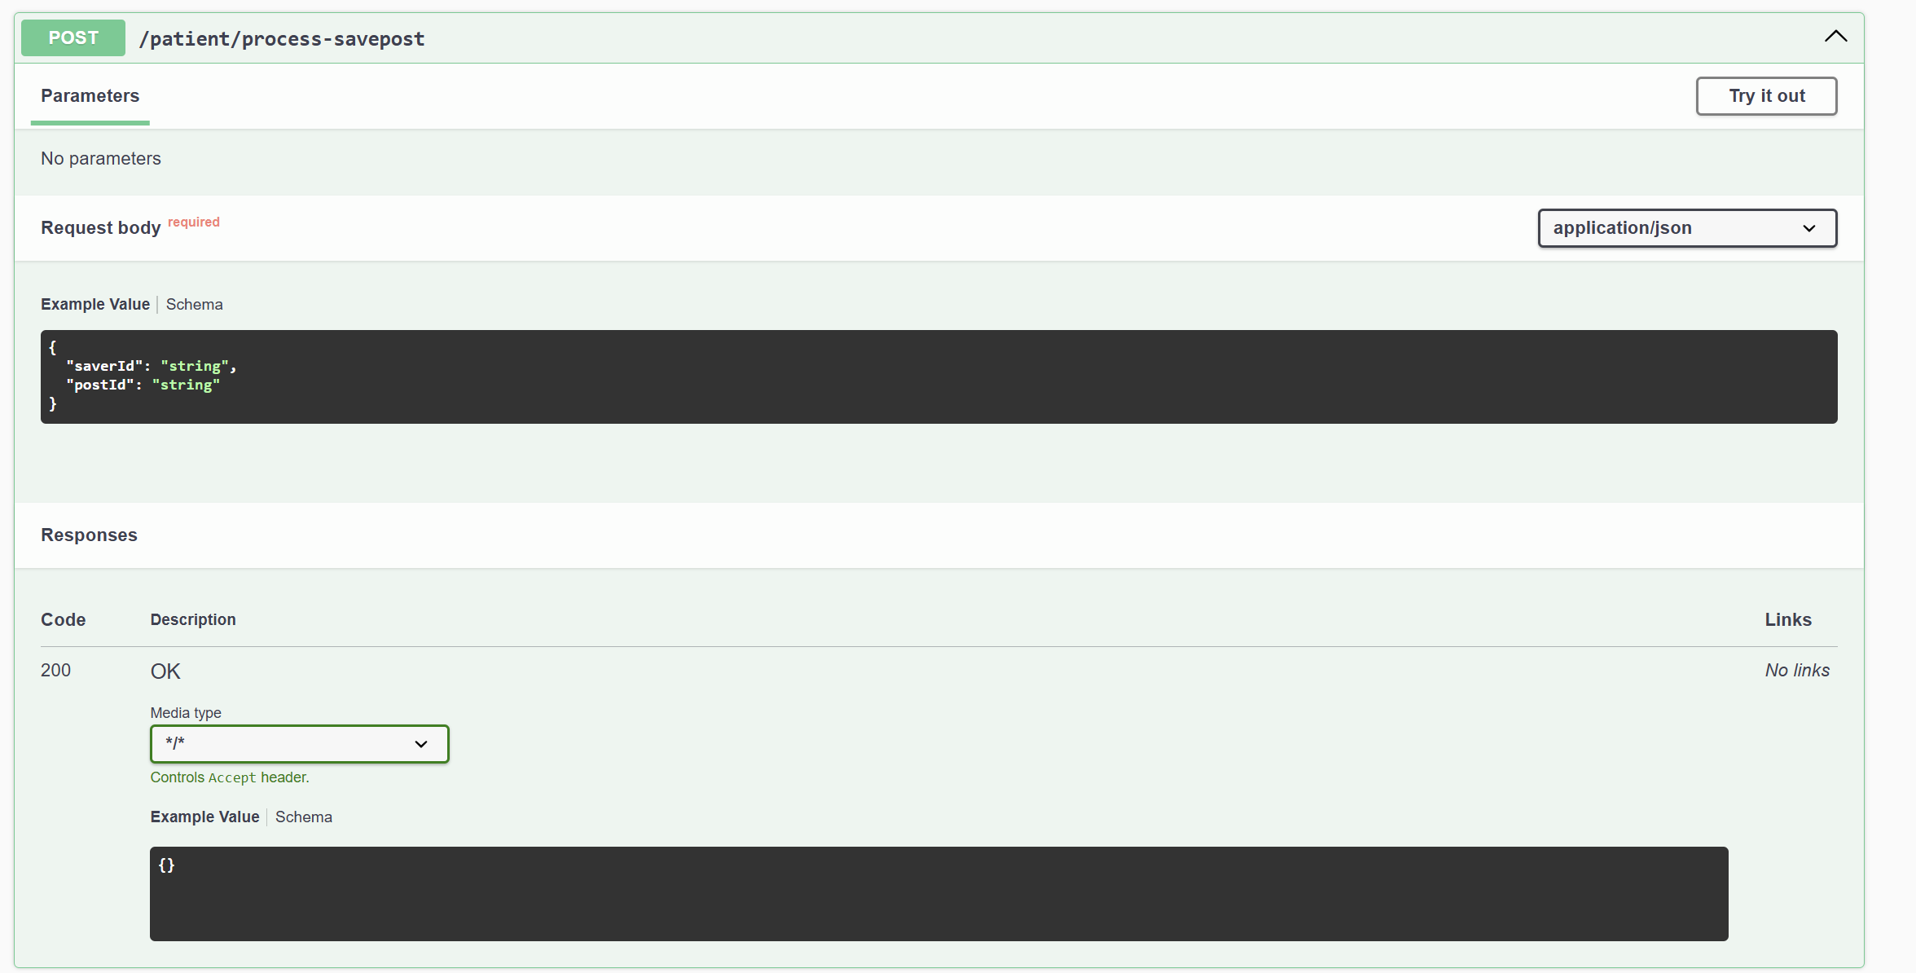

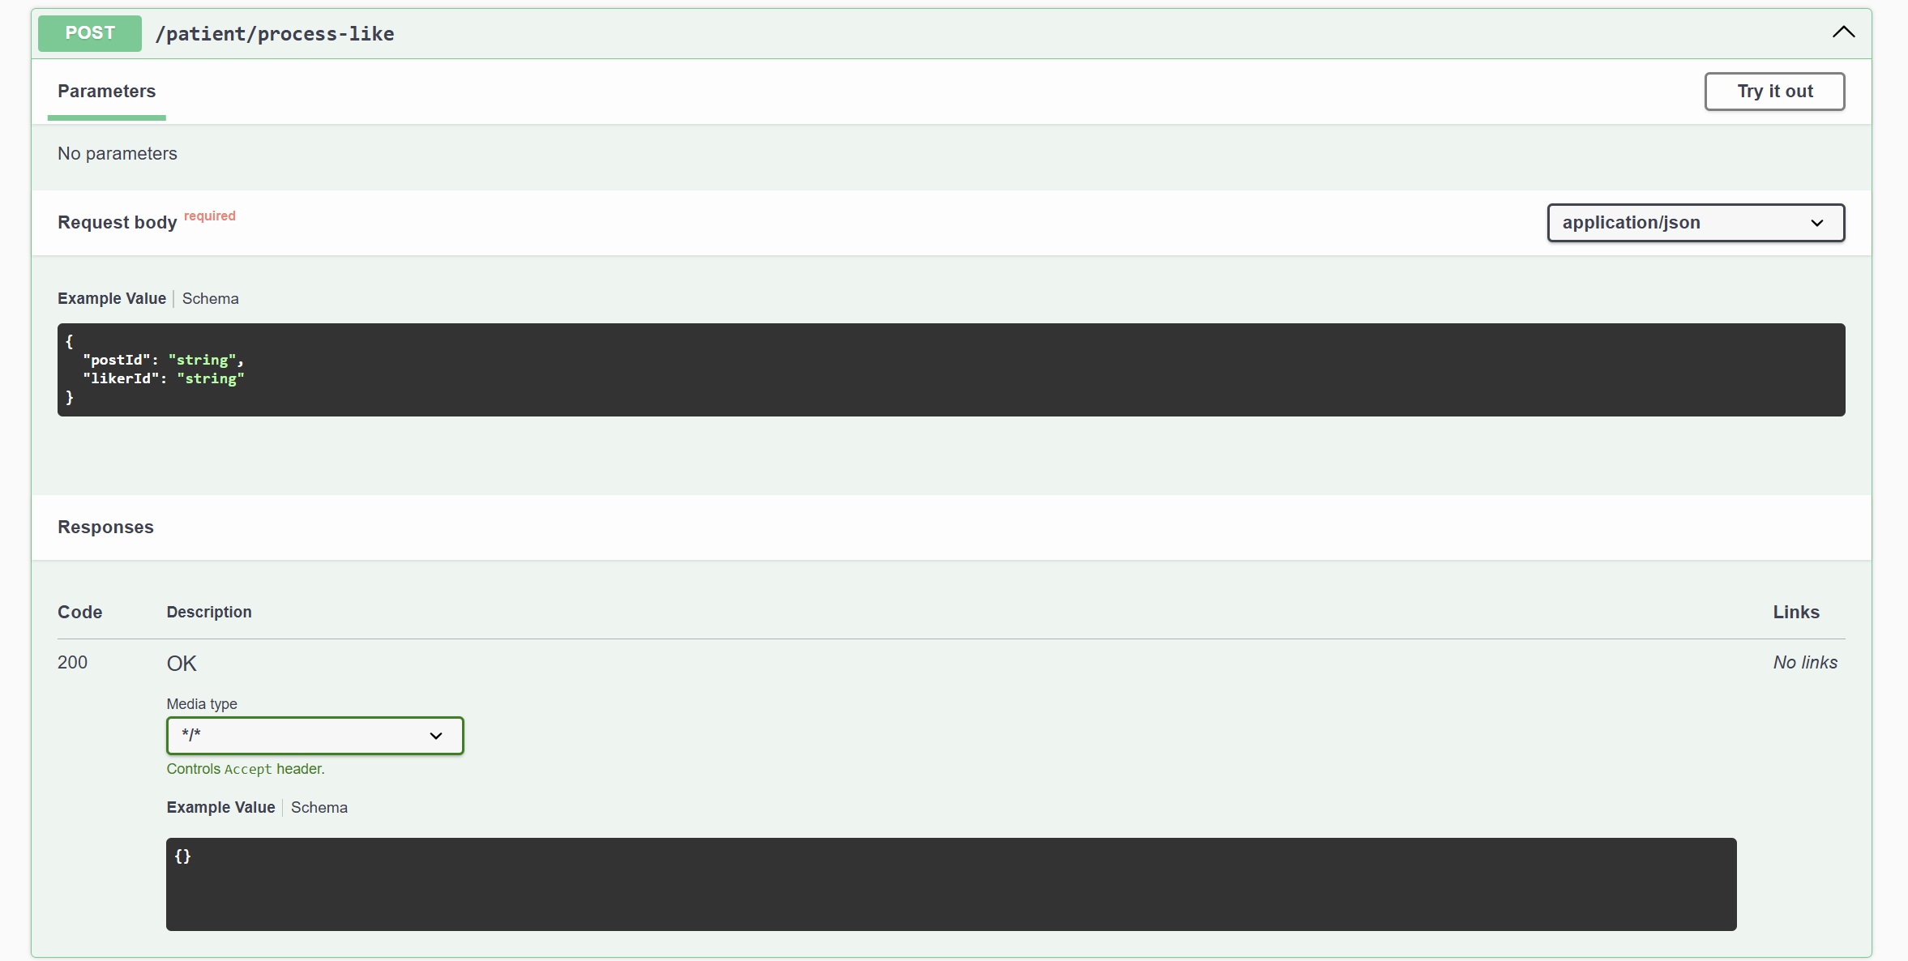

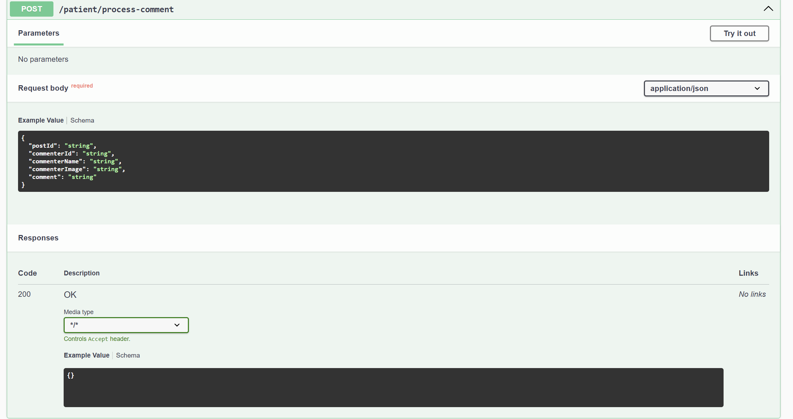

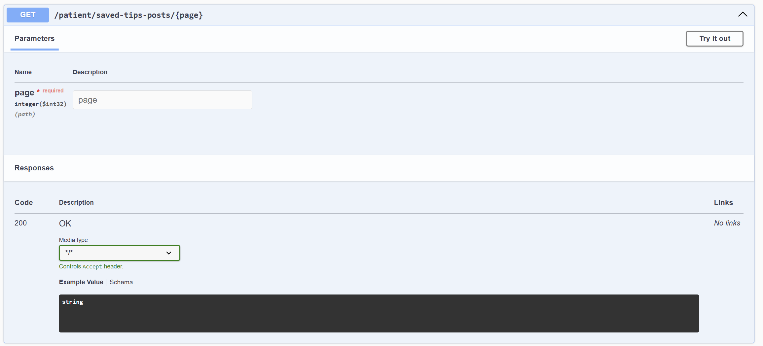

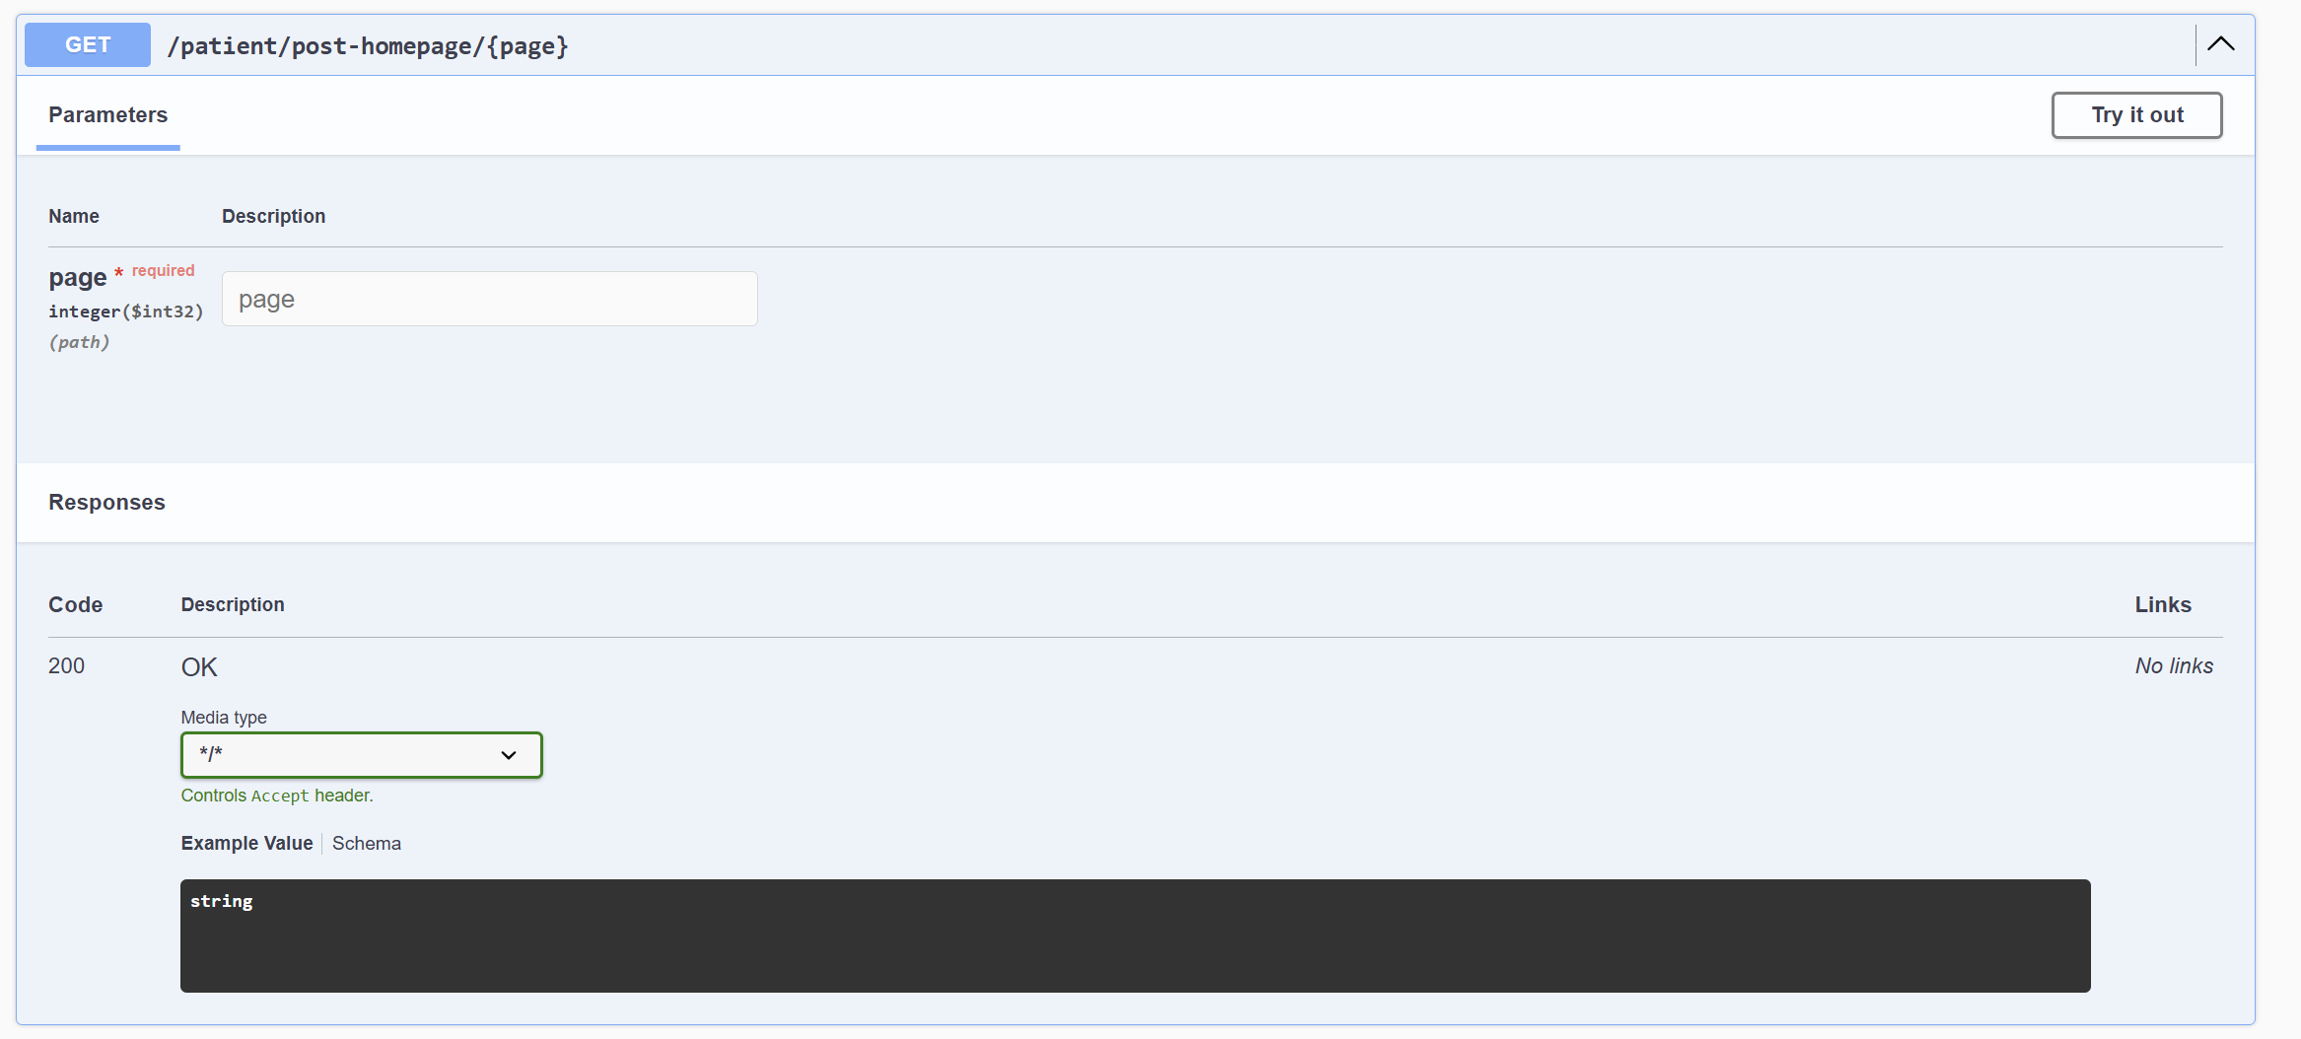

**4. PATIENT APPOINT DOCTOR CONTROLLER**

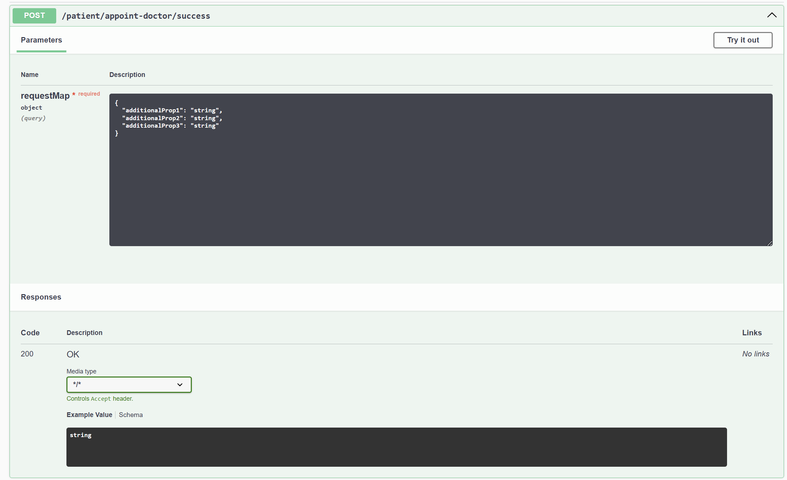

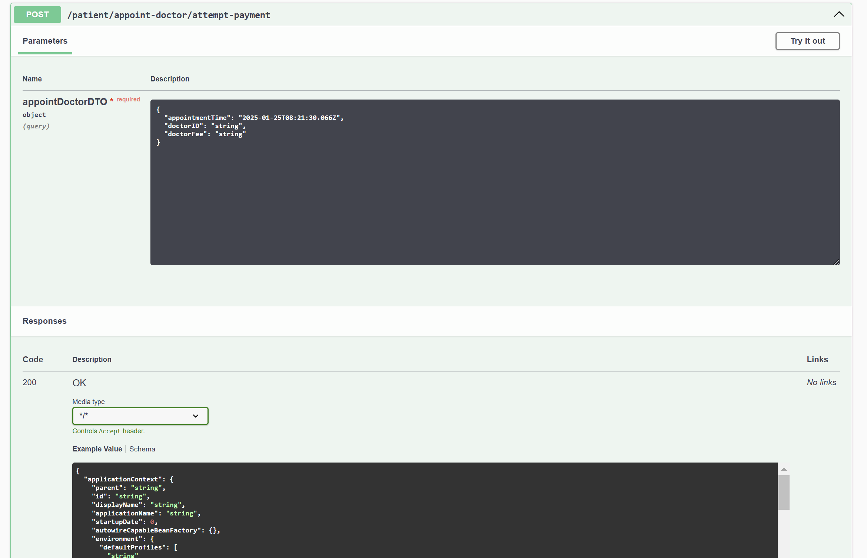

**Response:**

**{**

**"applicationContext": {**

**"parent": "string",**

**"id": "string",**

**"displayName": "string",**

**"applicationName": "string",**

**"startupDate": 0,**

**"autowireCapableBeanFactory": {},**

**"environment": {**

**"defaultProfiles": [**

**"string"**

**],**

**"activeProfiles": [**

**"string"**

**]**

**},**

**"beanDefinitionCount": 0,**

**"beanDefinitionNames": [**

**"string"**

**],**

**"parentBeanFactory": {},**

**"classLoader": {**

**"name": "string",**

**"registeredAsParallelCapable": true,**

**"parent": {**

**"name": "string",**

**"registeredAsParallelCapable": true,**

**"unnamedModule": {**

**"name": "string",**

**"classLoader": {**

**"name": "string",**

**"registeredAsParallelCapable": true,**

**"definedPackages": [**

**{**

**"name": "string",**

**"annotations": [**

**{}**

**],**

**"declaredAnnotations": [**

**{}**

**],**

**"sealed": true,**

**"specificationTitle": "string",**

**"specificationVersion": "string",**

**"specificationVendor": "string",**

**"implementationTitle": "string",**

**"implementationVersion": "string",**

**"implementationVendor": "string"**

**}**

**]**

**},**

**"descriptor": {**

**"open": true,**

**"automatic": true**

**},**

**"named": true,**

**"annotations": [**

**{}**

**],**

**"declaredAnnotations": [**

**{}**

**],**

**"packages": [**

**"string"**

**],**

**"nativeAccessEnabled": true,**

**"layer": {}**

**},**

**"definedPackages": [**

**{**

**"name": "string",**

**"annotations": [**

**{}**

**],**

**"declaredAnnotations": [**

**{}**

**],**

**"sealed": true,**

**"specificationTitle": "string",**

**"specificationVersion": "string",**

**"specificationVendor": "string",**

**"implementationTitle": "string",**

**"implementationVersion": "string",**

**"implementationVendor": "string"**

**}**

**]**

**},**

**"unnamedModule": {**

**"name": "string",**

**"classLoader": {**

**"name": "string",**

**"registeredAsParallelCapable": true,**

**"definedPackages": [**

**{**

**"name": "string",**

**"annotations": [**

**{}**

**],**

**"declaredAnnotations": [**

**{}**

**],**

**"sealed": true,**

**"specificationTitle": "string",**

**"specificationVersion": "string",**

**"specificationVendor": "string",**

**"implementationTitle": "string",**

**"implementationVersion": "string",**

**"implementationVendor": "string"**

**}**

**]**

**},**

**"descriptor": {**

**"open": true,**

**"automatic": true**

**},**

**"named": true,**

**"annotations": [**

**{}**

**],**

**"declaredAnnotations": [**

**{}**

**],**

**"packages": [**

**"string"**

**],**

**"nativeAccessEnabled": true,**

**"layer": {}**

**},**

**"definedPackages": [**

**{**

**"name": "string",**

**"annotations": [**

**{}**

**],**

**"declaredAnnotations": [**

**{}**

**],**

**"sealed": true,**

**"specificationTitle": "string",**

**"specificationVersion": "string",**

**"specificationVendor": "string",**

**"implementationTitle": "string",**

**"implementationVersion": "string",**

**"implementationVendor": "string"**

**}**

**]**

**}**

**},**

**"contentType": "string",**

**"requestContextAttribute": "string",**

**"staticAttributes": {**

**"additionalProp1": {},**

**"additionalProp2": {},**

**"additionalProp3": {}**

**},**

**"exposePathVariables": true,**

**"beanName": "string",**

**"url": "string",**

**"hosts": [**

**"string"**

**],**

**"redirectView": true,**

**"propagateQueryProperties": true,**

**"attributesMap": {**

**"additionalProp1": {},**

**"additionalProp2": {},**

**"additionalProp3": {}**

**}**

**}**

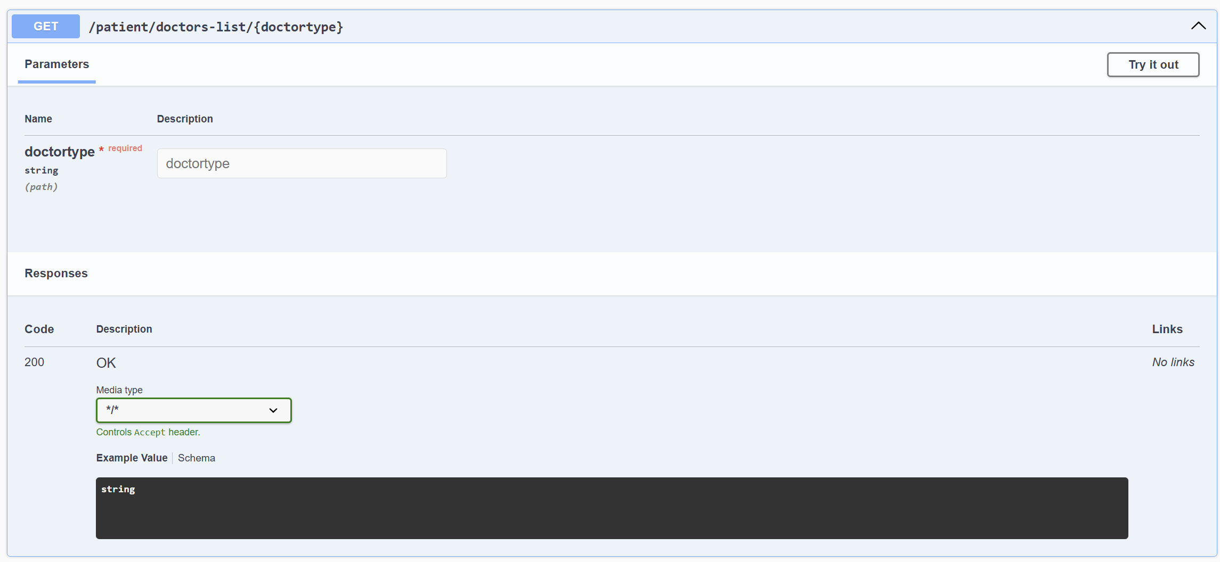

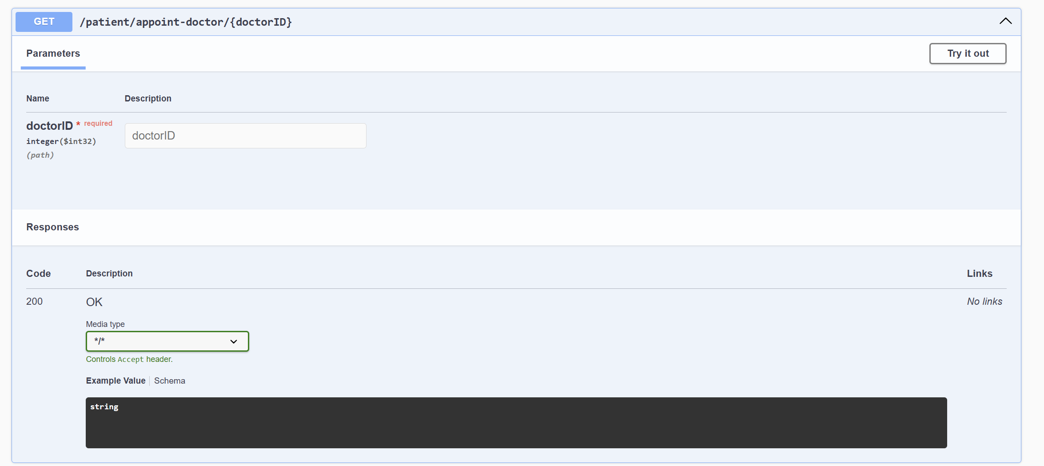

**5 DOCTOR PRESCRIPTION CONTROLLER**

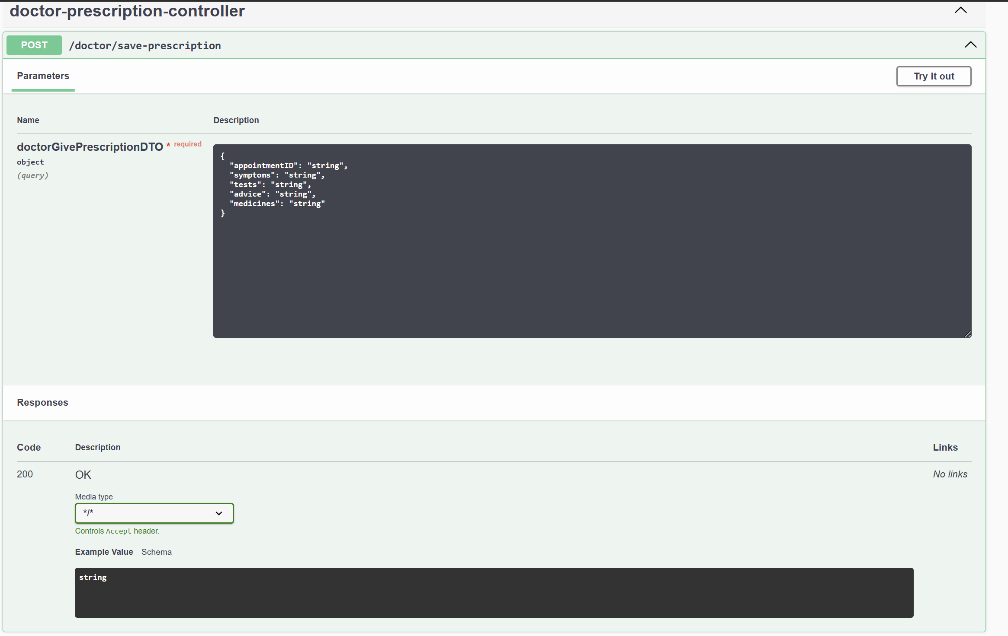

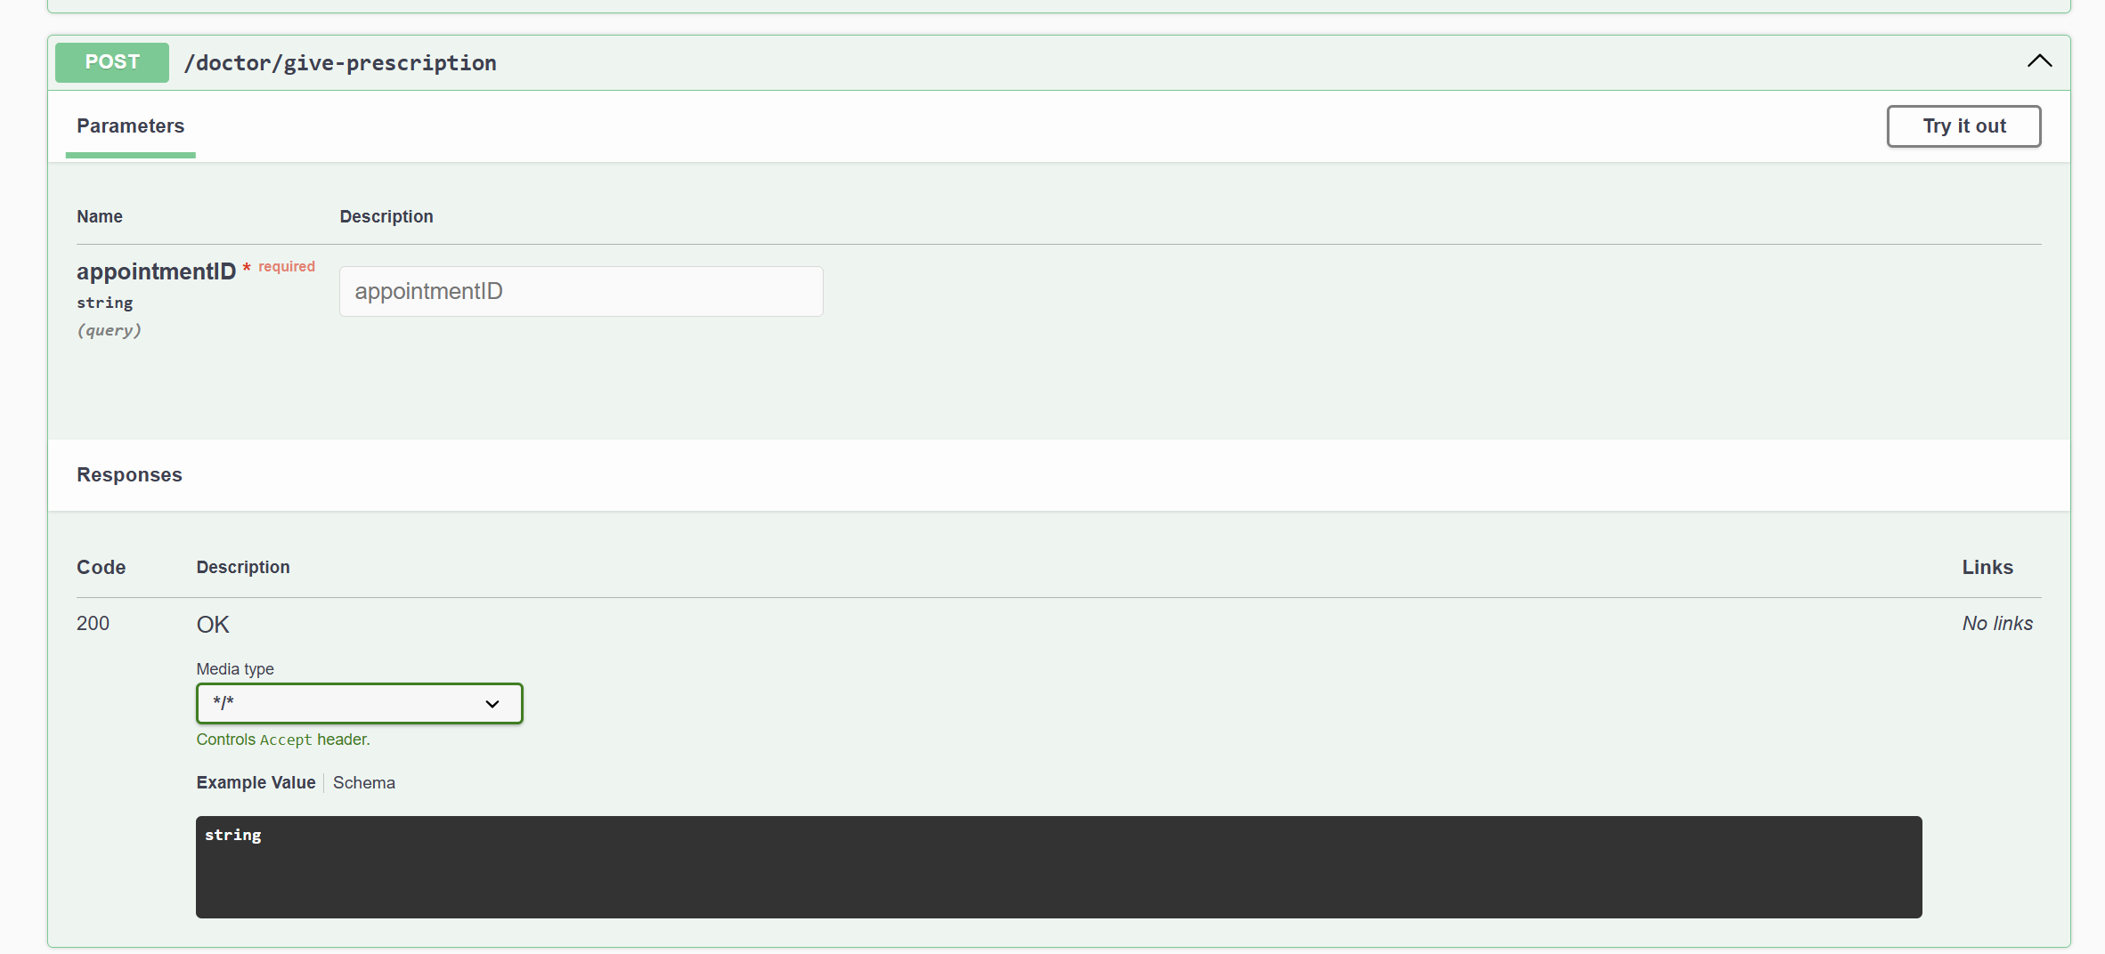

**6. DOCTOR POST HOMEPAGE CONTROLLER**

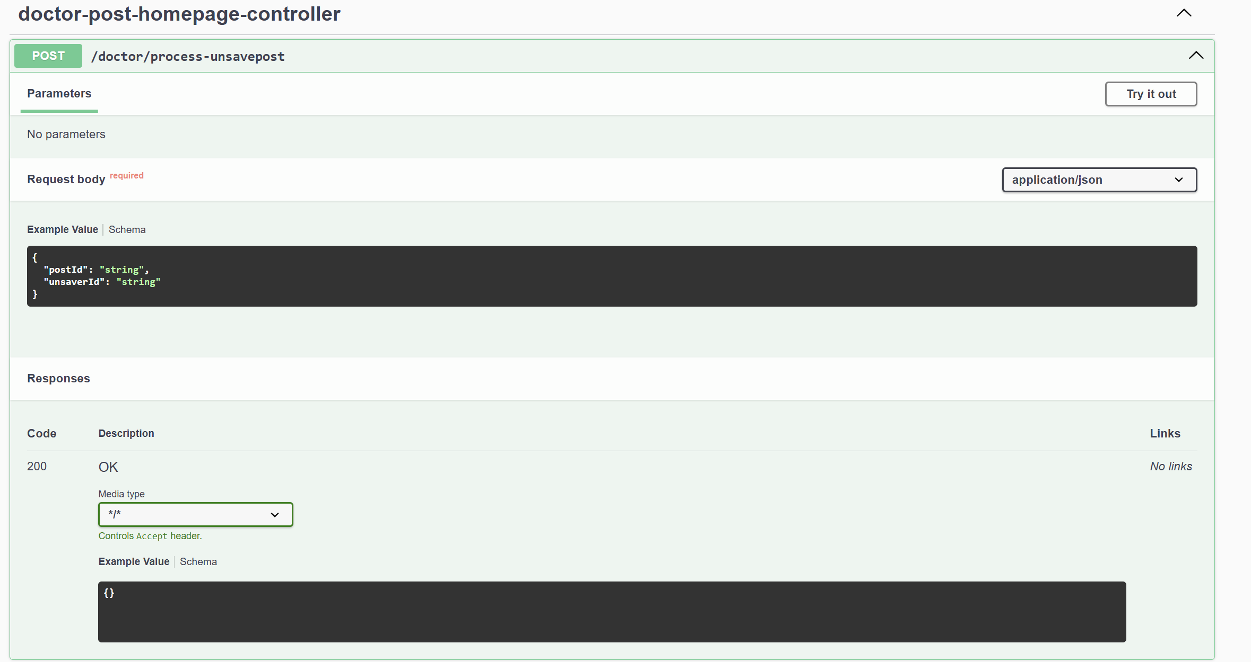

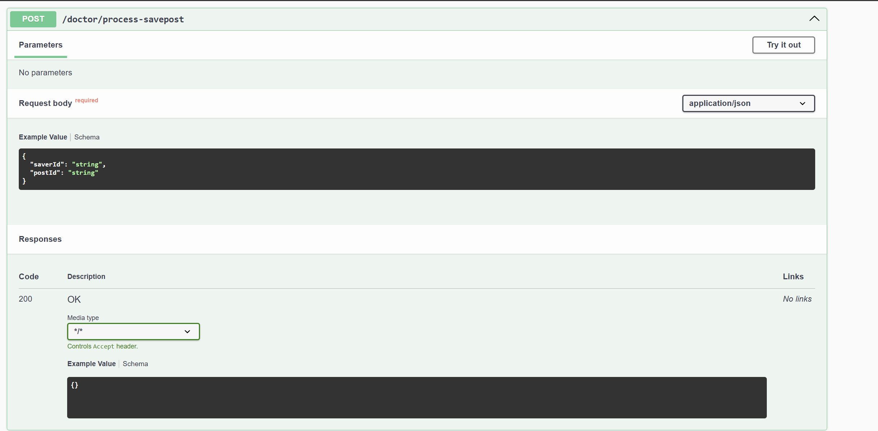

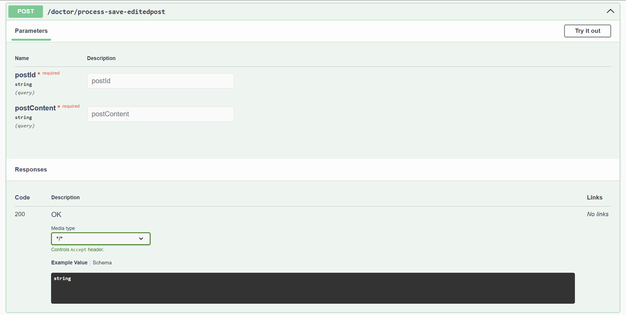

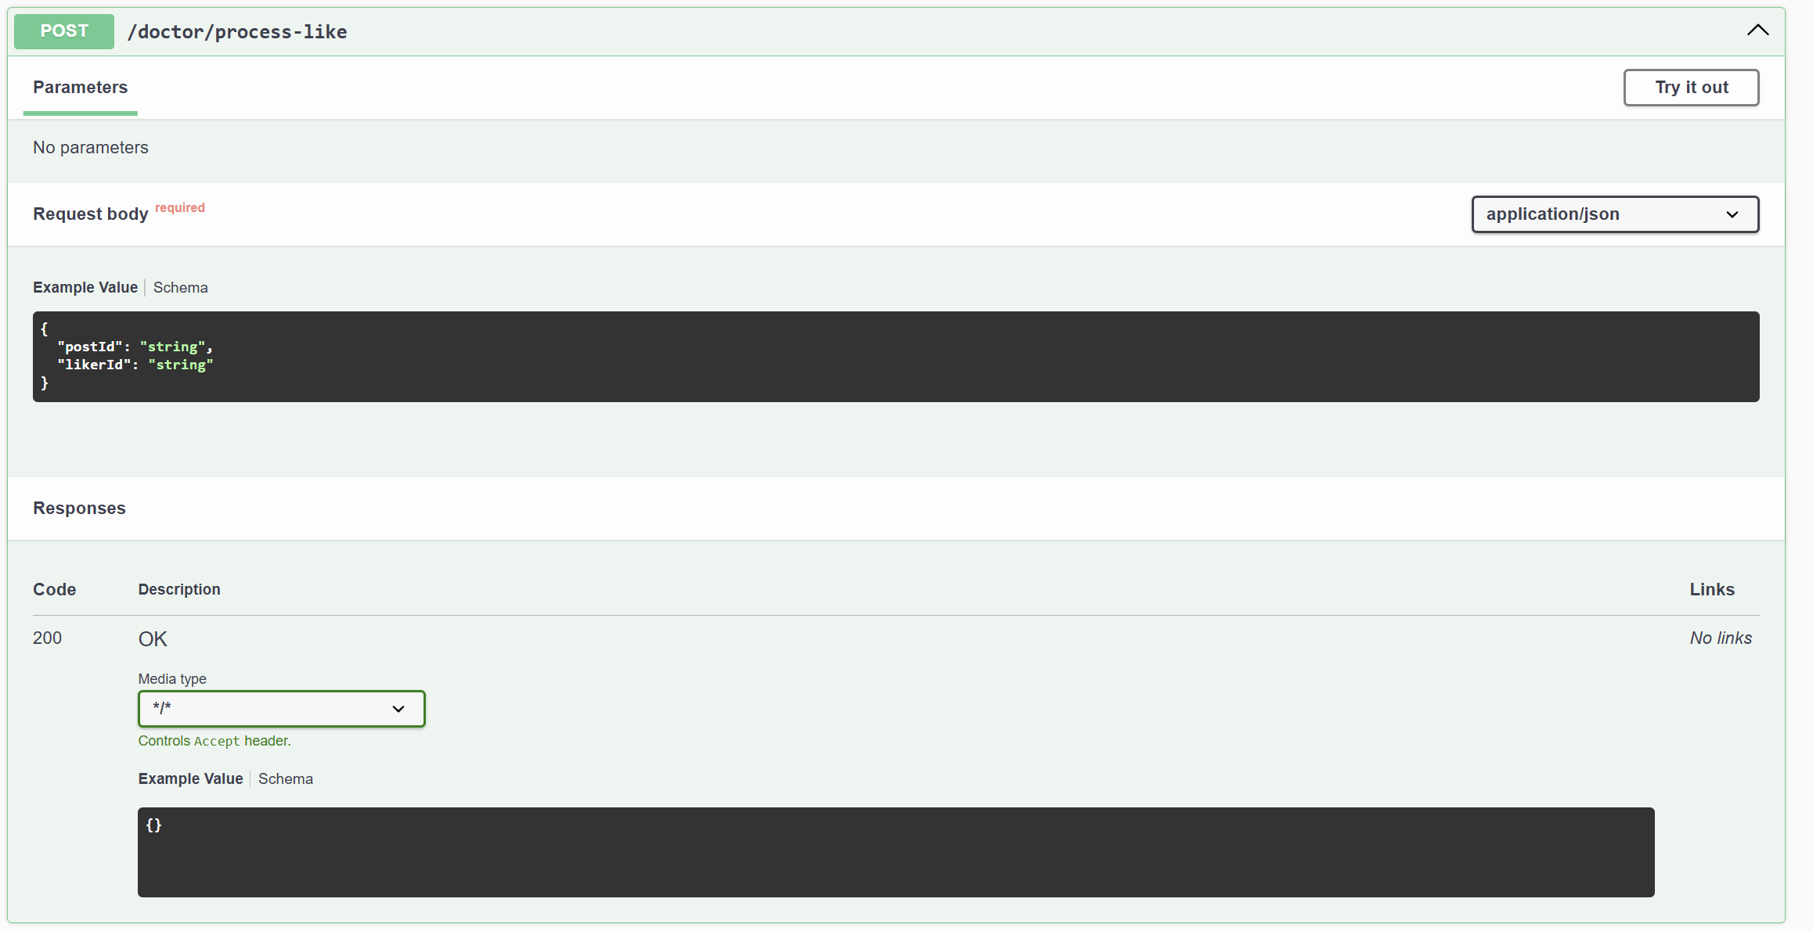

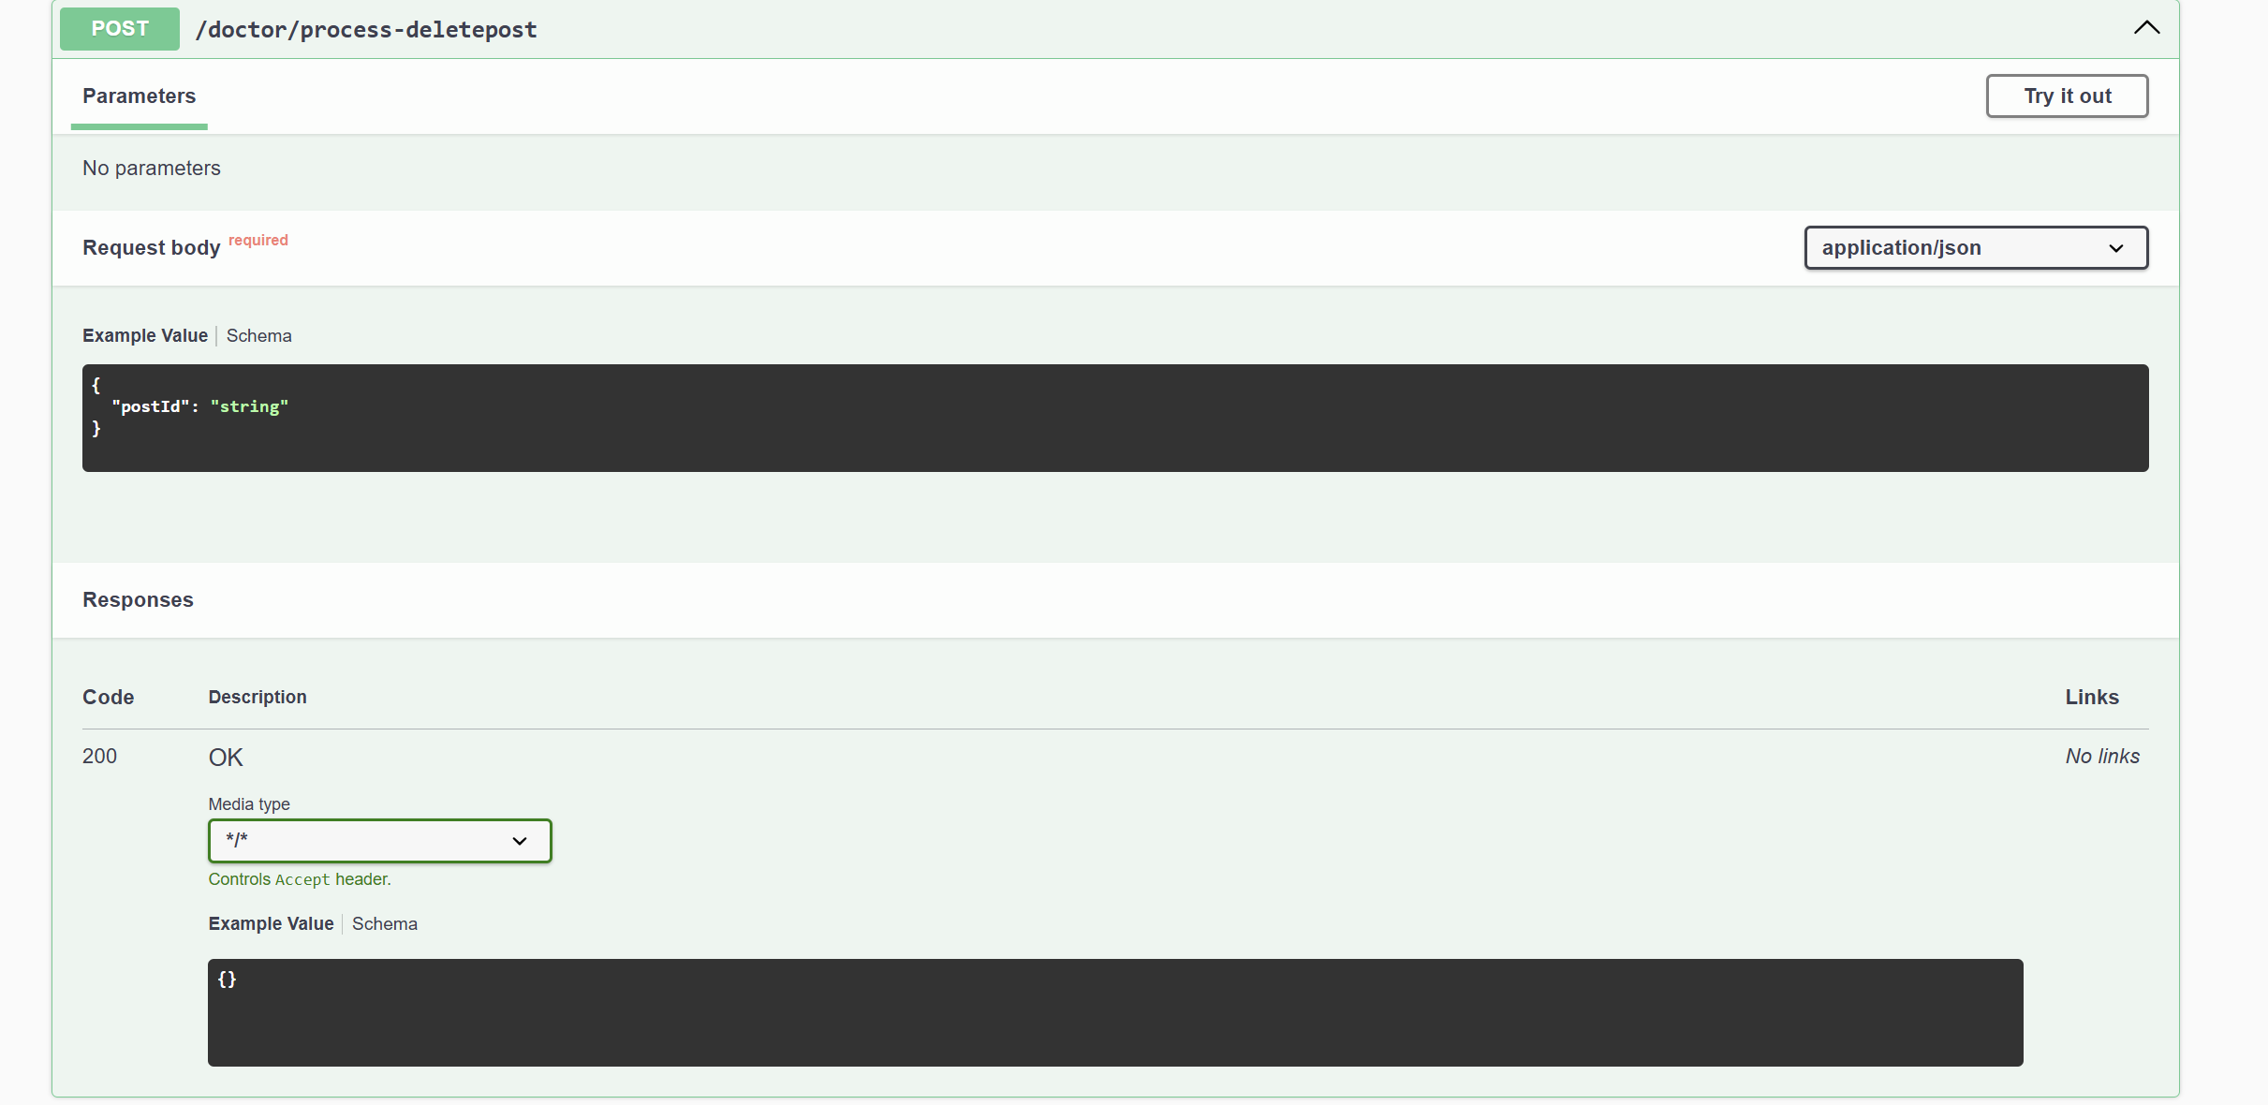

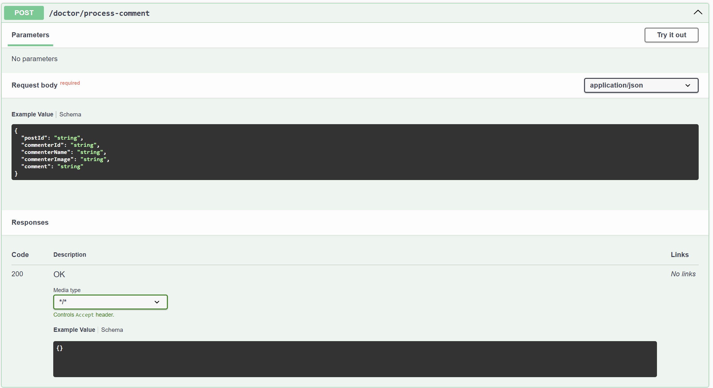

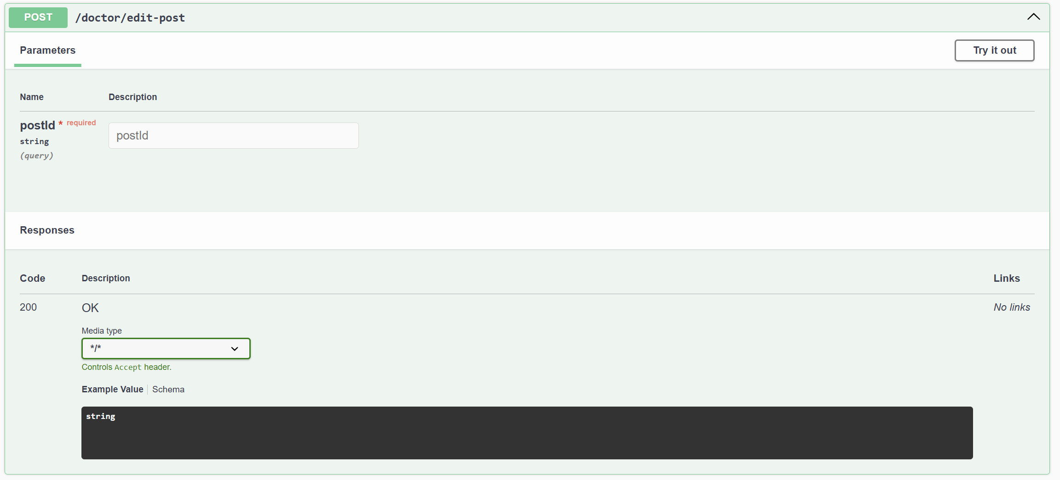

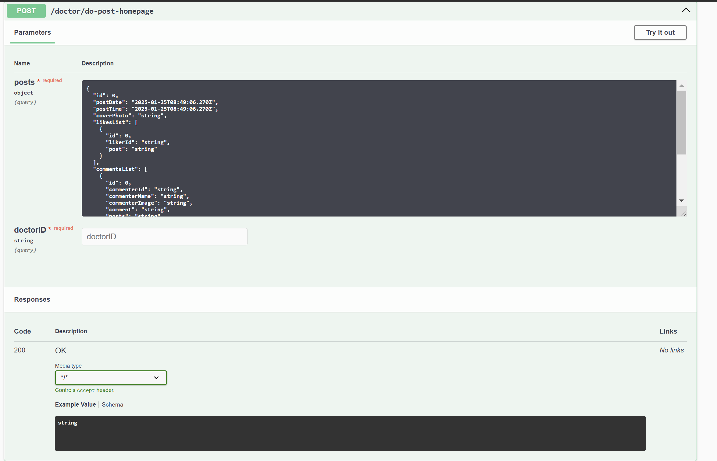

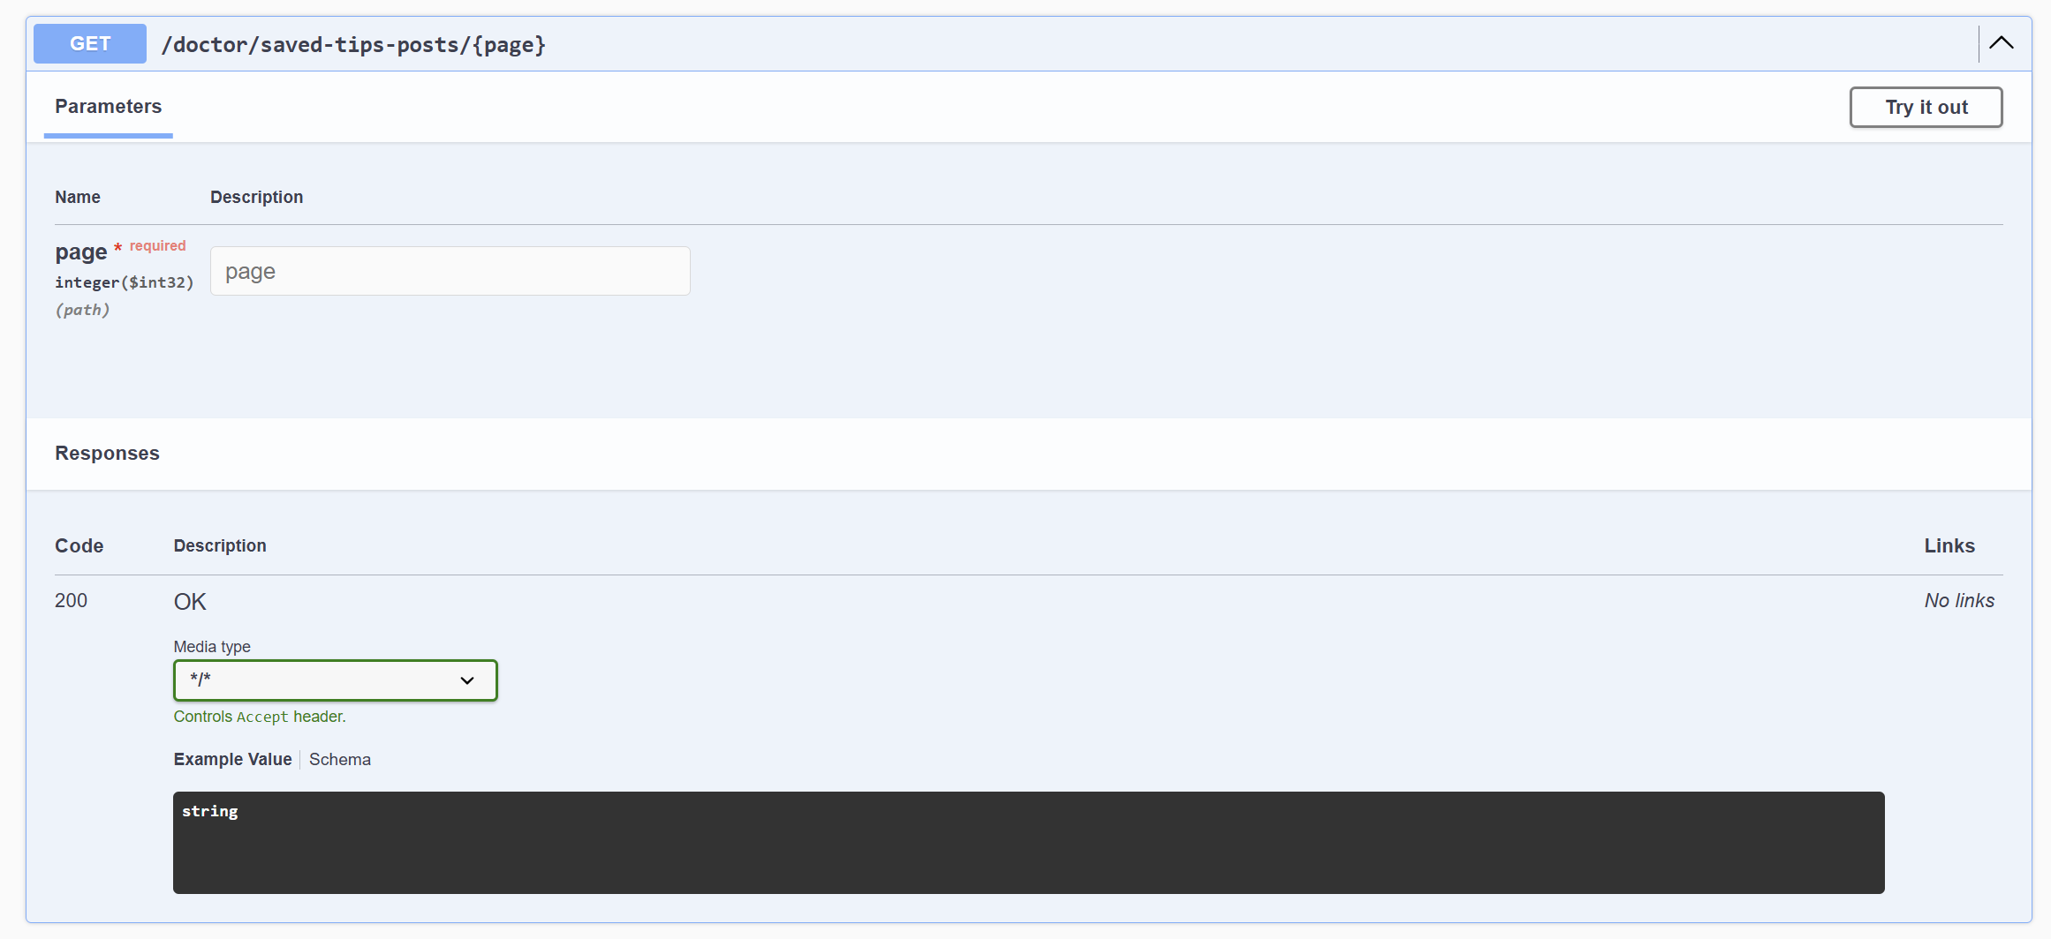

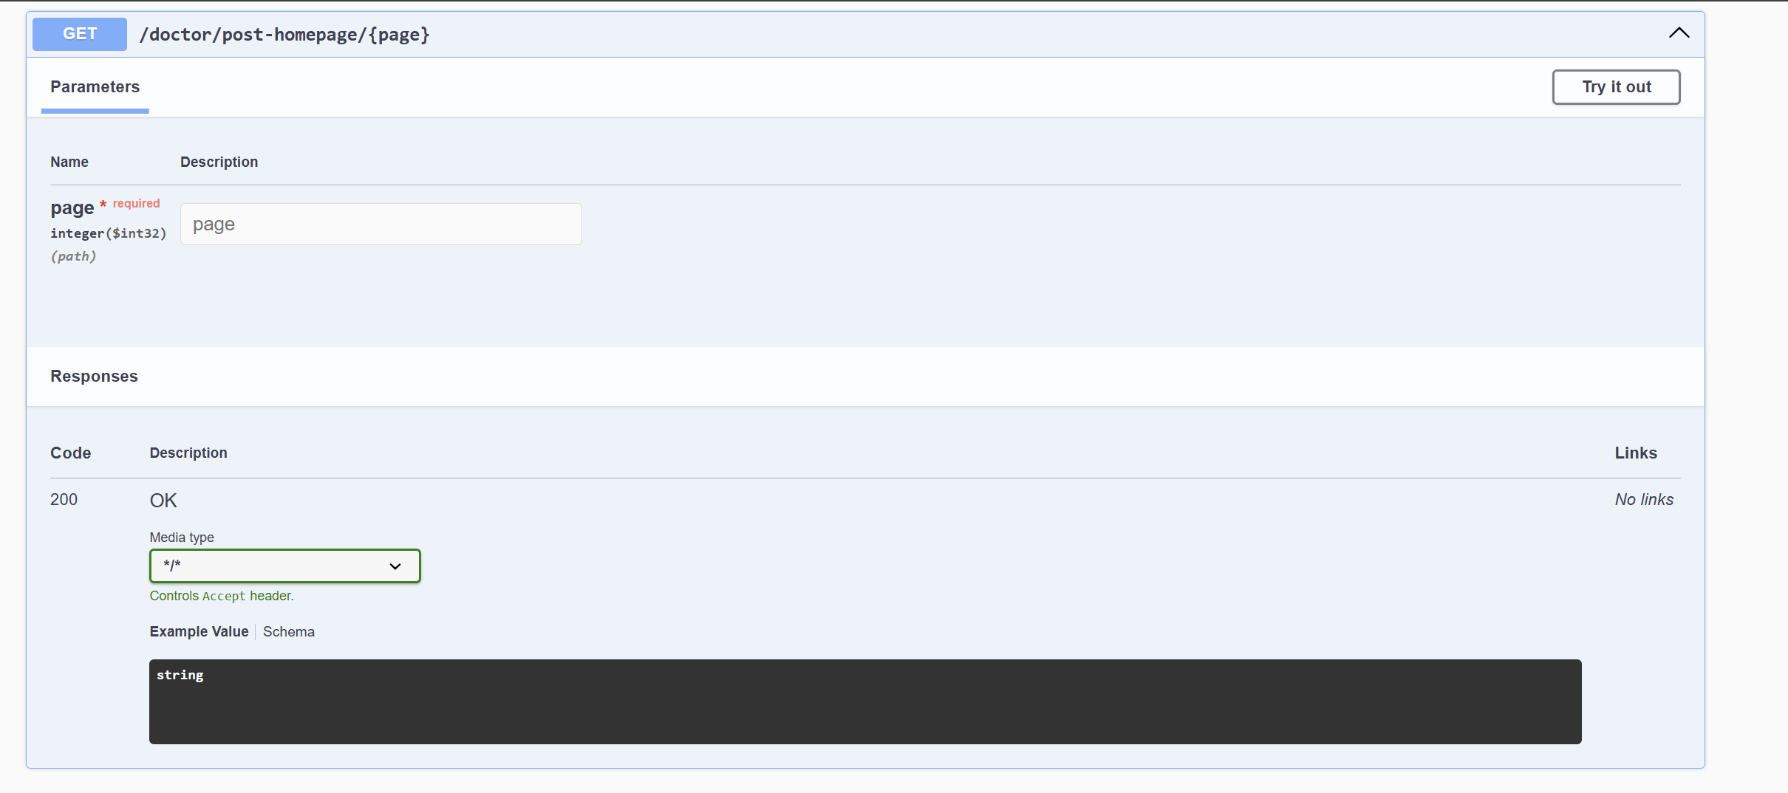

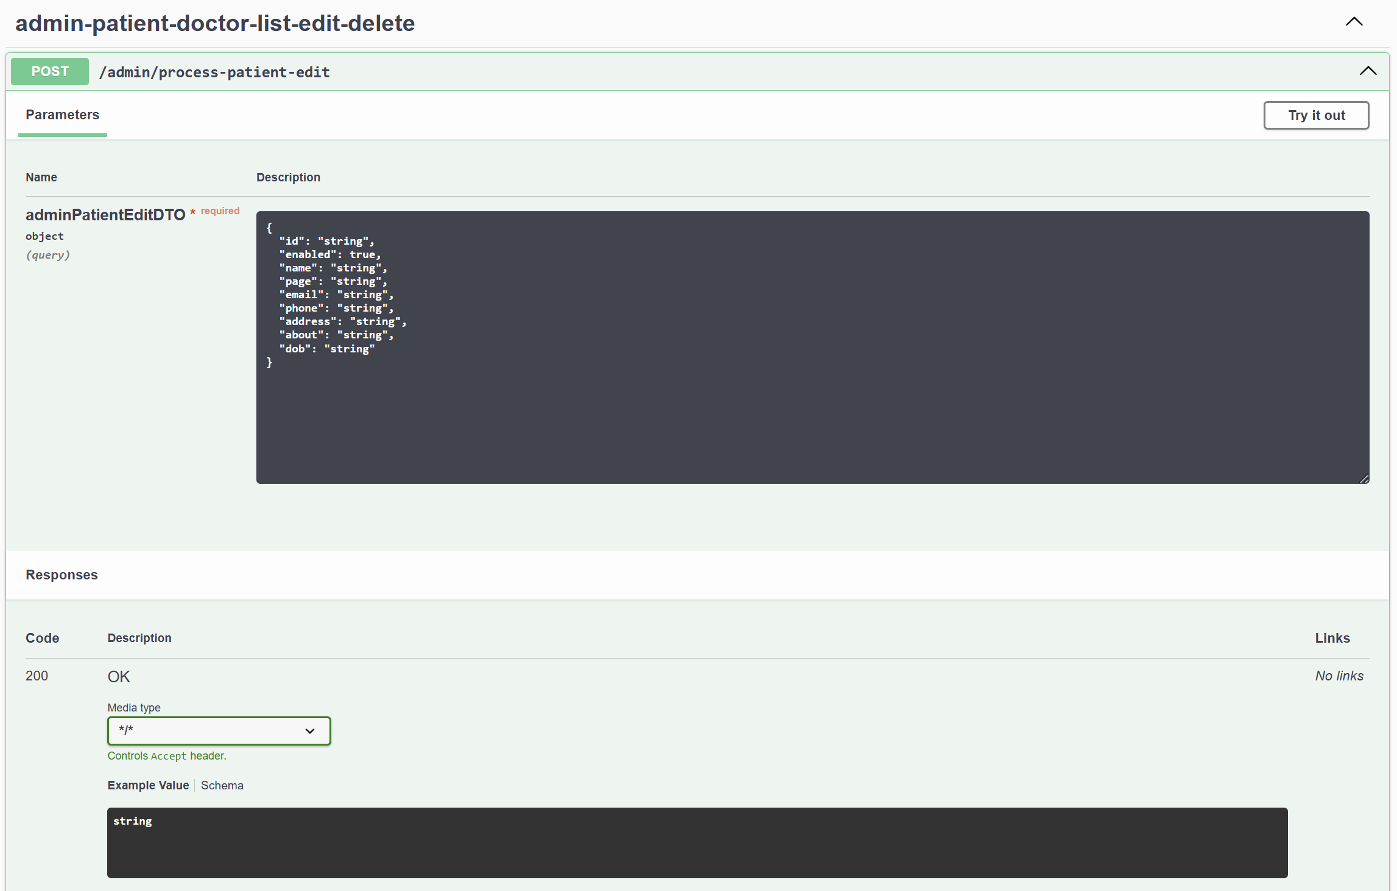

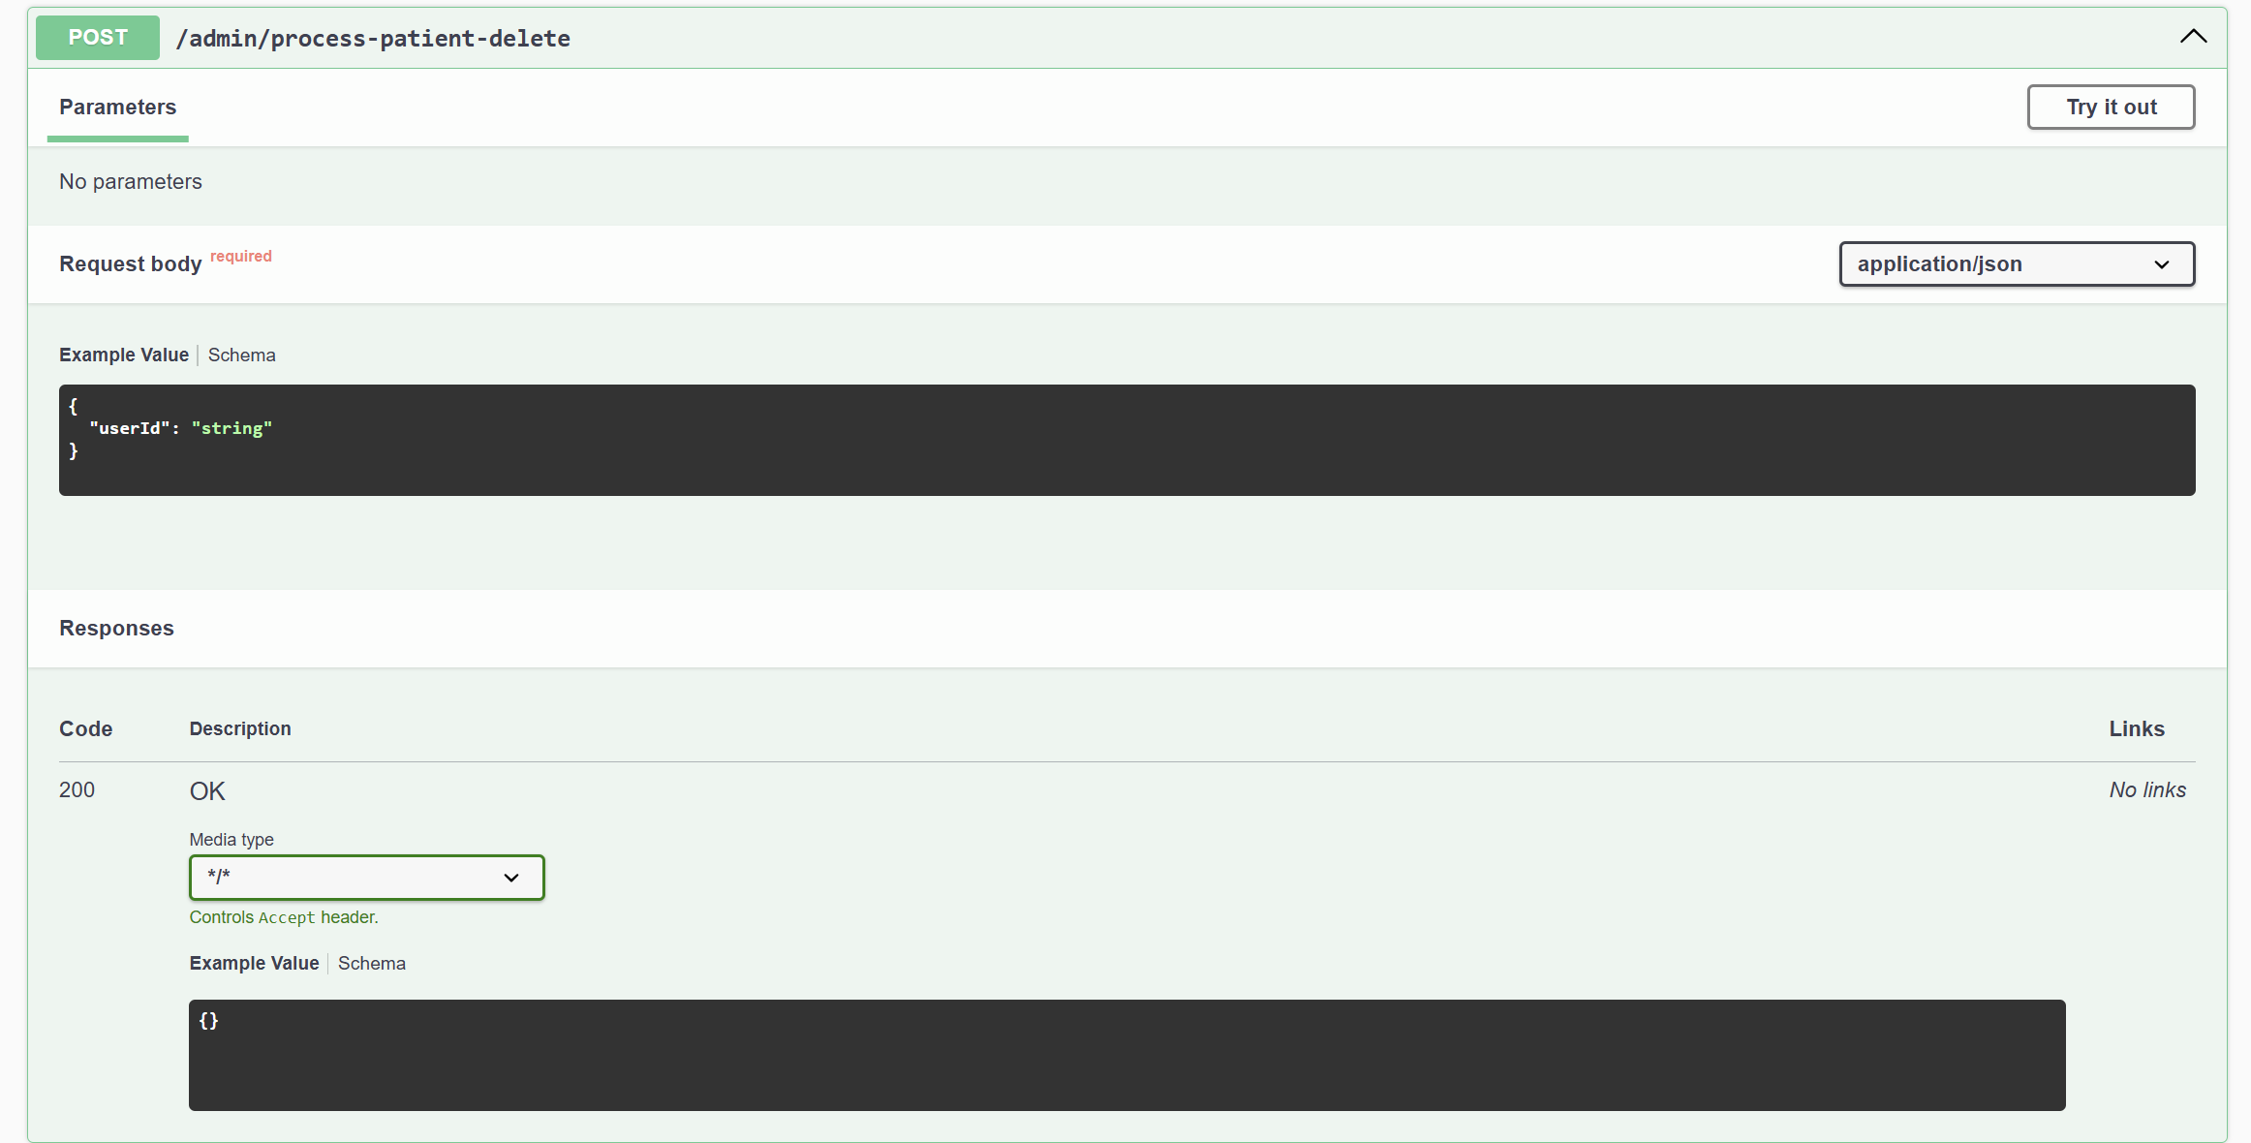

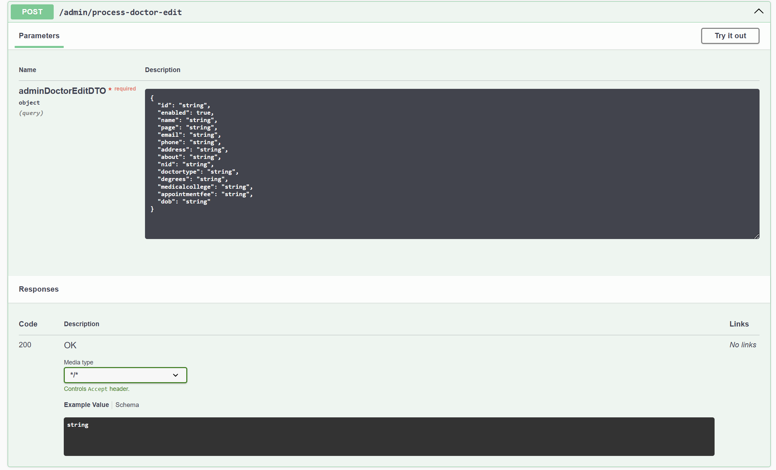

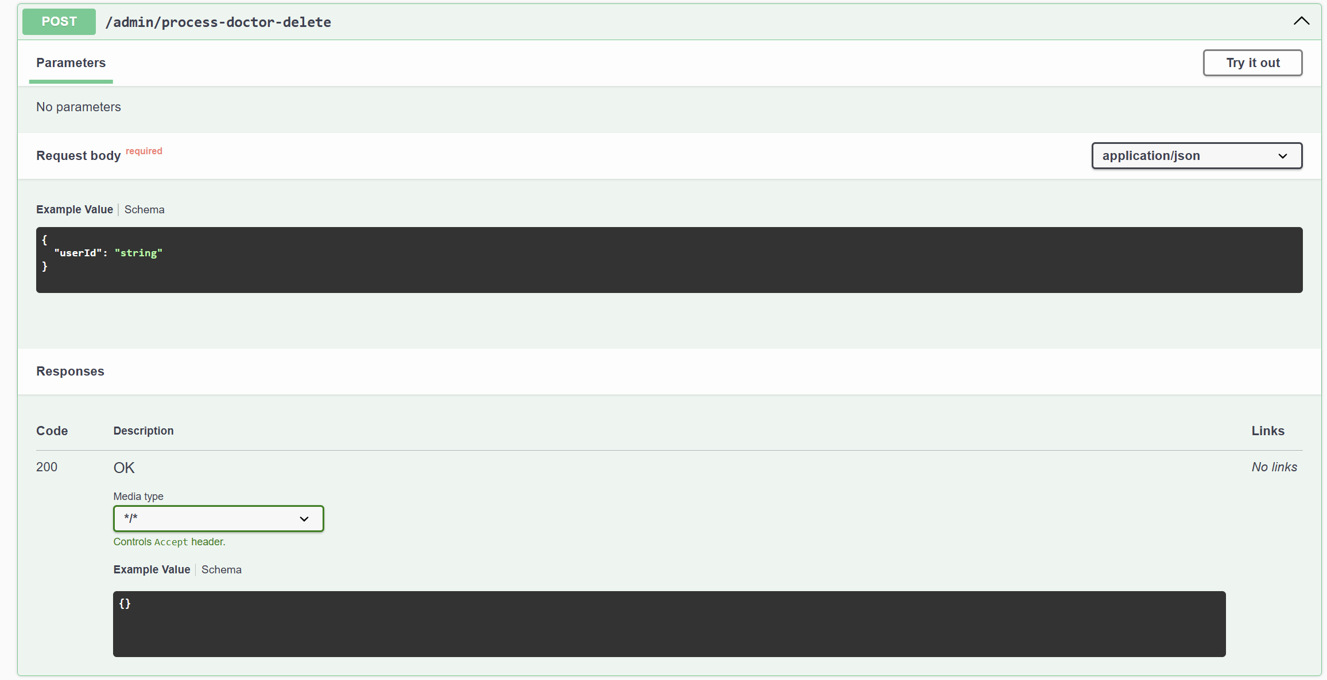

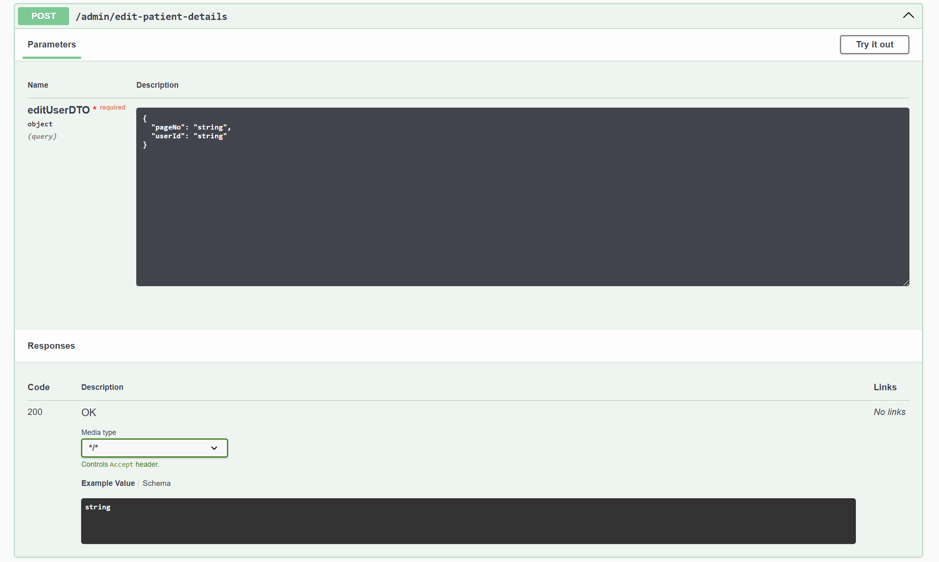

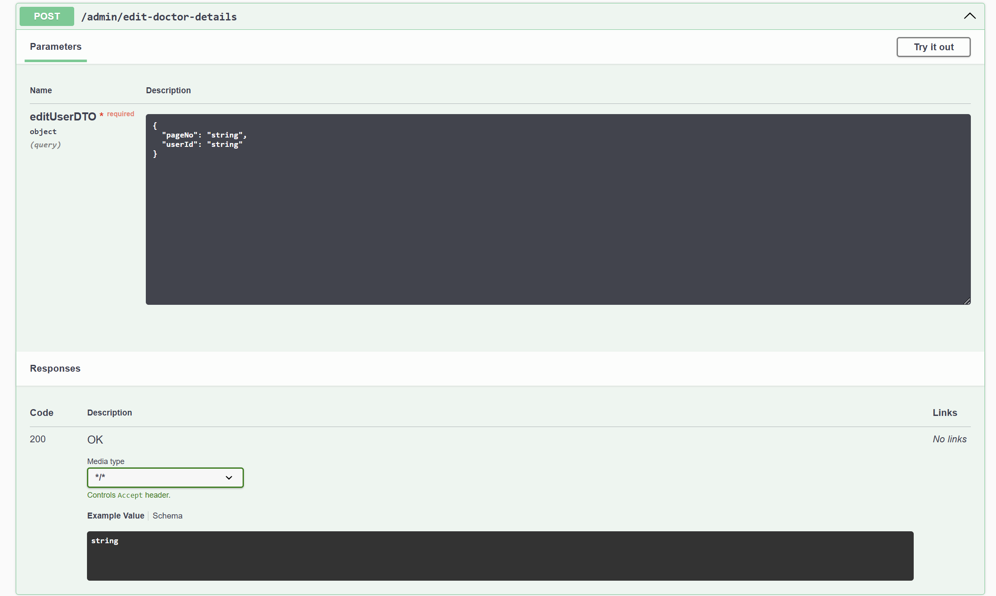

**7. ADMIN MAIN CONTROLLER**

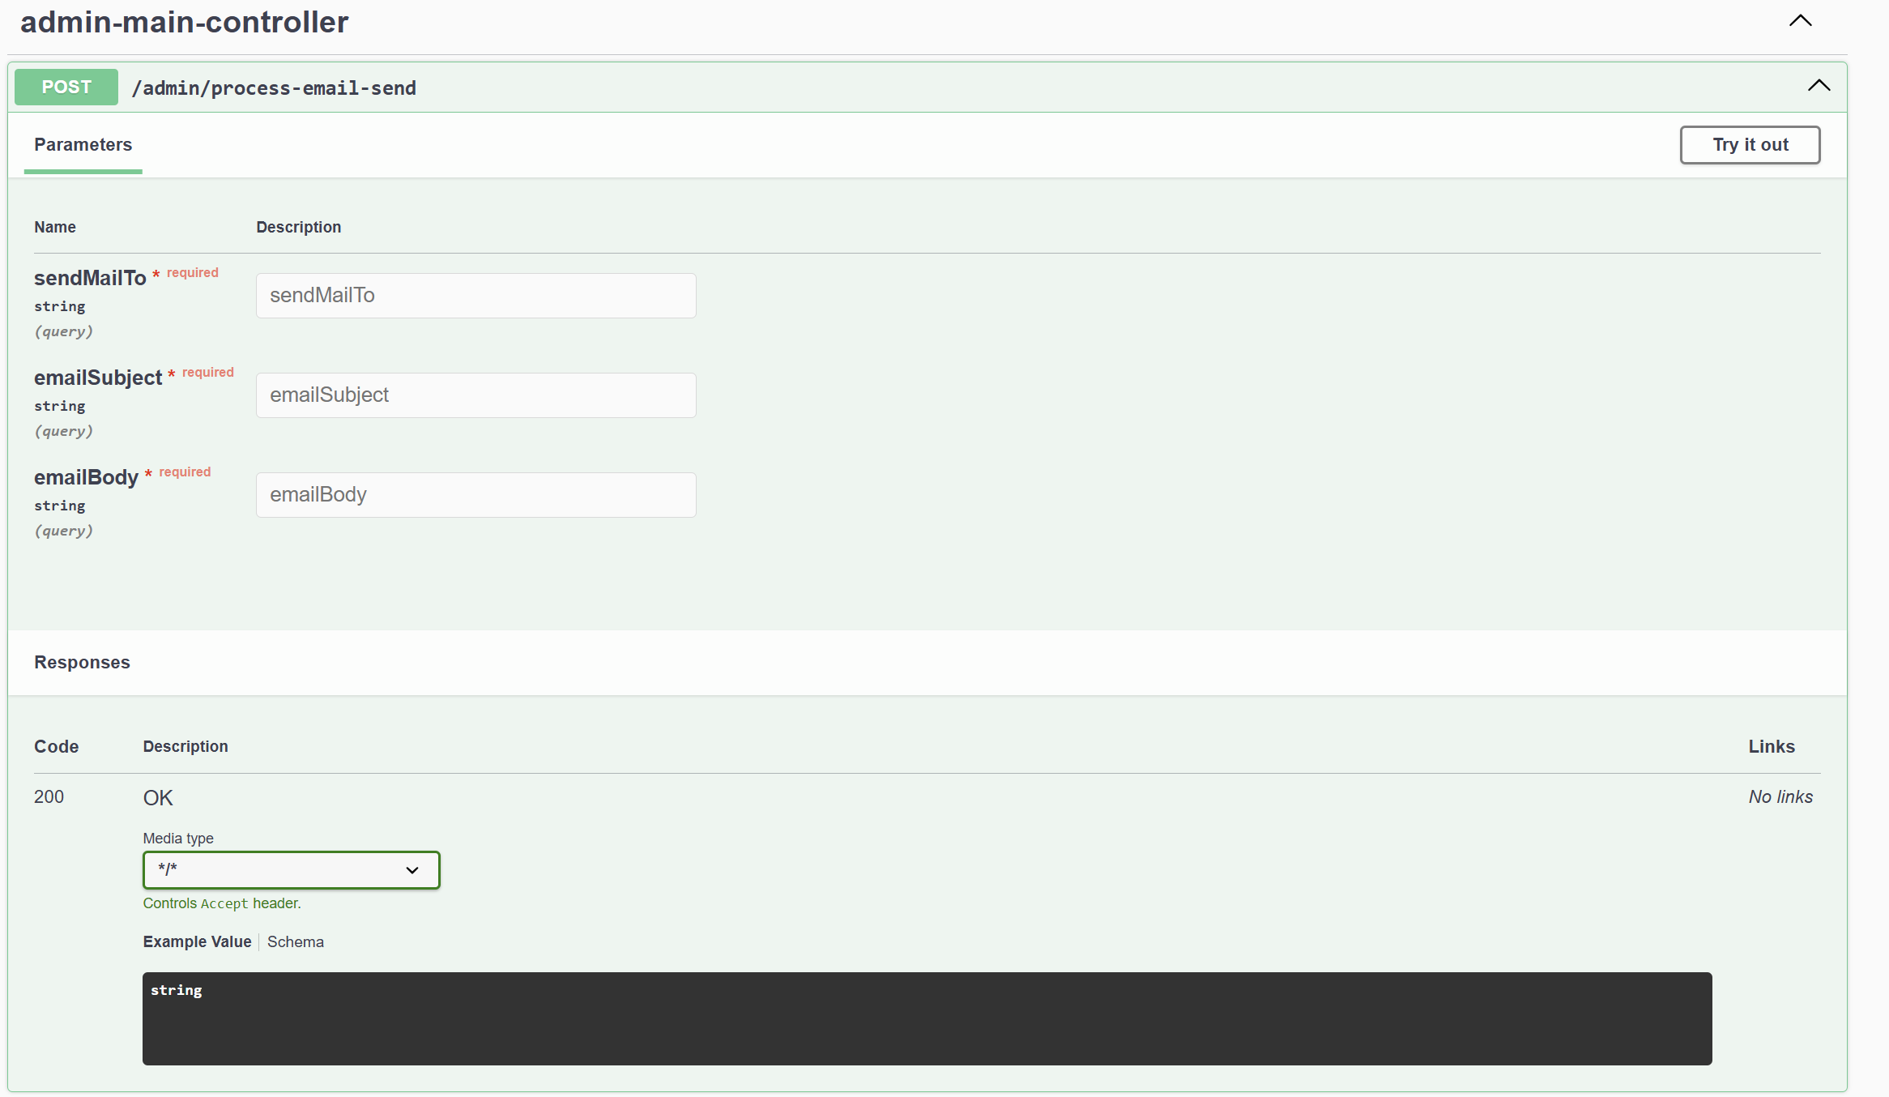

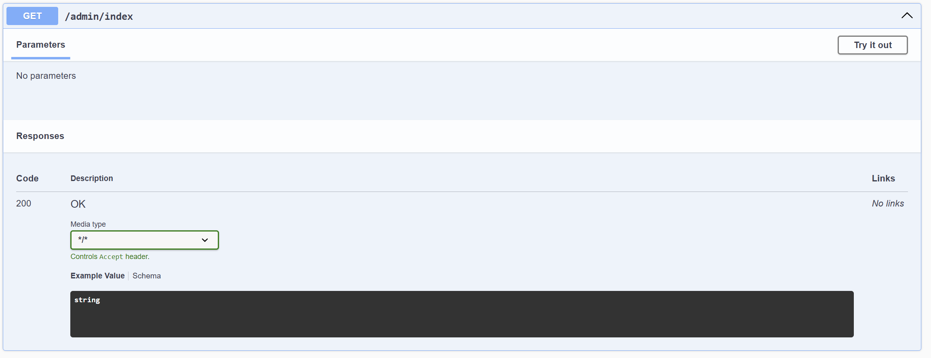

**8. DOCTOR MAIN CONTROLLER**

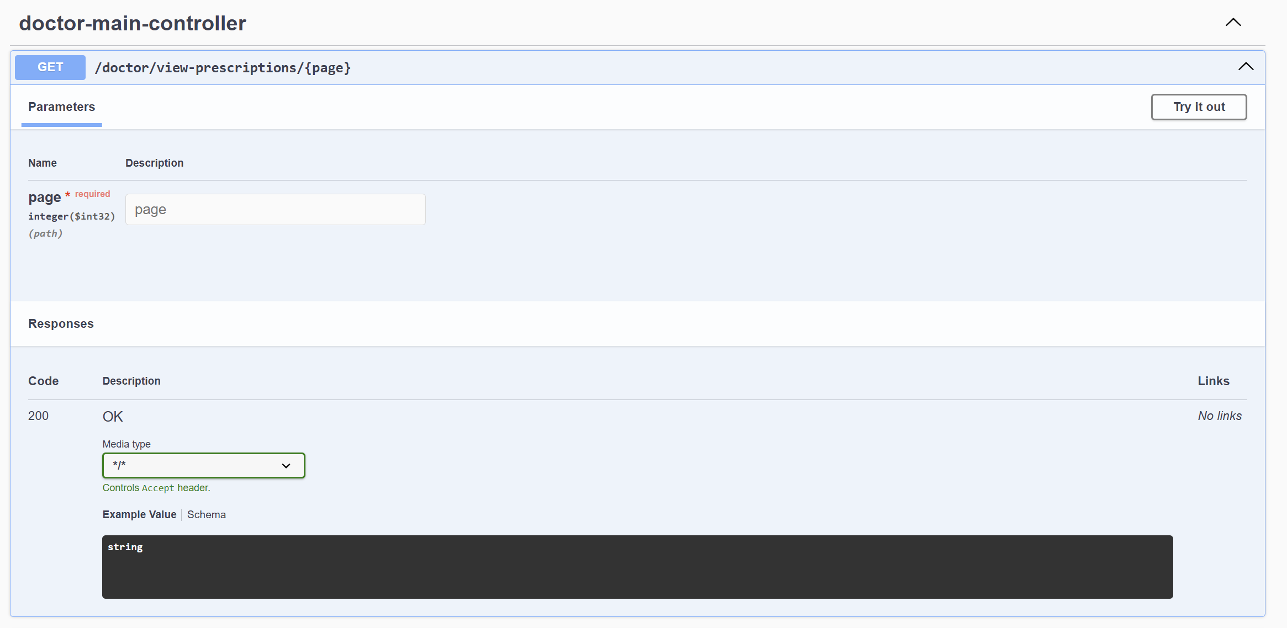

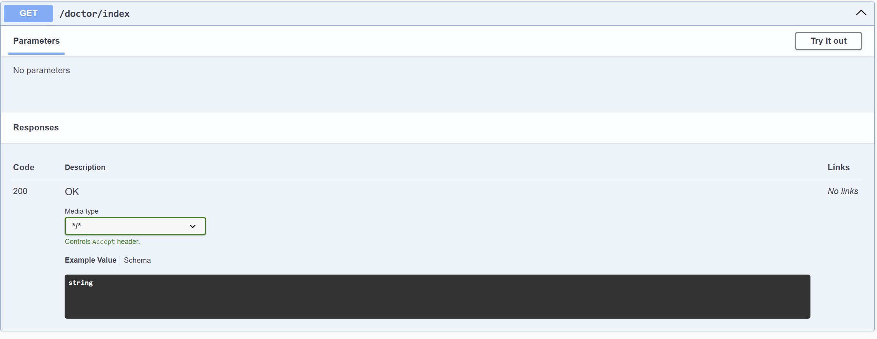

**9. ADMIN EARNING CONTROLLER**

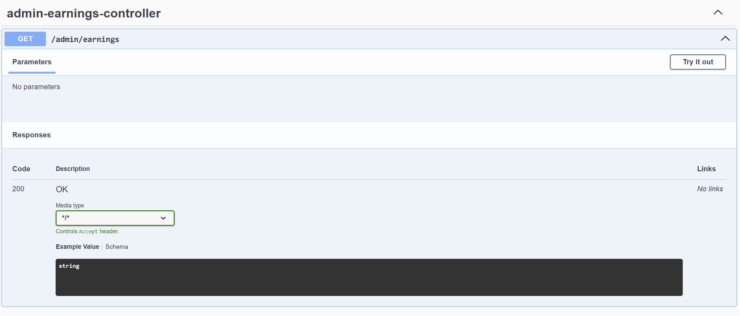

**Schema Details:  
  
